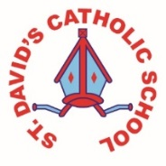
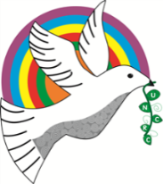
Class Caswell

Information for the week: 11/05/18
Literacy: | This week the children have read instructions and looked in detail at what instruction writing needs to include. Our particular focus has been imperative verbs or ‘bossy’ verbs. This has meant that we’ve all needed to be quite bossy this week; I hope they don’t carry on at home!
Numeracy: | The children are working on knowing what one more is than a number up to 20. Counting in 10s and bunny hopping in 10s.  They have practised counting on to find the answer and worked out what 2 more than a given number is by counting on. As well as this the children have added 10 to a two-digit number and tried adding 11. They also had a try at subtraction.
Religion: | The children have looked closely at the key words linked to this topic and used them when learning about the ascension. They have created ascension collages. The children have looked through gospel passages and highlighted key words and phrases Jesus said.
Any other information: | Mass this week was lead by the Y2 children and they did very well. Your children behaved beautifully and sang their little hearts out. I was very proud.
Maths mats and handwriting for homework.
Next Week (unfortunately)- I have been called for Jury service so may not be in next week. I will endeavour to come back to school each evening and I am available via email for any issues or questions
NEEDED | Tomato sauce squeezy bottles please. We want to decant our bigger paint pots into them to enable the children to independently access the paints.  Please do not forget FOSDA meeting 7pm school.

