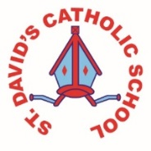
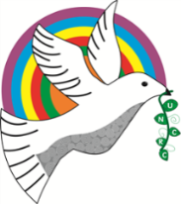
Class Caswell

Information for the week: 27/04/18
Literacy: | Thinking about lots of questions to ask Harry the hedgehog using capital letters and question marks. Writing a letter to Harry the hedgehog saying thank you for visiting. Reading non-fiction books and writing fact files on woodland animals.
Numeracy: | Subtraction up to and including 10. Subtraction and addition using a 100 square. Number bonds to 10.  Please see homework and practise these with your child.  Measuring tree trucks.
Religion: | We have looked at Jesus as the good shepherd and read about events after Easter.
Any other information: | We’ve had some exciting new resources this week to help us learn about the woodland. The children have enjoyed playing with the toys and reading the books.
Seren Yr Wythnos: | Congratulations Maria Martins for being awarded the Resourceful certificate!

