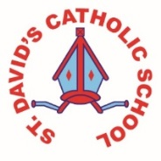
Class Caswell

Information for the week: 29/03/18
Literacy: | Sequencing and retelling the Easter story. Writing about Palm Sunday on Hwb.
Numeracy: | Easter has taken over our maths area with the children creating and labelling shape chicks and bunnies. They have counted out the correct amount of chicks.
Religion: | Holy week has been the focus in all subjects this week. The children have learnt all about Jesus entrance into Jerusalem, the last supper and Good Friday. They have also thought hard about times they have not behaved like Jesus and considered how they would put this right.
Any other information: | Easter assembly.  Easter Bonnet parade (well done all)  Watching Y3/4 stations of cross  Easter Mass  Junior egg rolling  Last Supper assembly  How did we fit it all in?  Next terms topic is The Enchanted Forest- we will visit a local woodland the first week back.
Seren Yr Wythnos: | No star this year due to the amount of Easter activities. If your child has not been ‘Star’ please let us know. The certificates are given on merit but we ensure all children receive it at least once.
Please see flyer about Foundation Phase film night.

Wishing you all a happy and holy Easter
Mrs Chamberlain

