Dosbarth Pwll - Du
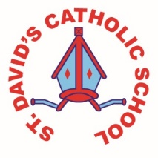
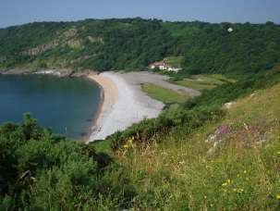
Information for 23rd – 27th of April

Literacy: | This week we wrote a recount on a memorable experience and also worked collaboratively to complete a reading test.  (That took a long time!)
Numeracy: | We’ve also been doing practice tests in our maths work ready for the up-coming national tests. We tried out using some new maths sheets to warm our brains up in the morning.
Religion: | In Religion we had a gathering to end our Lent/Easter topic. We were also introduced to our new topic Pentecost. We wrote down religious meanings to the Pentecost key words and on Friday we drew what the key words mean.
Topic: | This week we finished our Ancient Egypt topic by creating a display outside our class. Every group did a different part of the display.
Any other information: | This weekend’s homework is a practice Reasoning Test.
Seren Yr Wythnos: | Luca was our pupil of the week because he is always happy and friendly and focused on his work!
Resourcefulness  Certificate Winner | Susana was our resourcefulness winner this week because she always thinks outside the box.
Written by: | Amy, Ava and Sia.

