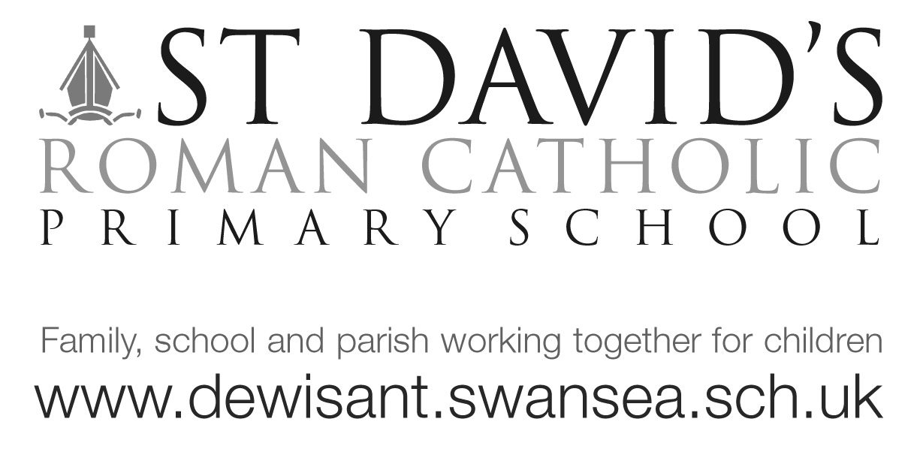
Dear Dosbarth Langland, 9/3/18

Well done to everyone who made a huge effort for World Book Day this year, we really did have lots of fun as well as doing lots of book related learning.
Well done to our winners Luca, Harry and Joe.V.

Massive congratulations go to Anais who very bravely did her class presentation in front of the whole school and totally won the show! Everyone was impressed by how confident, knowledgeable and animated she was. She was also on Chris Evans Radio 2 show talking about her presentation!

The class presentations really are an excellent way of boosting self-esteem and confidence. So far we’ve had presentations about Roald Dahl, Mary Berry, Sir David Attenborough, Katy Perry, Brunel, David Walliams, Ronaldo, Taylor Swift, The Beatles, Donald Trump and Gandhi.

If your child hasn’t done their presentation yet don’t worry there is still 3 weeks left, please help your child prepare a short talk on a famous person of their choice. It needs to be less than 2mins and could be as simple as talking about a picture they have drawn, a photograph of the famous person or as elaborate as a power point it’s up to you. The Literacy aspect of the Foundation Phase is split into Oracy, Reading and Writing with lots of emphasis on the Oracy (speaking) so this really is an excellent way to show off speaking talents.

We celebrated our Eisteddfod part 2 today and the children did some fantastic welsh dancing! Da iawn.

In maths we have been looking at fractions ½, ¼, ¾, of shapes and numbers. The Year 2 children who are using TTRockstars could quickly find ½ of a number, well done!

Also we will be continuing with our ‘Fit and friendly for #40’ daily exercise and kindness activities. Lets get as much sponsorship as possible

Tomorrow I will be at Southend gardens from 10.45 for the Mumbles Dragon parade. Dosbarth Langland have made a flag it would be great if you could join us to help parade it. Hopefully see you there.

Many thanks
Mrs Evans EvansC808@hwbmail.net

