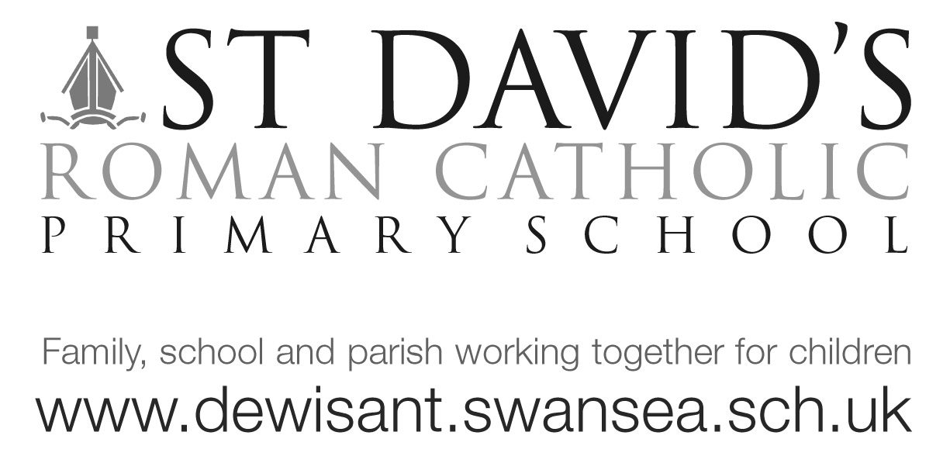
Dear Dosbarth Langland, 16/2/18

Our trip to Langland on Monday was most successful with only a slight shower of rain! The children had lots of fun exploring the beach and have been doing lots of beach art back in class as well as writing about the trip in Welsh!

Our other local visit to the library was also successful with the children seeing first hand all the library has to offer. The library is a great free resource!

Today for our Shwmae day we learnt a new welsh song and have introduced a tocyn iath (tokens) for welsh speaker of the week!

In maths we’ve been counting in 2’s, finding multiples of 2 and using our times tables to work out problems. Please can I remind Year 2’s that they should be using TTrockstars daily to enhance their multiplication skills.

It’s set to be busy after the half term with St David’s day and World book day all in the first week! For St David’s day we are having a class competition to ‘Dress a Leek’, that’s right….putting tiny clothes on a vegetable! Seriously, we have done this craft activity for many years and the children really enjoy it! I’m told it is an Eisteddfod tradition. Please bring your dressed leeks in on St David’s day.

Also we will be continuing with our ‘Fit and friendly for #40’ daily exercise and kindness activities. Lets get as much sponsorship as possible

We’ve done lots of work on diaries this term, if anyone would like to keep a half term diary we would love to see it when we get back.

Well done to Evie and Harry who are our Star of the week! Also to Anais who Mrs Jones gave a certificate to as she is still doing our 1k a day challenge!
Hope you have a happy half term.
Many thanks
Mrs Evans EvansC808@hwbmail.net

