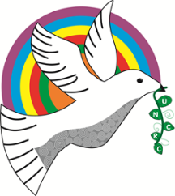
Bracelet Bay - Y3/4
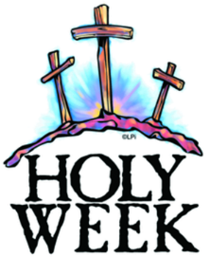
Have a wonderful holy Easter break.

Information for the week: 26th March 2018
Literacy: | This week we have published our explanations on the water cycle on HWB. We had to edit in our editing stations (spelling, punctuation, grammar, peer assessment and teacher assessment) before we published to make sure we had all of the features of a WAGOLL explanation!  This week your child had a huge key word spelling test based on the year 3/4 spellings. They all know what their results are. The words that your child does not know is in the front of their diaries. It is vital that they learn these before they move into their next year group. I hope you can support this at home. Thank you.
Numeracy: | This week we went over two test papers in maths. One to discuss our answers from our homework and the other to look at the marks given and where and how to get extra marks by doing jottings!  A lot of children felt that time is still hard for them (analogue). A good website to use to help practice time through games is https://www.topmarks.co.uk/Search.aspx?q=bang%20on%20time However you will need to ensure flashplayer is on your computer (free to download). Or failing that ask your child the time often and ask then to wear a watch. Can they change digital to analogue? Can they use the 24 hour clock. We will be going over time in the first two weeks of the new term too.  As if that wasn’t enough we revised dividing using the bus stop method and went over halving 2 and 3 digit numbers.
Religion: | What a lovely Holy week. We presented the Stations of the Cross to our friends in Foundation Phase and to families. We have made Holy wreaths depicting Holy Week and have made fun Easter cards. We have also talked about how Jesus was so giving and self-disciplined.
Topic: | We will roll our topic ‘Misty Mountains’ over into next term by a week as the children really want to finish it and explain what they have learnt to each other.  Next term we will be having a new topic called ‘Burps, bottoms and bile!’ What do you think you will learn? What would you like to learn?
Any other information: | I am sending home two test papers for you to see and go over with your child (Reading and reasoning).  Don’t forget to look on the website for other National Test papers. We will be completing more test to get us used to the formal sitting of them after Easter.  2nd May 2018 – Reading  3rd May 2018 – Procedural  4th May 2018 - Reasoning

