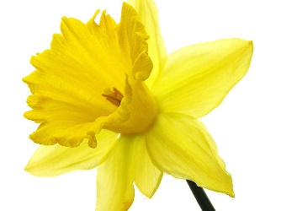
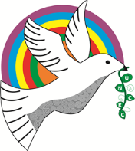
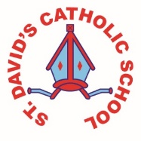
Bracelet Bay - Y3/4

Information for week: 26/02/18 Authors: Isabella and Mia.
Literacy: | This week we have been presenting our Power Point presentation on our Welsh mountains. We helped our friends learn how to improve them.
Numeracy: | We have measured our heights and converted them into metres and centimetre using decimals We have also looked at decimals using mm, cm and km.  In mental maths hew have been adding multiples of 50 that total 1000.
Topic: | We have started to weave on our looms that we have made just like the Himalayan tribes do!
Any other information: | At the start of the week we have learnt about our Parish and communities and released that there are lots of jobs to be done. People have to be responsible, reliable, friendly and welcoming to make a Church a community.  Soon all of our class will have completed an experiment using crisp packets. We have learnt that when you heat plastic it shrinks. We made key rings with mini crisp packets.  On the 1st March we had St David’s Day Esiteddfod. We loved it bendegedig!

