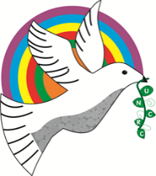
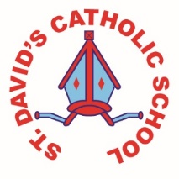
Class Caswell

Information for the week: 23/03/18
Literacy: | This week we have been budding estate agents and persuading one another to buy houses. We’ve looked at the language we needed to use when selling houses and played fun ‘through the key hole’ games.
Numeracy: | In maths the children have been finishing off their work on place value- this is tricky so I’ve added another game to have a go at on their Hwb page. Have a go!
Religion: | In religion we have been learning about special meals and in particularly the Last supper and Holy Communion. We’ve been extending our understanding of the different symbols and words used.
Topic: | We have been investigating which is the best material to build a bed for the Princess and even had a go and building our own beds to see whether we could feel the pea.
Any other information: | This week we have been practising for our assembly on Monday.  We have our Easter bonnet parade too on Monday.
Seren Yr Wythnos: | Gwaith gwych Finnley for your perseverance and focus in your writing.

