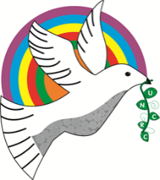
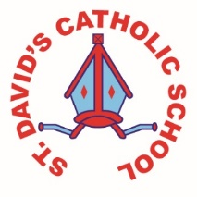
Dosbarth Mwmbles

Information for the week: 23/03/18 Authors: Daisy and Lauren
Literacy: | We have created very detailed bubble maps about  our trip to St. Fagans to help us write recounts of our trip. We read a text about a roundhouse for sale, stop spotted the key information and answered questions.
Numeracy: | We have been learning about diameter and have learnt how to measure the diameter of a circle. We had great fun solving a celtic maths problem helping Cenydd the Celt work out how many people could fit in his roundhouse. We used our knowledge of diameter, fractions and multiplication to solve the problems. We also enjoyed doing our Talk It, Solve It activities.
Religion: | We have learned about the 14 stations of the cross and have been practising for our Easter concerts.
Topic: | We have been learning about Celts so we went to St. Fagans to see the Celtic roundhouses. We also created amazing celtic battle scene imovies and used the app Comic Life to recount things we’d learnt in St. Fagans.
Any other information: | We have been doing lots of celtic coding! We programmed the beebots to travel to different roundhouses and timed ourselves to see how many roundhouses the beebot could travel to in a minute. We also created our own routes using quarter and half turns and wrote directions using the forward, turn, left and right. We also wrote Welsh Dyma Fi profiles for ourselves as celts.
Seren Yr Wythnos: | The star of the week was Taliesin Cox. Well done for leading your tribe in our round house problem solving task. Da iawn ti!

