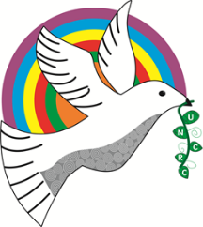
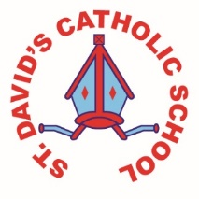
Bracelet Bay - Y3/4
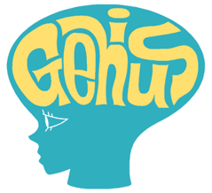
Information for the week: 12/03/18 Authors: Mia and Isabella
Literacy: | This week we have been writing non chorological reports about Pen Y Fan. We chose our own way of writing it but still used the features of explanation writing. Some of us chose to present it as a Power point, others as a poster or leaflet on HWB and some friends used poster paper and printed images. This week we have also looked at the features of information texts e.g. The Water Cycle. As well learning new spellings!
Numeracy: | In maths this week we learnt how to do the grid method (multiplying 2/3 digits by a single digit) and we have been using it in our problem solving. We have also used it as jottings in our stuck on the maths using decimals.
Religion: | In religion we have been learning about Ash Wednesday and Lent. We have learnt that Lent has 40 days and every day we have done a fit for forty! We have made Lenten promises about fasting, giving, prayer and charity.
Topic: | We have been sketching mountains in our topic on canvas. We really had to use out imaginations! Some of us include the water cycle in it.
Any other information: | This week we have been fortunate to present to the whole school our Genius Club presentations, ‘Multi Cultural Week!’ Mrs Winchester has asked us to think of new clubs linked to well-being for after Easter.  Please bring a yogurt pot so we can make a mini mountain out of paper Mache.
Seren Yr Wythnos: | Gwaith gwych Heinrich for your creative writing!

Don’t forget to look on the website for our National Test papers. Feel free to have a look or even a go at one!

