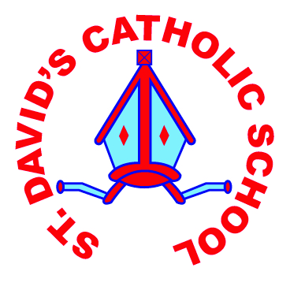
ST DAVID’S CATHOLIC PRIMARY SCHOOL

Spring Term 2018 Calendar Dates

Date | Activity | Time
08.01.18 | Inset Day – School closed to pupils | All day
09.01.18 | School Open to pupils | 08:50
15.01.18 | Welcome Mass – Start of the New Term - School | 14:00
16.01.18 | M&M Productions – ‘Hunchback of Notre Dame’ | 09:30
23.01.18 | Yr 3/4 trip to the University
06.02.18 | Safer Internet Day | All day
07.02.18 | Pandemonium Theatre Group
12.02.18 | Welsh Week
14.02.18 | Ash Wednesday – distribution of Ashes
16.02.18 | Culture Day – celebration of different countries | All day
16.02.18 | Children finish for HALF TERM
19.02.18 | HALF TERM
01.03.18 | St.David’s Day Eisteddfod
01.03.18 | St.David’s Day Mass – Our Lady Star of the Sea | 10:00
02.03.18 | World Book Day | All day
05.03.18 | Foundation Phase Film Club | 15:30 – 17:00
21.03.18 | Stations of the Cross – Our Lady Star of the Sea | 10:30
26.03.18 | Foundation Phase Easter Bonnet – All welcome  Foundation Phase Easter story – All welcome | 13:30  14:30
27.03.18 | Easter Mass - School | 14:00
28.03.18 | KS2 Easter Story | 14:30
29.03.18 | End of Term | 15:30
Unfortunately, sometimes events may have to be rescheduled or amended. We will give you as much notice as we can. Our website always carries the most up to date information.

