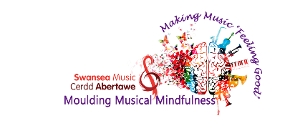

Hello to all the young musicians in our Swansea Schools!

We have a very important message from the lovely teachers at Swansea Music.
They are feeling really sad that they haven’t been able to hear you playing your instruments or singing with your beautiful voices.
They have been busy behind the scenes hatching a plan to keep you going with all things music related, and are launching their new E-Music Clubs online!

Click here to see the link of what’s coming up soon!

This will include:
- bite sized lessons
- fun and creative musical activities
- Tips, Tricks, quizzes, puzzles and lots more!

‘Swansea Music Young Musician of the Month’
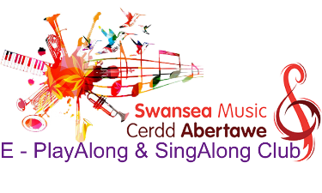
We know that many of you will have been busy practising for your graded exams. To celebrate our launch, we would like to give you an opportunity to show off your hard work by entering the ‘Swansea Music Young Musician of the Month’ competition as part of our new and exciting:

‘E-PlayAlong & SingAlong Music Club’
Can’t wait to hear what you have been practising!

How to Enter
All you need to do to enter is record yourself playing or singing one of your favourite graded exam pieces of music e.g ABRSM,Trinity College etc
- Introduce yourself and the name of the piece/song before starting your recording.
- Also if you have already sat your exam and received your marks, let us know how you got on at the start of your recording.
- Click here to complete the consent form.
- Once we have received your consent form we will send you a link to upload your recording via HWB OneDrive. The closing date for entries for April’s Swansea Music Young Musician of the Month will be Friday, 8 May 2020 1pm. Winners will be announced by Friday, 15 May.

A winner will be chosen from each grade exam from primary and secondary school and will be featured in the Swansea Music Hall of Fame!

Keep following Swansea Music’s social media pages for more details and what’s coming up next!
Remember!! Stay home, protect the NHS and Save Lives! We are all looking forward to ‘Making music and Feeling Good’ again!

Good Luck!

Cofion/Regards
Karin
Karin Jenkins
Pennaeth, Cerdd Abertawe
Head, Swansea Music
Cerdd Abertawe-Swansea Music

https://swanseavirtualschool.org/
Cerdd Abertawe-Swansea Music
@swanseamusic1
#mouldingmusicalminds

