 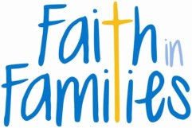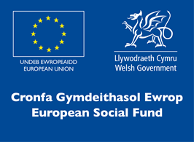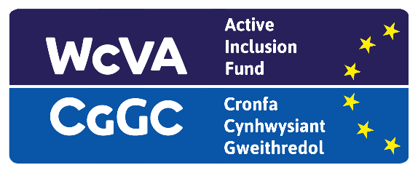

**We offer:-**

* **Online / telephone support**
* **Online Accredited training**
* **Well-being support**
* **Practical support**
* **Support to address issues that are affecting your wellbeing.**

We are still working with current participants as well as signing up new ones both digitally and over the phone!

If you need support please get in touch using the information provided below!

Let us help you to:

* build your self-esteem and confidence
* Discover your strengths and work on your weaknesses
* Build your skills and increase your motivation
* Develop positive thinking and attitudes
* Support your personal and professional development

***We support people age 25+ who are not on a job search benefit or have been on a Job search benefit for 12 months +***

***We area based in the Bonymaen, Clase and Portmead Community Cwtches.***

For more information or to get involved contact Natasha at:

[natasha@faithinfamilies.wales](mailto:natasha@faithinfamilies.wales)

07926088193

**Inspiring Futures!**

***We are still here for you!!***