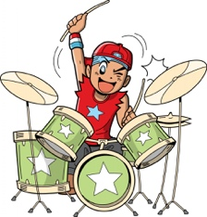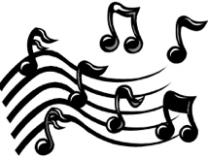

Musical Elements

Can you correctly match these musical elements with

their meanings?

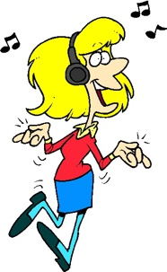

If you get confused you could try using a dictionary to help you, or even do some online research!

Pace

Loud or soft

Thick or thin

No sound at all

Pitch

Long or short

High or low

Duration

Silence

Timbre

Texture

Structure

Dynamics

The layout of the music

The type of sound

Fast or slow