A song that makes me feel:  Happy | A song that makes me feel:  Excited | A song that makes me feel:  Nervous | A song that makes me feel:  A Little Sad | A song that makes me feel:  Silly | A song that makes me feel:  Thoughtful | A song that makes me feel:  Like Dancing
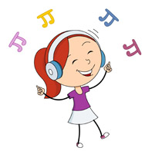
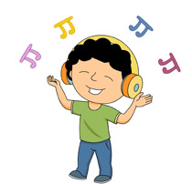
Are You Feeling Good?
Music is a wonderful thing! Music can change our mood and the way that we think and feel about things. What is your favourite song? How does it make you feel? Why does it make you feel like that? There are no right or wrong answers, which is great! Music is personal, it’s all about you!

Spend some time this week listening to lots of different songs and think about how they make you feel. Add them to the chart below and soon enough you’ll have created your own personal playlist of music that you can listen to during any situation. Why not get your family to make their own chart full of ideas too?

Listen to all of your favourite songs together, dance around the kitchen, sing on the top of your voice and remember have lots of fun!

If you’d like you can watch ‘How does it make you feel?’ on BBC Bitesize for some inspiration to get you started: https://www.bbc.co.uk/bitesize/topics/zcbkcj6/articles/zc7m7p3

