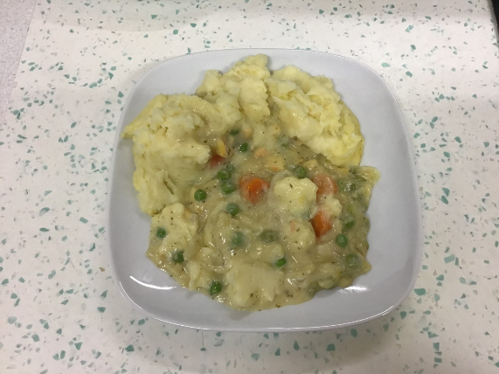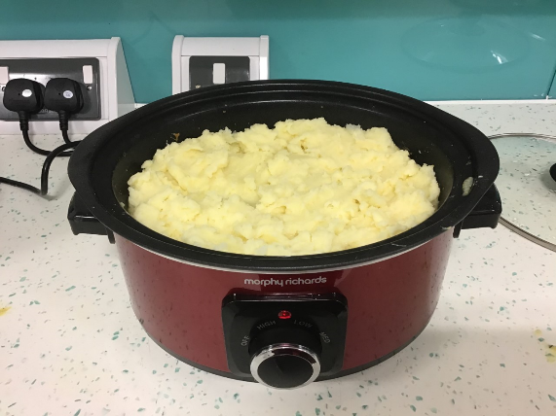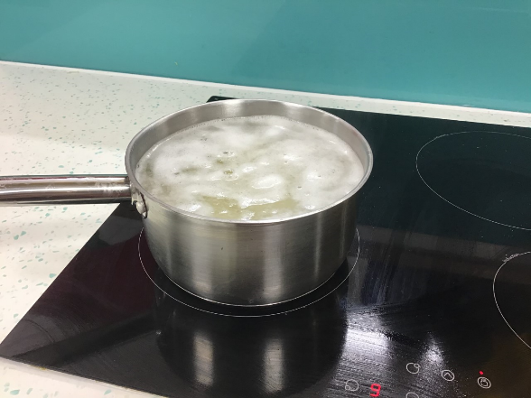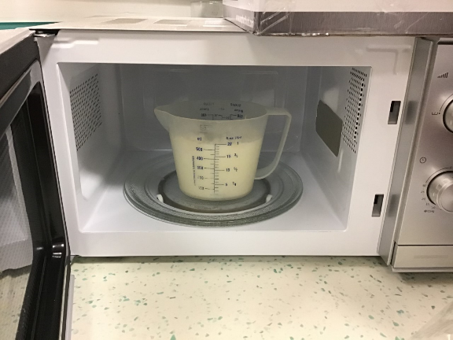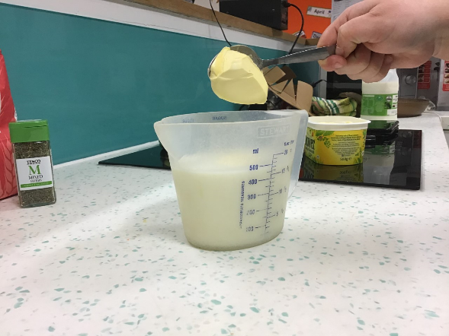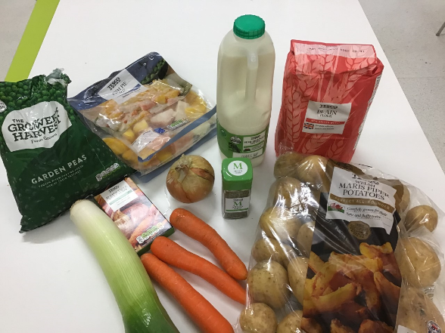

**3.** Microwave mixture on high for 4 minutes or until mixture has thickened. Add to slow cooker and cook on medium for 6 hours.

**1.**  Wash hands and surfaces and prepare ingredients. Chop up carrots, leek, onion and mushroom and add to slow cooker.

**2.** Add 400ml of milk to a jug. Add 2 heaped tablespoons of margarine, 2 heaped table spoons of plain flour, sprinkle mixed herbs, 1 vegetable stock cube.

**Allergens**

Fish, dairy, wheat

**Ingredients**

Plain flour

Potatoes

Fish pie mix

3 carrots

1 leek

Garden peas

1 onion

Milk

Butter

**Equipment**

Slow cooker

Sharp knife

Chopping board

Microwave

Table spoon

**Serves 4**

Total cost of ingredients:

£8.82

Price of serving per person:

£2.20

**6.** Cook for a further 45 minutes on medium. Serve and enjoy!

**5.** Mash potato and add a heaped tablespoon of margarine. Next top the fish mixture with the mashed potato.

**4.** Cut up potatoes and boil until knife slides through.

WORKING TOGETHER IN PARTNERHSIP

FISH PIE

SLOW COOKER MEALS