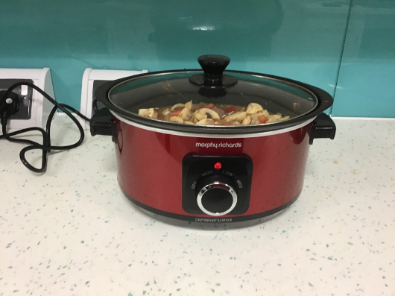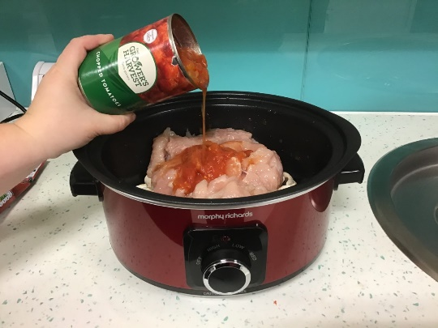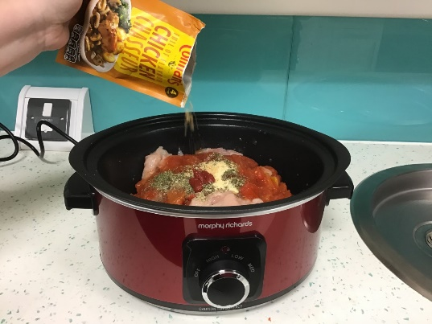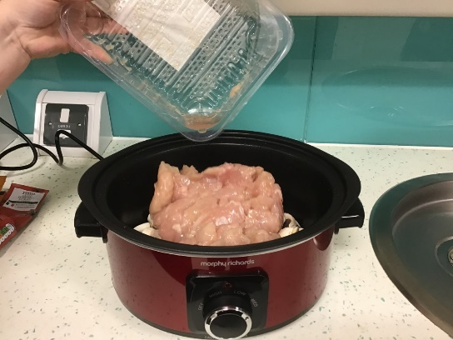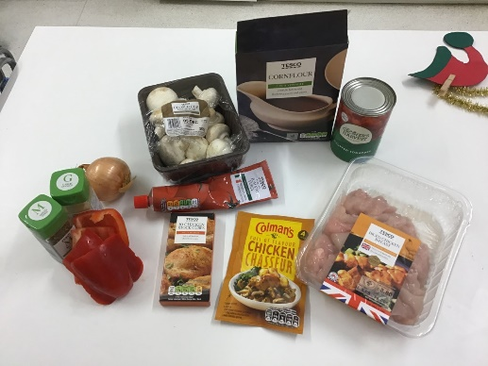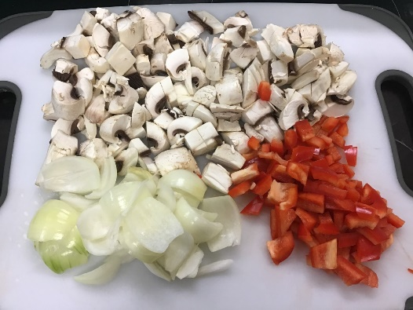

**6.** Cook on low for 8 hours. Mix and serve with desired side dish. Enjoy!

**4.** Add 1 tin of chopped tomatoes and a sprinkle of herbs and garlic granules.

**5.** Next add 2 tea spoons of tomato puree and the chicken chasseur sachet. Then add 200ml of hot water and mix.

**3.** Add diced chicken on top of vegetables to slow cooker.

**2.** Peel and chop up vegetables and add to slow cooker.

**1.**  Wash hands and surfaces and prepare ingredients.

**Allergens**

Stock cubes: Milk, celery seed

Chicken chasseur sachet: Celery, eggs, mustard, rye, soya, cereals, gluten, wheat

**Ingredients**

Fresh diced chicken

Mushrooms

1 onion

1 red pepper

1 tin of chopped tomatoes

Tomato puree

Chicken chasseur sachet

Chicken stock cubes

Cornflour

Mixed herbs

Garlic granules

**Equipment**

Slow cooker

Sharp knife

Chopping board

**Serves 4**

Total cost of ingredients:

£6.24

Price of serving per person:

£1.56

WORKING TOGETHER IN PARTNERHSIP

CHICKEN CHASSEUR

SLOW COOKER MEALS