MAYALS PRIMARY SCHOOL | Spring Term Newsletter 2020  Year 6 |  |  | 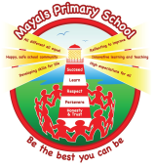
A message from the teacher
Welcome back and Happy New Year to you all! I trust you all had lovely break. In this newsletter I hope to give you some useful information about the learning opportunities that your child will experience this term. I would like to continue building positive partnerships with all parents and guardians, in order to ensure the best possible learning experience for the children. If you have any queries then please feel free to contact me in school.
Mr J G Paynter
This term’s topics are… (we will continue our topic Frozen Kingdom for the first few weeks)
Pits and Ponies  How did it feel to work in the coal mines of Wales? How has the coal mining industry changed over the years and does it have a future? Explore these questions and more through this topic about the coal industry and its impact on the towns and valleys of Wales. |  | 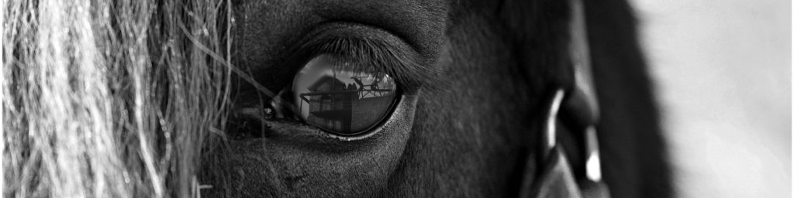
Blood Heart
Crimson, scarlet, burgundy, cherry…blood flows through our bodies in all its vibrant shades of red. Let’s explore your circulation system! Now surgeons don’t be squeamish as we dissect an animal heart and examine the veins, arteries and chambers up close. They all work hard to move blood around our bodies.
Mathematics and Numeracy
In Maths, pupils will have opportunities to apply and develop their skills across the curriculum. This term we will be looking at place value in seven digit numbers as well as the four operations of addition, subtraction, multiplication and division. We will create Historical timelines sequencing important events. We will be adding and subtracting decimals with 3 decimal places and multiplying and dividing decimals with two decimal places. Children will investigate ‘How much coal Wales produced in a year?’. We will plot points and draw polygons in all 4 quadrants. Children will construct and interpret a variety of charts and graphs. Collecting and representing data from trips to ‘Big Pit’ and ‘South Wales mining museum’. Your child will experience using fractions, ratio and percentages. We will also be looking at area and volume of shapes as well as algebra and using simple formulae.
Language, Literacy and Communication (English) |  | Reading
Through our topic work on Pits and Ponies! & Blood Heart, we will be developing our understanding of recounts, stories, letters and forms of poetry including shape poems. Your child will also experience writing slogans, biography writing, instructions, and narrative using personification. We are encouraging the children to join their letters using the cursive handwriting scheme |  |  | Guided Reading – As well as your child reading their independent reading book at home, in school we will continue to improve reading during guided group reading sessions. Reading skills will be enhanced through a carousel of activities each day.
Expressive arts |  | Health and well being
Through our topic work, your child will experience modelling and sculpture making as well as abstract art! In DT, we will be creating healthy recipes. We will look at product packaging and working models. In music, we will experience pulse heart rate raps and traditional Welsh folk music and songs. |  | In PE we will be exploring various aspects of gymnastics including floor work as well as apparatus work. The children will be developing a variety of skills in games. Through our topic of Blood Heart we will focus on cardiovascular exercise. In PSE we will look at harmful substances, feelings and emotions, empathy, cause and effect and sustainability.

Language, Literacy and Communication (Welsh) |  | Science and Technology
Over the course of the term there will be a focus on developing skills in speaking, writing and reading Welsh. Some sentence patterns we will be studying this term will include talking about themselves and talking about a third person. |  | We will link our science work to our topic Blood Heart. We will study the human circulatory system, measuring heart rate, the history of blood groups as well as lifestyle effects. Your child will develop their scientific skills by carrying out and evaluating science investigations such as ‘What can your heart rate tell you? How does blood flow? What’s in blood?’ These investigations will include dissecting a pig’s heart. In IT we will be using a variety of websites and creating flow diagrams. Your child will also create and interpret spreadsheets and charts related to our topic ‘Pits and Ponies’.
Humanities
Through our topics Pits and Ponies! your child will investigate coal mining in Wales, children’s role in mining, the strikes and riots that took place, mining disasters, the pit ponies used and the legacy of coal mining in Wales. They will also be interpreting maps and sketching maps.
How you can help your child
* Practise times tables with your child.
* Read as much as possible and question your child about the text they are reading.
Useful Information (stick me on the fridge!)
Homework:  - Class Homework (out on Friday in on Wednesday)  - Reading (Every night if possible as this is so important) | Reading books:  Please read with your child every night (or as often as possible) for at least 10 minutes. They should bring their reading books to school every day.
PE days and required kit:  - Gymnastics and games kit will be needed on a Tuesday (so trainers and clothes suitable for outdoors). Dependant on the weather.  - Please send in an old shirt for your child to wear during art and craft activities (Any spares will be gratefully received). | Spelling:  As a school we are working hard on promoting the importance of spelling correctly. This term we are having a big push on spelling accurately in our work and trying to make spelling fun. Our aim is to produce capable and independent spellers through an engaging and challenging whole school approach. All children will be given spellings each week to learn and will be assessed through activities during the week.
Contact information
Email: Mayals.PrimarySchool@swansea-edunet.gov.uk
Phone: 01792 402755
Twitter: Mayals PrimaryProtected Tweets@MayalsPrimary
Website: http://mayals-primary-school.j2bloggy.com/
Class email: Year6.mayals@gmail.com (this will only be used for pupils to send in homework etc.)

