MAYALS PRIMARY SCHOOL | Spring Term Newsletter  Year 4 |  |  |  | 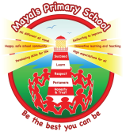
A message from the teacher
Welcome back! It’s always a tough term to come back especially after having a lovely Christmas and New Year. I hope you all had a lovely holiday and managed to enjoy the festivities with your family and friends. Below is an overview of our topics this term, it’s another exciting one which I’m sure the class will engage in with great gusto as they did with our previous topic! Here goes…
This term’s topics are…
Road Trip USA!  Buckle up, sunglasses on – we’re going on a road trip across the good old US of A!  It’s going to be a long ride, put the roof down and let the wind blow through your hair…we’re off!! |  | 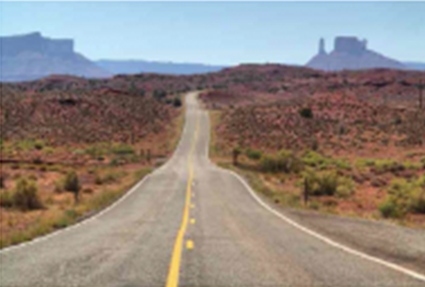
Misty Mountain Sierra
Mighty mountains peak above the morning mists, imposing and eternal, rocky outcrops at their feet. But beware, look out! What’s that by the tree? Its footprints are huge! Have we found the yeti?
Mathematics and Numeracy
In our maths lessons this term, we will be looking at number and place value and the four operations of addition, subtraction, multiplication, and division. We will be looking at fractions and decimals and focusing on learning our times tables. Your child will also be studying measure and converting measurements. Children will find out information and record their results in tables. They will then look at ways of representing data in bar charts. They will learn about time and will investigate the use of coordinates. Children will also be developing our mental recall of multiplication and division facts and applying it to real life situations.
Language, Literacy and Communication (English) |  |  |  | Reading
Through our topic work on Road Trip USA! and Misty Mountain Sierra, we will be developing our understanding of writing postcards, historical narrative, Emails, diary writing, myths and legends, poetry, fact files and information texts. |  |  | Children will be encouraged to read daily in Guided Reading activities and apply their skills in a variety of contexts. Children will use the iPads for Newsround, Spelling Journals and ‘Morning Books’ to encourage independence when applying their reading skills.
Spelling
As a school we are working hard on promoting the importance of spelling correctly. Class spelling activities involve using a variety of methods to learn the patterns each week. Our aim is to produce capable and independent spellers through an engaging and challenging whole school approach. Please encourage your children to really think carefully about their spelling words and to learn the patterns that are sent home. An overview will be sent out at the start of term highlighting the patterns taught in class each week which will then be assessed through class activities.
Expressive arts |  |  | Health and well being
Through our topic work, your child will experience drawing, weaving, making a dream catcher and clay modelling. In DT, your child will learn about preparing US dishes, Model making, Totem Pole design, and traditional and cultural music. |  |  | In PE we will be developing, consolidating and applying skills and techniques needed to take part in a variety of dance activities. In PSE, children will be encouraged to express their views and ideas confidently through a range of appropriate methods.

Language, Literacy and Communication (Welsh) |  | Science and Technology
Incidental Welsh will be encouraged throughout the class routines. The patterns this term will be focusing on the past tense e.g Ble est ti? (Where did you go?) Pryd est ti? (When did you go?) Beth wnest ti? (What did you do?) Es i… (I went…) Gwelais i… (I saw…) Welsh is encouraged and used daily during our Drilio sessions. |  | We will link our science work to our topics. We will study electricity and will investigate making simple circuits to produce light, all the while working scientifically. Your child will develop the scientific skills of predicting, carrying out and evaluating science investigations. In ICT, children will use the iPads and Chromebooks to enhance all areas of the curriculum. Children will be working within the new DCF framework developing ICT skills including safety using ICT in our daily lives.
Humanities
Through our topics Road Trip USA! Your child will use world and US maps, imagery and ICT to research and present online information effectively. They will learn about the Native American tribes and compare and contrast the native American culture. In RE, we will be looking at Judaism as a stand-alone mini topic.
How you can help your child
You can help your child by handing homework in on time (Tuesday) and reading regularly at home. Reading about the class topic too also helps as little snippets of information helps us with our class work! There are lots of really useful websites to help with this and don’t forget that you can use the local library too.
Useful Information (stick me on the fridge!)
Homework:  Homework will be given out on Friday and will be handed in on the following Tuesday. Homework will be topic based as well as maths skills practised that week. Spelling lists will also come home at the start of each term highlighting the spelling pattern for that week if you wish to practise. | Reading:  Please read with your child every night (or as often as possible) for at least 10 minutes. They should bring their reading book and diary to school every day. Books will be changed on the day your child reads. Children can bring in books from home for reading time.
PE days and required kit:  Please make sure PE kit is in school every Thursday, gym shoes or trainers will be needed for outdoor games activities. In colder weather warmer clothes should be worn i.e. leggings, jogging trousers and a sweatshirt. | Lunch:  Hot & cold lunches are prepared by the school kitchen staff every day. Lunch is £2.40 a day (£12.00 a week). Dinner money is to be paid via Squid, any further information required please speak to the school office.
Contact information
Email: Mayals.PrimarySchool@swansea-edunet.gov.uk
Phone: 01792 402755
Twitter: @MayalsPrimary
Website: www.mayals.swansea.sch.uk
Class email: mayalsyear4login@gmail.com

