**Elements**

Elements are sometimes called the building blocks of life. The periodic table (a copy is on the next page) contains all the known elements and each one has a name and symbol.

**Task 1**

Use the Periodic Table to write down the symbols of the following elements.

a) Fluorine f) Palladium

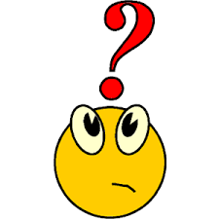

b) Lithium g) Lead

c) Strontium h) Gold

d) Xenon i) Tungsten

e) Cobalt j) Mercury

**Task 2**

Use the Periodic Table to write down the names of the following elements.

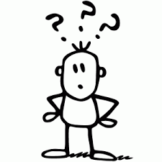

a) Rn f) Ag

b) He g) Sn

c) Pt h) V

d) Zn i) H

e) Cs j) Rb

**Challenge Task 1**

What are the rules for writing the symbols of the elements?

**Challenge Task 2**



Research what the definition of an element is.

**Challenge Task 3**

Research who Dmitri Mendeleev is.

**Challenge Task 3**

Use the symbols of the elements to write down as many words as you can that contain five or more letters. You can use the symbols as many times as you want in each word.

**The Periodic Table**

