The Periodic Table

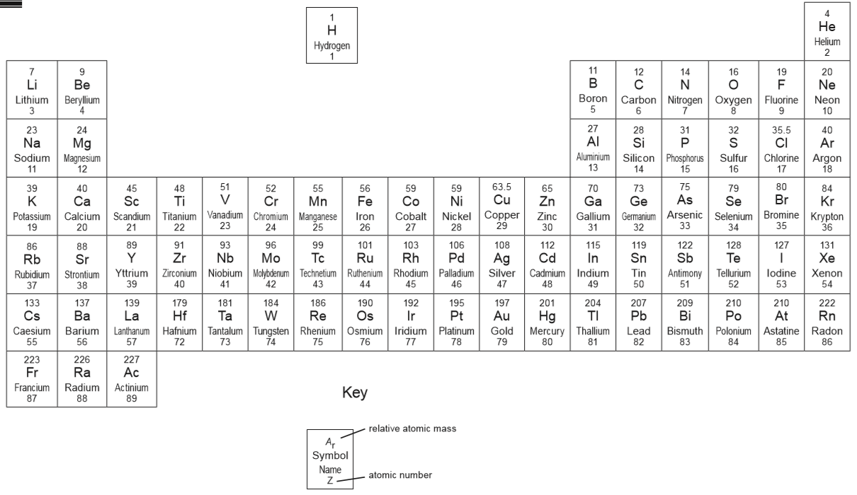

Relative Formula Mass
A relative formula mass (or M_{r} for short) tells us the total mass of all the particles found in each formula of a substance. To be able to calculate the M_{r} we need to know the mass of the individual particles, which is called the relative atomic mass (or A_{r} for short). The A_{r} of each atom can be found using the periodic table. Each element has got two numbers and the A_{r} is the top number.
Example
¹⁹ F
This shows that the A_{r} of fluorine (F) is 19

How to calculate the M_{r} of a substance
Work out how many particles there are of each element and then multiply by the A_{r} of that element.

Examples
- Sodium chloride has the formula NaCl. This tells us there is one sodium (Na) particle and one chlorine (Cl) particle.

²³Na and ^{35.5}Cl are the A_{r} values

Na x 1 = 23 x 1 = 23
Cl x 1 = 35.5 x 1 = 35.5

M_{r} of NaCl = 23 + 35.5 = 58.5

- Calcium chloride has a formula CaCl₂. This tells us there is one calcium (Ca) particle and two chlorine (Cl) particles.
⁴⁰Ca and ^{35.5}Cl are the A_{r} values

Ca x 1 = 40 x 1 = 40
Cl x 2 = 35.5 x 2 = 71

M_{r} of CaCl₂ = 40 + 71 = 111

- Calcium nitrate has a formula Ca(NO₃)₂. This tells us there is one calcium (Ca) particle, two nitrogen (N) particles and six oxygen (O) particles.
⁴⁰Ca, ¹⁴N and ¹⁶O are the A_{r} values

Ca x 1 = 40 x 1 = 40
N x 2 = 14 x 2 = 28
O x 6 = 16 x 6 = 96

M_{r} of Ca(NO₃)₂ = 40 + 28 + 96 = 164

Task
Calculate the M_{r} of the following compounds.

a) NaF f) Ca(OH)₂ k) Zn(NO₃)₂
b) MgBr₂ g) Fe₂(SO₄)₃ l) Al₂(SO₄)₃
c) K₂O h) Al₂(CO₃)₃ m) (NH₄)₂CO₃
d) Fe₂O₃ i) (NH₄)₂SO₄ n) C₆H₃(NO₂)₃
e) H₂SO₄ j) Cu(NO₃)₂ o) C₆H₄(NH₂)N₂C₆H₃(OH)₂

Challenge Task
In the following formulae there is a mystery particle, X. By finding the relative atomic mass of X, identify the name and symbol of X.
- XO (M_{r} XO = 25)
- XO₂ (M_{r} XO₂ = 64)
- X₂O₃ (M_{r} X₂O₃ = 160)
O = oxygen for each example

