Inside The Synagogue
Starter: Other than worship, list 3 things you may do inside a synagogue

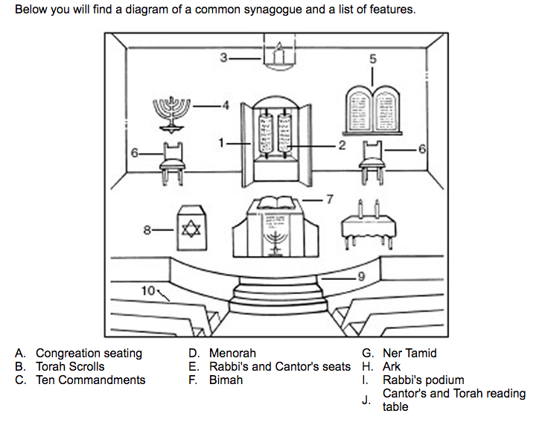
Task 1: Label the key objects you will find in a Synagogue using the information below

The importance of the synagogue: internal features.

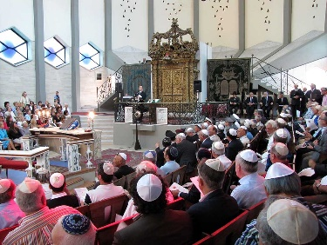
We have seen that statues and representations of living beings, including God, will not be found in synagogues. This is to prevent idolatry – the worship of images.
Do not represent gods by any carved statue or picture of anything in the heaven above, on the earth below, or in the water below land. (Exodus 20.4)
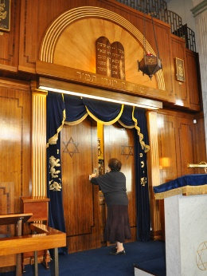
Aron HaKodesh
The Aron HaKodesh (also known as the ark) is the most important place in a synagogue as it is here the Torah scrolls are kept. It is on the wall facing Jerusalem and is the focal point of the synagogue. There are several customs and traditions connected with the ark. It is opened for certain prayers and during Rosh Hashanah and Yom Kippur.
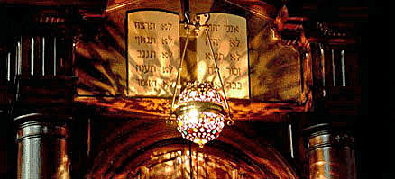
Ner tamid
In the front of and slightly above the Aron HaKodesh, is the ner tamid, often called the eternal lamp. This kept continually burning and should never be extinguished. The lamp symbolises the menorah (seven branched lamp). Many Jews consider it as a symbol of God’s eternal presence.
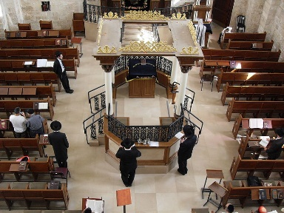
The bimah
The bimah is a central platform in the synagogue on which stands the desk from which the Torah scrolls are read. In Orthodox synagogues, the bimah is usually in the middle so the rabbi faces the congregation. In Reform synagogues, everyone sits together and the bimah is at the front, combined with the ark, rather than in the middle.
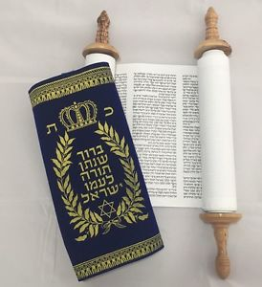
The Torah scrolls
The Torah scrolls are the most sacred part of any synagogue. They are made from animal skins and are hand written. The scrolls are wrapped in silk or velvet when not used and often decorated with silver.
Ten Commandments
The Torah contains 613 commandments which are clearly displayed in synagogues. They are often placed near to or above the ark to remind worshippers of their duty to follow God’s commands. The sayings are written in Hebrew and displayed on two plaques.
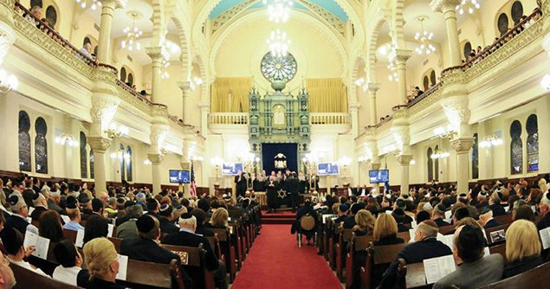
Seating
The seating for women is one of the main difference between Orthodox and Reform synagogues. In Orthodox synagogues there is a separate area where women are seated. This might be an upper-floor balcony or an area separated by a curtain. The Talmud says that men and women can concentrate more on their worship if they are separated. In Reform synagogues there is no partition between males and female, and they may sit together throughput the worship.
Synagogues are always built facing Israel, if possible, where the Temple stood.
There are many features of a synagogue. Some of these are common to all synagogues, and some depend on whether the community is Orthodox or Reform.
The Bimah (reading desk)
In the centre of the synagogue there is a raised platform called a Bimah. The Torah is read from this platform and there is a table at the front where the scroll is laid.
The Ark (Aron Hakadesh)
At the front of the synagogue, where the Holy Place would have been in the Temple, is the Ark. This is a cupboard in the East-facing wall. This is so that it faces the holy city of Jerusalem. A curtain stretches across the front of the ark. This is called the Parochet. The Ark houses the scrolls on which the books of the Torah are written.

Torah Scroll (Sefer Torah)
The Sefer Torah is a handwritten copy of the Torah (Jewish Law). In the synagogue, the Torah is written on scrolls which are kept in the Ark when not being read. These are the holiest objects in the synagogue. The scrolls are handwritten by a man called a scribe. He uses special ink and writes in columns in Hebrew. They are written on animal skin, called parchment, which is sewn together to form one, long, continuous piece
Each scroll is ‘dressed’ in a special cover called a mantle. This is made of silk or velvet and is beautifully decorated with tassels and silver objects called crowns and bells. When the scrolls are taken out of the ark, everyone stands as a sign of respect.
The Ner Tamid – eternal light
In front of the Ark is a lamp called the Ner Tamid. It is always kept burning and is never deliberately put out. This is to remind people that God is always present. It also reminds Jews of the light that always burned in the Temple.
The 10 Commandments
These will be above the Ark in the synagogue. Sometimes they will be written in full in Hebrew and in other synagogues only the beginning or the number of each one will be written.

The Magen David
The six-pointed Star of David is the most commonly used symbol to represent Judaism. It is made up of two equilateral triangles. This was an ancient symbol of fire and water. In the Middle Ages, this symbol was regarded as a shield against evil.

Task 3: Explain the purpose of the main objects you will find in a Synagogue.
(8 marks)

