**How much does it cost?**



£ 0.22

Numeracy Task



£0.22



1p



£ 0.50



38p



2p



£ 0.26



£0.30



£0.06

Each of these objects use lots of energy. The value represents how much it **costs per hour** to use the object.

How much does it cost to use an oven for two hours?

What is the cost of a refrigerator for a week?

Billy has a busy morning. He puts on the washing machine for 1 hour, cooks a roast dinner which takes 3 hours and vacuums the floor for twenty minutes. During this time he is listening to music (3 hours). How much does this cost?

Kim is relaxing whilst Billy is working hard. She watches TV for 1.5 hours after she has dried her hair which takes 20 minutes. How much has she spent?

A 40 watt light bulb costs approximately 0.5p per hour. How much would it cost to light a house for seven hours if the house had 6 light bulbs a room in a 11 roomed house?

By turning the lights off so that the bulbs are on only two hours a day would save you how much?

**Energy and Foods**

Numeracy Task

**100g of these foods provide …**

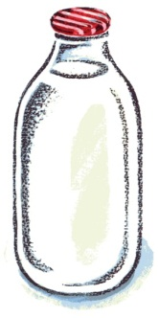

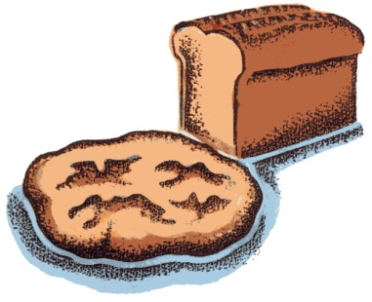

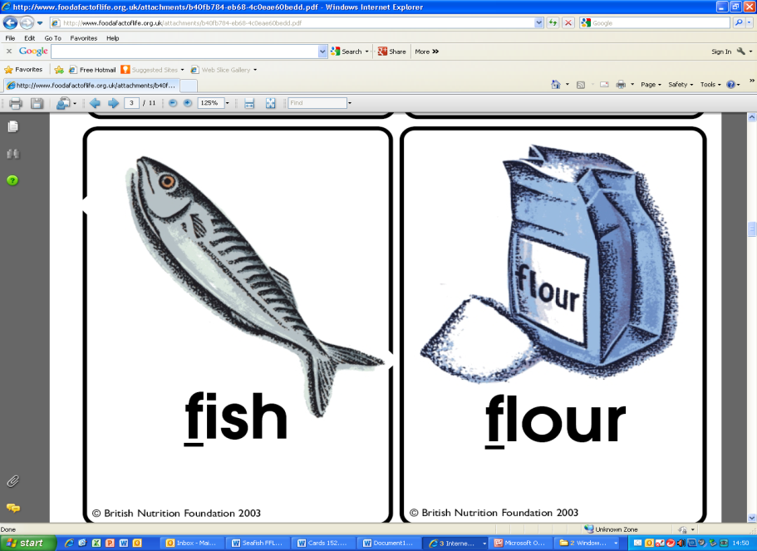

**962 kJ**

**205 kJ**

**920 kJ**

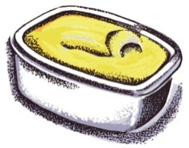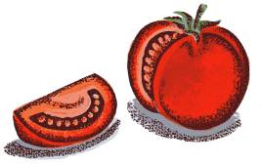

**80 kJ**

**3200 kJ**

Some foods give more energy than others. Which type of foods do you think give the most energy and why?

Butter normally comes in packs weighing 250 g. How many kilojoules would be in a regular pack?

How many kilojoules would a sandwich made from 100 g of fish, 10 g of butter, 100 g of bread and 50 g of tomatoes have?

Walking for an hour at a moderate pace can burn 896.8 kJ. How long would it take to burn of the sandwich?

**Pregnancy**

Numeracy Task

|  |  |
| --- | --- |
| Time weeks | Length mm |
| 12 | 90 |
| 16 | 120 |
| 20 | 250 |
| 24 | 360 |
| 28 | 380 |
| 32 | 430 |
| 36 | 490 |
| 40 | 520 |

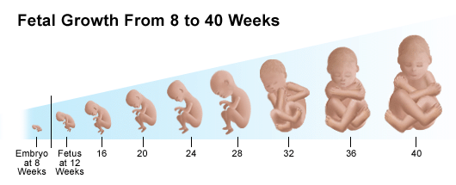

C:\Users\pb.AMAN.001\AppData\Local\Microsoft\Windows\Temporary Internet Files\Content.IE5\UEVJD40B\MC900016035[1].wmf

C:\Users\pb.AMAN.001\AppData\Local\Microsoft\Windows\Temporary Internet Files\Content.IE5\UEVJD40B\MC900016035[1].wmfThis table shows the length of a baby during stages of pregnancy.

Use the grid below to draw a line graph representing this data.



How much does the baby grow between 16 and 20 weeks?

Does the baby grow more between the 36th week to the 40th week or the 16th to the 20th week?

What is the change in length between the 20thweek to the 36th week? How many mm does the baby grow each week?

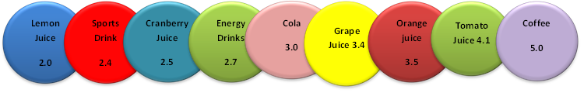**Drinks and their acidity**

Numeracy Task

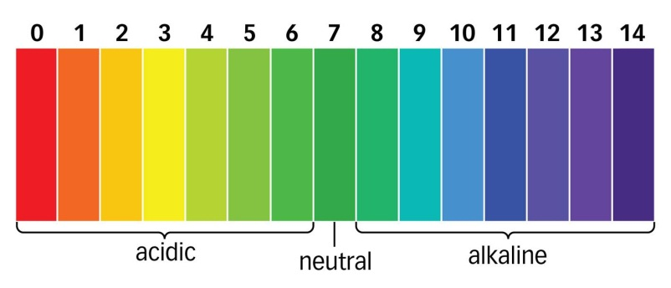The list above shows the pH level of selected drinks. The pH of your mouth is very important. Once you eat or drink the pH will change, generally becoming more acidic. This can cause tooth decay.

How much will the pH need to increase to neutralise cola?

What is the difference in pH between tomato juice and cranberry juice?

Which one of the drinks is the median?

The pH of yoghurt is 2.6 more than the sports drink. What is its pH?

The pH of milk is twice the pH of the energy drink. What is the pH of milk?

If the pH of coffee is increased by 50 %, what will its pH be?

The pH of tap water is 2.2 times bigger than orange juice. What is its pH?

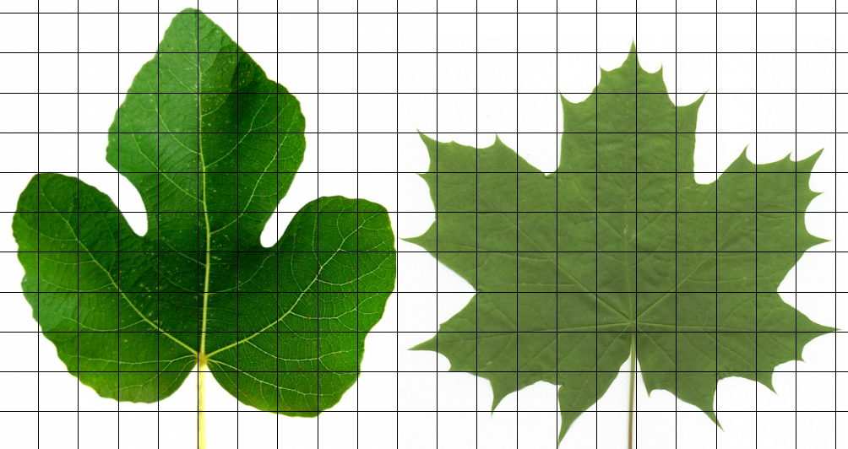**Trees and Leaves**

Numeracy Task

Find the area of both leafs. Which leaf is bigger and by how much?

The age of a tree is proportional to its circumference. The formula we use to calculate a trees age is:

$$Tree Age= \frac{Circumference}{3.7}$$

Use the formula to fill in the missing gaps below.

|  |  |  |
| --- | --- | --- |
| Tree | Circumference cm | Age years |
| 1 | 18.5 |  |
| 2 | 44.4 |  |
| 3 | 111 |  |
| 4 | 55.5 |  |
| 5 |  | 10 |
| 6 |  | 60 |
| 7 |  | 25 |
| 8 |  | 85.5 |

**C:\Users\pb.AMAN.001\AppData\Local\Microsoft\Windows\Temporary Internet Files\Content.IE5\CTV1VE86\MC900358183[1].wmfFood Chains**

Numeracy Task

1

[](http://thumbs.dreamstime.com/z/green-sea-urchin-13945614.jpg)

Otter

Urchins

[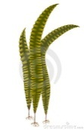](http://thumbs.dreamstime.com/z/japanese-kelp-laminaria-vector-illustration-18759482.jpg)

Kelp

Otters eat urchins. Urchins eat kelp plants. Given that the otter box represents ONE otter, answer the following questions.

How many urchins are needed to sustain 1 otter?

How many kelp plants are needed for 1 otter?

How many urchins could survive on 1 kelp plant?

If there were five otters, how many urchins would be needed?

How many otters could survive on 44 kelp plants?

How many urchins could survive on 20 kelp plants?

A river has a population of 7 otters, how many urchins and kelp is needed to sustain the family?

The otters leave the river, what do you think will happen to the kelp and the urchins? Sketch a graph to show what could happen?

**Planets**

Numeracy Task

|  |  |  |  |
| --- | --- | --- | --- |
| Planet | Distance from the Sun (million km) | Time to travel around the Sun (years) | Temperature on surface (°C) |
| Mercury | 58 | 0.2 | 350 |
| Venus | 108 | 0.6 | 460 |
| Earth | 150 | 1 | 20 |
| Mars | ? | 2 | -23 |
| Jupiter | 750 | ? | -120 |
| Saturn | 1427 | 30 | -180 |
| Uranus | 2670 | 84 | -210 |
| Neptune | 4496 | 165 | -220 |
| Pluto | 5906 | 248 | -240 |

Which planet is warmer – Neptune or Pluto?

What is the difference in temperature between Mercury and Venus?

How many orbits can Mercury complete in one of Earths?

How much further away from the Sun is Saturn than Jupiter?

Mars is twice the distance from the sun than Venus, what is its distance?

The time Jupiter takes to complete one orbit is $\frac{2}{5}$ of Saturn’s time. What is the time for Jupiter to travel around the sun?

Using a scale 1mm: 2 million km what distance is Pluto from the Sun? What distance is Earth?

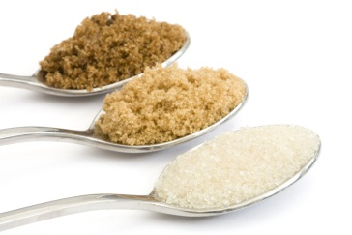**Solute, Solvent and Solution**

Numeracy Task

**Solute + Solvent Solution**

For example

**100g water + 5g coffee granules = 105g coffee solution**.

Fill in the missing gaps of the table below:

|  |  |  |
| --- | --- | --- |
| Mass of Solute | Mass of Solvent | Mass of Solution |
| 40g of water | 32g of coffee |  |
| 20.35 of water | 49.26g of sugar |  |
| 1020.25 g of water |  | 1279.50g of baby milk |

The solubility of a liquid is affected by the temperature. Draw a graph to represent the table and comment about the graph.

|  |  |
| --- | --- |
| Temperature (oC) | Solubility of sugar (g per 100 g of water)  Comment |
| 0 | **180** |
| 10 | **190** |
| 20 | **205** |
| 30 | **220** |
| 40 | **240** |
| 50 | **270** |



**CO2 Emissions**

Numeracy Task

The table below highlights the amount of carbon dioxide produced a **year** by a **10 mile weekly round** trip for a family of **four** people.

|  |  |  |
| --- | --- | --- |
| Transport | | CO2 kg per year |
| Walk | C:\Users\pb.AMAN.001\AppData\Local\Microsoft\Windows\Temporary Internet Files\Content.IE5\03JMN83E\MC900436163[1].wmf | 0 |
| Cycle | C:\Users\pb.AMAN.001\AppData\Local\Microsoft\Windows\Temporary Internet Files\Content.IE5\CTV1VE86\MC900318754[1].wmf | 0 |
| Bus | C:\Users\pb.AMAN.001\AppData\Local\Microsoft\Windows\Temporary Internet Files\Content.IE5\OL8MDS2I\MC900383850[1].wmf | 220 |
| Train | C:\Users\pb.AMAN.001\AppData\Local\Microsoft\Windows\Temporary Internet Files\Content.IE5\03JMN83E\MC900413498[1].wmf | 100 |
| Small Car | C:\Users\pb.AMAN.001\AppData\Local\Microsoft\Windows\Temporary Internet Files\Content.IE5\OL8MDS2I\MP900438719[1].jpg | 480 |
| 4 x 4 | C:\Users\pb.AMAN.001\AppData\Local\Microsoft\Windows\Temporary Internet Files\Content.IE5\HUBA8NTL\MC900388752[1].wmf | 800 |
| Eco-Car | C:\Users\pb.AMAN.001\AppData\Local\Microsoft\Windows\Temporary Internet Files\Content.IE5\HUBA8NTL\MC900439329[1].jpg | 350 |
| Family Car | C:\Users\pb.AMAN.001\AppData\Local\Microsoft\Windows\Temporary Internet Files\Content.IE5\HUBA8NTL\MC900440349[1].png | 580 |

What is the difference between the CO2 emissions of a 4 x 4 and a train?

If the journey increased to 20 miles a week for 8 people how much CO2 would be produced for a family sized car per year?

What is the mass of the CO2 emissions for a family of 2 travelling by bus for 6 months?

A family of four used a train for 3 months, then an eco-car for the rest of the year, what were their emissions?

How much emissions are produced by family of 6 using a 4 x 4 travelling 15 miles for 36 months?

What is the amount of emissions for a small car travelling ten miles for 1 year with 1 person in? What assumptions have been made?

**4 x 100 m Relay**

Numeracy Task

|  |  |  |  |  |  |
| --- | --- | --- | --- | --- | --- |
| C:\Users\pb.AMAN.001\AppData\Local\Microsoft\Windows\Temporary Internet Files\Content.IE5\8LQDBD5Q\MC900168562[1].wmf | Leg 1 (s) | Leg 2 (s) | Leg 3 (s) | Leg 4 (s) | Total  (s) |
| Team 1 | 9.81 | 9.30 | 8.94 | 9.22 | C:\Users\pb.AMAN.001\AppData\Local\Microsoft\Windows\Temporary Internet Files\Content.IE5\RBS98N66\MC900222055[1].wmf |
| Team 2 | 10.02 | $$9\frac{1}{10}$$ | $$8\frac{9}{10}$$ | 8.95 |  |
| Team 3 | 9.85 | $$9\frac{1}{2}$$ | $$9\frac{1}{100}$$ | 9.39 |  |

What is the number 9 $\frac{1}{10}$ as a decimal?

Similarly what is the number 8 $\frac{9}{10}$ as a decimal?

What is the number 9 $\frac{1}{100}$ as a decimal?

Which runner was the fastest?

Which runner was the slowest?

Calculate the total time for each team and find out who won the race.

**Melting and Boiling Points**

Numeracy Task

The graph displays the melting point and boiling point of 5 elements.

Which colour bar represents the melting point?

What is the difference between the melting and boiling point of fluorine?

What is the boiling point of astatine? How much more is this than the boiling point of Chlorine?

What state is bromine at 0oC?

Which element(s) has the largest temperature range between melting point and boiling point?

The boiling point of oxygen is 250oC lower than that of bromine. What is the boiling point of oxygen? Add this to the graph.

**C:\Users\pb.AMAN.001\AppData\Local\Microsoft\Windows\Temporary Internet Files\Content.IE5\T0GYZ3K2\MC900356135[1].wmfC:\Users\pb.AMAN.001\AppData\Local\Microsoft\Windows\Temporary Internet Files\Content.IE5\KE5U7F5N\MC900358183[1].wmfVenn Diagrams**

Numeracy Task

Live on Land

Live in Water

Place the following animals in the correct place and answer the following questions.

Kangaroo, Fish, Squid, Snail, Beetle, Butterfly, Crab, Seal, Duck, Starfish, Shark, Antelope, Sparrow, Rabbit, Crow, Penguin, Hermit Crab, Octopus, Ray, Turtle, Tortoise, Frog, Dog, Otter, Platypus, Sea Horse, Squirrel

How many animals can live on land?

How many animals can live in water?

How many animals can live on land or in water?

How many animals can live on land and in water?

How else could you group the animals? Use the Venn diagram below to group them.

C:\Users\pb.AMAN.001\AppData\Local\Microsoft\Windows\Temporary Internet Files\Content.IE5\KE5U7F5N\MC900001632[1].wmfC:\Users\pb.AMAN.001\AppData\Local\Microsoft\Windows\Temporary Internet Files\Content.IE5\T0GYZ3K2\MC900326476[1].wmf

**C:\Users\pb.AMAN.001\AppData\Local\Microsoft\Windows\Temporary Internet Files\Content.IE5\KE5U7F5N\MC900384268[1].wmfGrowth Rates**

Numeracy Task

Both lines have a similar shape. Describe the relationship between age and length.

A 6 month year old girl is 68 cm in length. Is she bigger or smaller than the median child?

How much longer is a 7 month year old boy than a 7 month year old girl?

The length of a baby at one year is twice the length of 6 months. Is this statement true or false? Why?

What is the increase in length for a new-born month girl to a 3 month girl? Is this the same for 9 months to 12 months? Explain what this means.

Can you predict the length of 2 year old boy? Show your workings.

**C:\Users\pb.AMAN.001\AppData\Local\Microsoft\Windows\Temporary Internet Files\Content.IE5\KE5U7F5N\MC900319432[1].wmfPetrol**

Numeracy Task

|  |  |
| --- | --- |
| Amount of Petrol (litres) | Distance travelled (kilometres)  A series of tests were carried out to see how far a car would travel depending on the amount of petrol. The averages of the results are displayed in the table. Using the grid below draw a line graph to represent the data and use the graph to answer the questions. |
| 1 | 13 |
| 2 | 25 |
| 3 | 38 |
| 4 | 46 |
| 5 | 58 |
| 6 | C:\Program Files\Microsoft Office\MEDIA\CAGCAT10\j0212957.wmfC:\Users\pb.AMAN.001\AppData\Local\Microsoft\Windows\Temporary Internet Files\Content.IE5\T0GYZ3K2\MC900310980[1].wmf40 |
| 7 | 85 |
| 8 | 93 |
| 9 | 105 |
| 10 | 120 |



Draw a line of best fit on the graph

One of the points is an anomalous event. Which one and what should it be?

How far would a car travel it had 3.5 litres of petrol?

How far would a car travel if it had 20 litres of petrol?

James has to travel 90 kilometres. How much fuel would he need?

C:\Users\pb.AMAN\AppData\Local\Microsoft\Windows\Temporary Internet Files\Content.IE5\EXXWRRH4\MC900237332[1].wmfChemical Reaction

Numeracy Task

|  |  |
| --- | --- |
| Mass of calcium chloride (g) | Temperature (oC) |
| 0 | 20 |
| 5 | 28 |
| 10 | 34 |
| 15 | 41 |
| 20 | 50 |
| 25 | 57 |

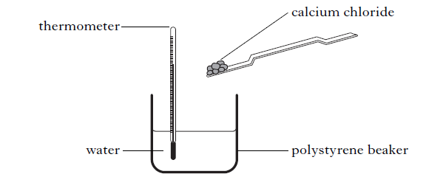

When calcium chloride meets water a chemical reaction occurs and heat is produced. The table shows the results collected during an experiment.

Draw a line graph and answer the questions.

What is the relationship between the mass of calcium chloride and water temperature?

What would be the temperature for 12.5 g of calcium chloride?

What would be the temperature for 30 g of calcium chloride?

How much calcium chloride is needed to produce a temperature of 30 oC?

What temperature would be produced for 50 g of calcium chloride? Is this possible?