**Reading a Thermometer**

Numeracy Task

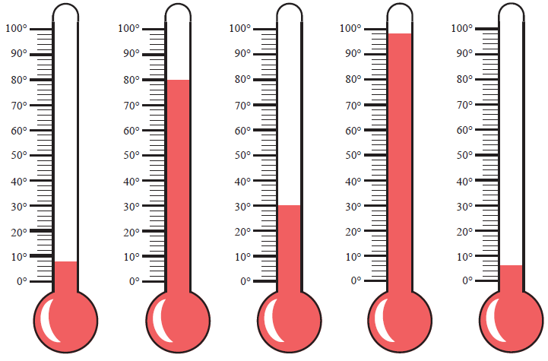Write down the temperature of each thermometer

1. b) c) d) e)

What is the difference between the highest and the lowest temperature?

Which thermometer is closest to 58 oC? What is the difference?

Thermometer c) rises by 29 oC. What is its new temperature?

If thermometer d) decreased by 47 oC what would be the new temperature?

If thermometer a) decreases by 15 oC, what is the new temperature?

Find the total temperature of the five thermometers.

**Calories**

Numeracy Task

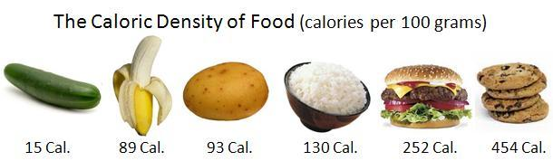

60 kJ

360 kJ

380 kJ

520 kJ

1000 kJ

1800 kJ

The

Our body need energy which we get from food. The six foods above all have different qualities. The numbers shown represent the number of kilojoules each food has per **100g.**

**Draw a bar chart to display the data**

How many more kJ have rice than potatoes per 100 g?

MMMMMC



100 g of chicken has twice the kJ of rice. How many kJ in 100 g of chicken?

Do 400 g of bananas have more kJ than 100 g of cookies?

How many kilojoules are in the following?

1. 100 g of banana and 100 g of potato
2. 100 g of cookies and 100 g of cheeseburger
3. 50 g of banana and 300 g of cucumber

**Bouncing Ball**

Numeracy Task

[](http://max.wilsonsd.org:8080/Clip_Art/Pmpa3/people_m_z/stick_people/joe_bouncing_ball_hw.gif)Kim is doing an experiment. She is dropping a ball from different heights and measuring how high they bounce. Here are the results

|  |  |
| --- | --- |
| Drop Height (cm) | Rebound Height (cm) |
| [http://www.topendsports.com/image/clipart/basketball/bouncing-basketball.gif.php](http://chaaad.files.wordpress.com/2011/11/bouncing-basketball_500_copyright1.gif)10 | 8 |
| 20 | 15 |
| 30 | 23 |
| 40 | 31 |
| 50 | 38 |
| 60 | 43 |
| 70 | 50 |
| 80 | 58 |
| 90 | 65 |
| 100 | 74 |

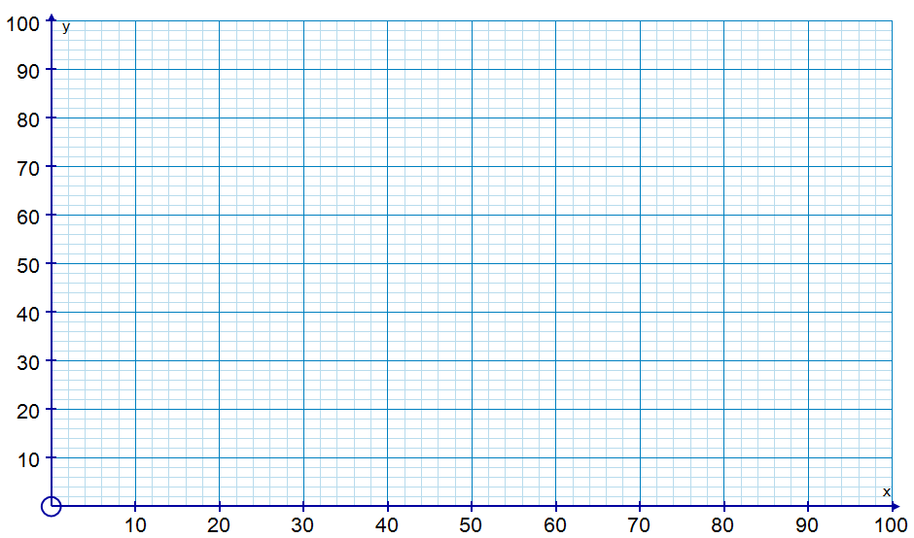Plot a line graph and draw a line of best fit

Rebound Height (cm)

Drop height (cm)

Kim drops the ball from waist height; will it bounce back into her arms? Why?

How high would you need to drop the ball to have a rebound height of 40cm?

What height would a ball bounce if it was dropped from 85cm?

**How much do we grow?**

Numeracy Task

The graph below shows the height (cm) of an average child in the UK with respect to their age (years).

How tall would be the average 12 year old child? Are you taller or shorter?

What is the height of an 8 year old? What is the height of a 9 year? What is the difference in height?

How much do you grow each month between 13 and 14? Write your answer as a fraction.

Between which years is there the least growth?

Four 13 year olds were measured in this school.

They were 164 cm, 170 cm, 172 cm, and 155 cm.

What was their total height? What is their average height? Were they taller than or shorter than the average pupils in the UK?

**Temperature of a classroom throughout day**

Numeracy Task

|  |  |  |  |
| --- | --- | --- | --- |
| **Clock** | **Analogue Time** | **Digital Time (24 hr clock)** | **Temperature (oC)**  Complete the table. |
| **A** |  |  | 16  What is the change in temperature between clock A and D? |
| **B** |  |  | 19  Calculate the mean temperature. |
| **C** |  |  | 23  At 9.00am the room was 7oC colder than clock A, What was its temperature? |
| **D** |  |  | 25 |
| **E** |  |  | 26 |
| **F** |  |  | 21  Show the time 18.00 on the clock face below.  At 21:55 the room was half the temperature of 13:00 draw the time 21:55 on the clock below and write down its temperature |
| **G** |  |  | 18 |
| **H** |  |  | rr1  16 |

C:\Users\pb.AMAN.002\AppData\Local\Microsoft\Windows\Temporary Internet Files\Content.IE5\G6O1L9WH\MC900339842[1].wmfC:\Users\pb.AMAN.002\AppData\Local\Microsoft\Windows\Temporary Internet Files\Content.IE5\G6O1L9WH\MC900199233[1].wmf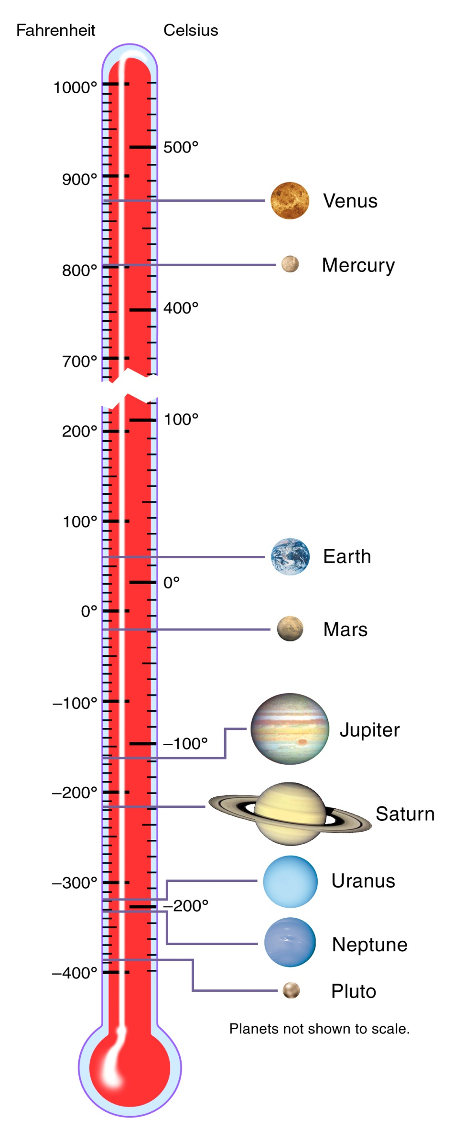

**Planets**

|  |  |
| --- | --- |
| Planets | Temperature (oC) |
| Mercury |  |
| Venus |  |
| Earth |  |
| Mars |  |
| Jupiter |  |
| Saturn |  |
| Uranus |  |
| Neptune |  |
| Pluto |  |

What is the difference in temperature between Earth and Mars in Celsius?

What is the temperature of Earth in Fahrenheit?

Eris is a dwarf planet 80 billion kilometres away from the Sun. It is 40 oC colder than Pluto. What is its temperature?

Why do you think Mars is colder than Earth?

**C:\Users\pb.AMAN.002\AppData\Local\Microsoft\Windows\Temporary Internet Files\Content.IE5\SE37ATTT\MC900413628[1].wmfSolar System Scoreboard**

NASA and other space agencies are always looking for new dwarf planets, asteroids and comets. Here is the scorecard at the moment

|  |  |  |  |  |
| --- | --- | --- | --- | --- |
| Planets | Moons | Dwarf Planets | Asteroids | Comets |
| [Planets](https://solarsystem.nasa.gov/planets/profile.cfm?Object=SolarSys) | [Moons](https://solarsystem.nasa.gov/planets/profile.cfm?Object=SolarSys&Display=Moons) | [Dwarf Planets](https://solarsystem.nasa.gov/planets/profile.cfm?Object=Dwarf) | [Asteroids](https://solarsystem.nasa.gov/planets/profile.cfm?Object=Asteroids) | [Comets](https://solarsystem.nasa.gov/planets/profile.cfm?Object=Comets) |
|  |  |  |  |  |

There are 20 times more comets than moons. How many comets are there?

How many comets are there to the nearest hundred?

New asteroids are being discovered every day. At the moment there are approximately 100 times more asteroids than comets. How many are there? Write this in words.

**[](http://www.preppingblog.com/wp-content/uploads/2012/05/Tent-Camping-Image.jpg)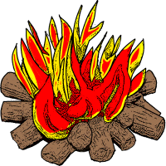Survival**

|  |  |  |  |  |  |
| --- | --- | --- | --- | --- | --- |
| Empty water canister  £80 | First Aid Kit  £20 | Swiss Army Knife  £25 | Tweezers  £7 | Toothpaste  £3 | Mobile phone  £40 |
| Plastic bucket  £7 | Torch  £30 | Plate, bowl and cup  £8 | A compass  £30 | Binoculars  £30 | Spare batteries  £12 |
| A whistle  £1 | Matches  £5 | Candles  £8 | Mobile phone charger  £80 | Tinned food per can  £2.50 | Dried food per packet (day)  £7 |
| Tin opener  £10 | Spade  £15 | Small tent  £80 | Dust mask  £7 | Hat  £15 | Blankets (each)  £15 |
| 4 litres mineral water  £2 per bottle | Water purifying tablets  £15 | Toilet paper  £4 | A rope  £30 | Sun Tan Cream  £30 | Camping gas and stove  £40 |

You are going away but this isn’t a holiday. You are travelling to a **desert** in **North Africa** where you are expected to survive for 1 week. Use the shopping list above to decide what you are going to take. Yourlimitis **£250**. Explain why you would need the items.

Total Spend: Money left:

If I had more money I would take:

**Caffeine**

Numeracy Task

Caffeine is a stimulant. The graph below describes the amount of caffeine a regular drink contains. Fill out the table below and answer the following questions

How much more caffeine is in a cup of black tea than green tea?

500 ml can

60 ml

240 ml cup

250 ml can

240 ml cup

240 ml cup

240 ml cup

240 ml cup

|  |  |
| --- | --- |
| **Drink** | **Caffeine (mg)** |
| Green Tea |  |
| Cola |  |
| Diet Cola | The recommended maximum daily consumption of caffeine for an adult is 300 mg. How many cans of Red Bull is that? |
| Black Tea |  |
| Red Bull |  |
| Coffee |  |
| Espresso |  |
| Monster |  |

What is the amount of caffeine consumed in 4 cups of black tea, two diet cokes, a red bull and an espresso? Is this above or below the recommended daily maximum?

Which drink has the strongest concentration of caffeine? Show your workings.

**Reaction Times**

Numeracy Task

William wanted to know how quick his reactions were. He conducted an experiment using a ruler, recording the distance it took to catch the ruler after someone else had dropped it. The table shows his results.

|  |  |
| --- | --- |
| **Attempt** | **[https://encrypted-tbn3.gstatic.com/images?q=tbn:ANd9GcShdZSUbf2wbbt4_d9W5tP90_U7W7-3Uq4DGCb2QJvK1LEnm6o1AQ](http://www.google.co.uk/url?sa=i&rct=j&q=&esrc=s&frm=1&source=images&cd=&cad=rja&uact=8&docid=e9a_wqs7Uqo8hM&tbnid=fApbvJgthJk6AM:&ved=0CAUQjRw&url=http://eric-elementaryphysicaleducation.blogspot.com/2012/03/lab-25-experiencing-health-and-skill.html&ei=xFAYU8KZHoushQey5IH4DQ&psig=AFQjCNEBYycBoxrh6RSHcAACQrNtuLEaAg&ust=1394188726186939)Distance** |
| **1** | 57 mm |
| **2** | 32 mm |
| **3** | 57 mm |
| **4** | 4.5 cm |
| **5** | 0.65 m |
| **6** | 4 cm |
| **7** | 3.45 mm |
| **8** | 130 mm |
| **9** | 0.46 m |
| **10** | 3.5 cm |

Which attempt was William’s quickest?

Which attempt was William’s slowest?

Write the distances in ascending order

What is the median (middle number of ordered list)?

Find the sum of the distances.

What is the mean of the distances?

Neil has quicker reactions than William. His quickest reaction was 2.5 cm quicker than William’s quickest. What is Neil’s quickest reaction distance?

One of William’s results was anomalous? Which one do you think? Why?

**[](http://thumbs.dreamstime.com/z/coloured-cupcake-baking-paper-cases-white-26257886.jpg)Cupcake Drop**

Numeracy Task

Year 7 conducted a scientific experiment. They dropped 1 cupcake case from the desk and measured the time it hit the floor. They then repeated for two cupcakes, three cupcakes etc. Here are their results.

|  |  |  |  |  |  |
| --- | --- | --- | --- | --- | --- |
| Number of Cases | Attempt 1 (s) | Attempt 2 (s) | Attempt 3 (s) | Total (s) | Mean (s) |
| 2 | 0.65 | 0.70 | 0.78 |  |  |
| 4 | 0.43 | 0.42 | 0.50 |  |  |
| 6 | 0.27 | 0.36 | 0.30 |  |  |
| 8 | 0.25 | 0.26 | 0.27 |  |  |
| 10 | 0.23 | 0.26 | 0.23 |  |  |
| 12 | 0.22 | 0.22 | 0.28 |  |  |

What equipment would they need to complete the experiment?

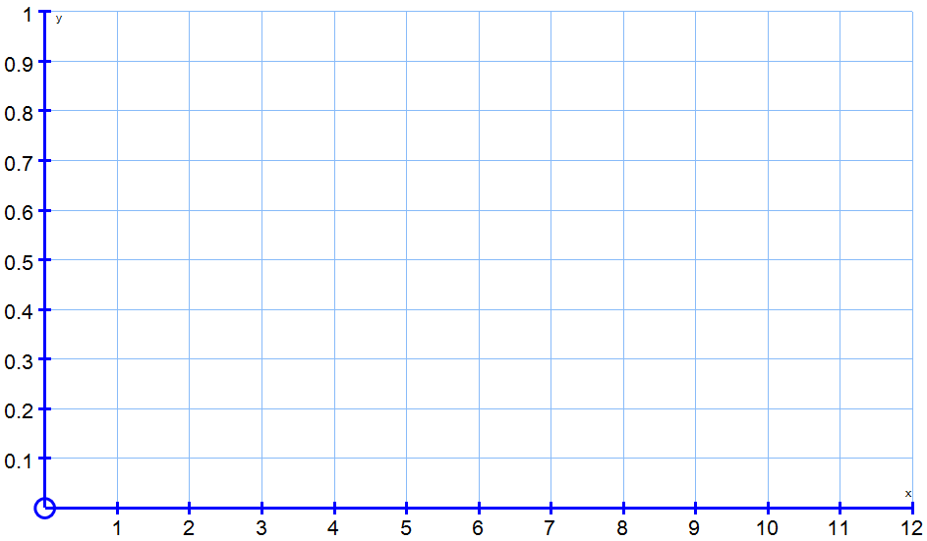In the space below plot a graph using a **curved line of best fit.**

Time (s)

Number of cases

How long would it take for 3 cupcake cases to hit the floor?

What would happen if the number of cupcake cases continued to increase? What time would it take to drop 100 cases?

**C:\Users\pb.AMAN.003\AppData\Local\Microsoft\Windows\Temporary Internet Files\Content.IE5\RZ1CUCNY\MC900331621[1].wmfWhat colour are your eyes?**

Numeracy Task

|  |  |  |
| --- | --- | --- |
| Eye Colour | Pictogram | Frequency |
| Blue | http://sweetclipart.com/multisite/sweetclipart/files/people_symbols_eye_blue.pnghttp://sweetclipart.com/multisite/sweetclipart/files/people_symbols_eye_blue.pnghttp://sweetclipart.com/multisite/sweetclipart/files/people_symbols_eye_blue.png |  |
| Brown | http://sweetclipart.com/multisite/sweetclipart/files/people_symbols_eye_blue.pnghttp://sweetclipart.com/multisite/sweetclipart/files/people_symbols_eye_blue.pnghttp://sweetclipart.com/multisite/sweetclipart/files/people_symbols_eye_blue.pnghttp://sweetclipart.com/multisite/sweetclipart/files/people_symbols_eye_blue.png |  |
| Green | http://sweetclipart.com/multisite/sweetclipart/files/people_symbols_eye_blue.pnghttp://sweetclipart.com/multisite/sweetclipart/files/people_symbols_eye_blue.png |  |
| Grey | http://sweetclipart.com/multisite/sweetclipart/files/people_symbols_eye_blue.pnghttp://sweetclipart.com/multisite/sweetclipart/files/people_symbols_eye_blue.png |  |
| Hazel | http://sweetclipart.com/multisite/sweetclipart/files/people_symbols_eye_blue.pnghttp://sweetclipart.com/multisite/sweetclipart/files/people_symbols_eye_blue.png |  |
| Other |  |  |



= 8 people

100 people filled in the survey. Find out how many had other colour eyes. Fill in the pictogram

**[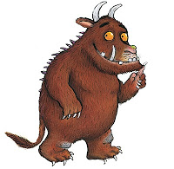](http://1.bp.blogspot.com/-N4BjDkYNH0s/TZLjSAuobsI/AAAAAAAAAxo/51TyLSDGnRs/s1600/1_gruffalo_alt.jpg)Food Chains**

Numeracy Task

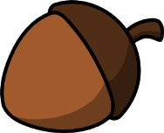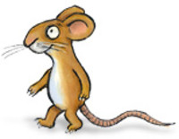

1 Gruffalo needs 40 mice. 1 mouse needs 15 acorns. Using this information answer the following questions

How many mice are needed for 2 Gruffalo?

How many acorns are needed to feed the mice for 2 Gruffalo?

How many mice could 90 acorns feed? How many Gruffalo would that feed?

How many Gruffalo could survive with 120 mice? How many acorns would be needed for 120 mice?

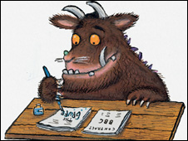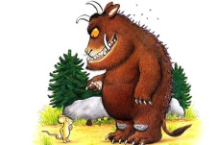To calculate how many mice is needed, the word formula below can be used

**Number of mice = number of Gruffalo times forty**

Write the same formula for mice and acorns.

What is the word formula linking the number of acorns to the number of Gruffalo?

**C:\Users\pb.AMAN.003\AppData\Local\Microsoft\Windows\Temporary Internet Files\Content.IE5\RAHHQI4P\MC900384030[1].wmfNoise**

Numeracy Task

Sound is measured in decibels (dB). Use the chart below to answer the questions

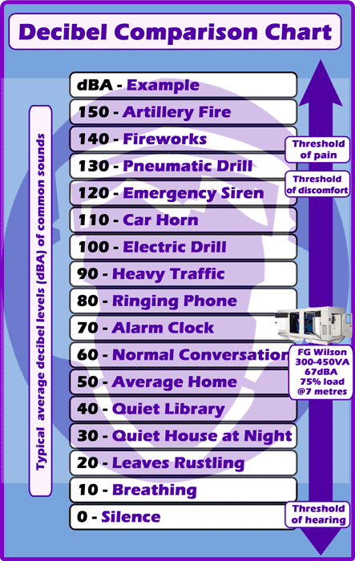What is the difference id dB between heavy traffic and a quiet library?

What sound is 60 dB louder than breathing?

What sound has half the noise level of fireworks?

A person experiences an emergency siren for 2 minutes then talks for 3.5 minutes. How many seconds is this?

An average home produces 50 dB of sound. Write down the typical noises produced in your house. Do you think your house is louder or quieter than the average?