**Lesson 1**

Starter:

Look at the picture,

What do you see?

What can you infer from this photograph?

What questions can you ask to further your knowledge?

[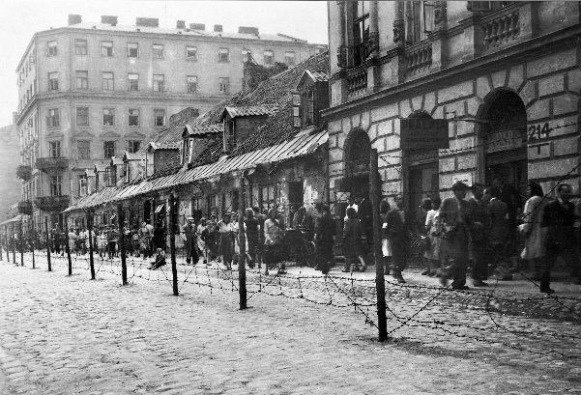](https://www.google.com/url?sa=i&url=https://time.com/5513280/holocaust-remembrance-archive/&psig=AOvVaw0N5TwOMCKeT5gngIsIHk36&ust=1582245524660000&source=images&cd=vfe&ved=0CAIQjRxqFwoTCOiKz4ny3ucCFQAAAAAdAAAAABA7)

**What is a ghetto?**

A ghetto is a part of a city occupied by a minority group.

In Nazi Germany, ghettos were city districts where Jews were isolated from the non-Jewish population.

**Life in the Ghettos**

Jews were made to live in ghettos, which were small sections of cities or towns. Often they had walls around them and people were not allowed in or out.

The Nazis were not sure what would happen to the Jews in these ghettos.

Some wanted them to starve to death, others just wanted to keep them all in the same place.

In Warsaw, 400,000 Jews were ordered to live in the Jewish district. The Ghetto made up less than 3 per cent of the city’s area but now had 1/3rd of its population.

Only 1% of the houses in the Warsaw ghetto had running water.

They were only rationed 300 calories a day (we need 2,000 to live).

**Task 1:** What information are these sources giving us about the ghettos?

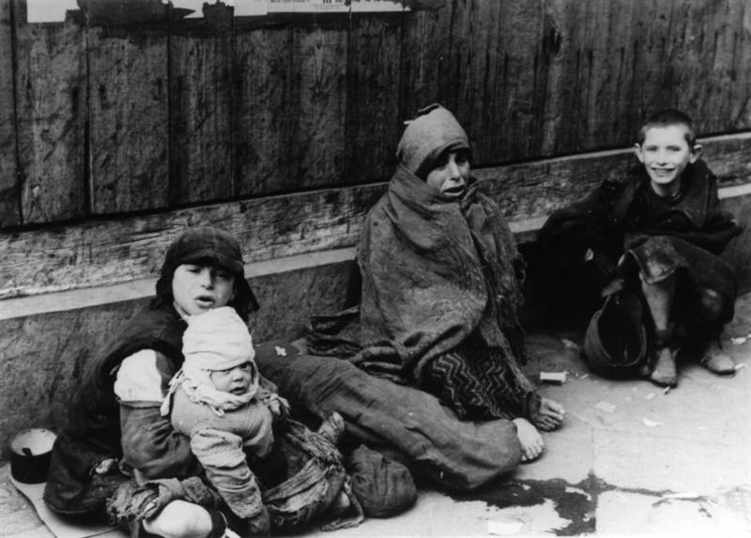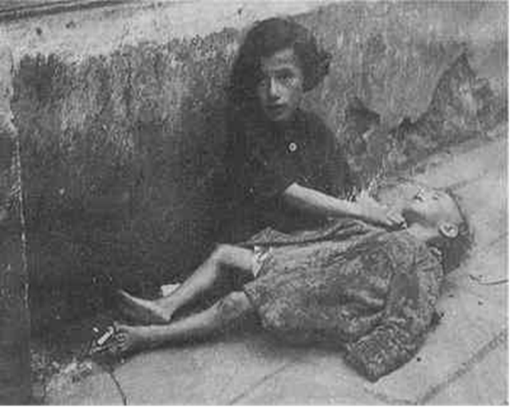

What information are these sources giving us about the ghettos?

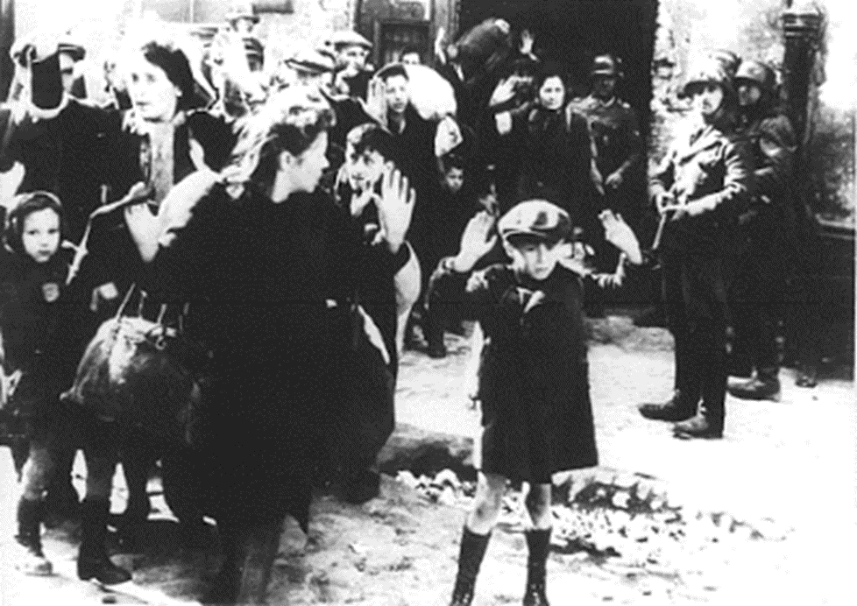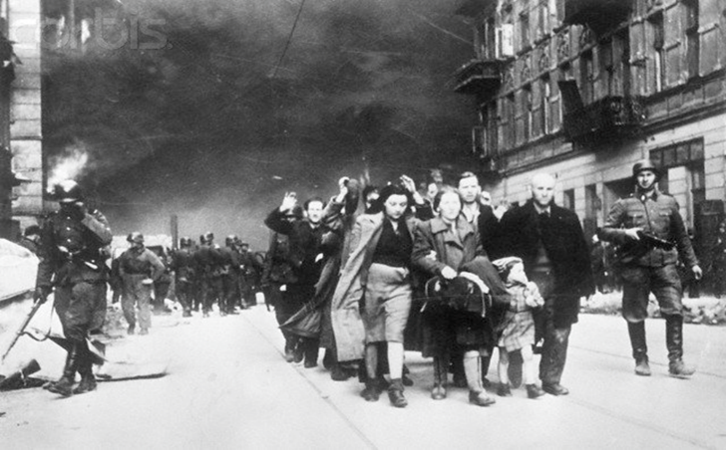What do you think is happening in this picture?

Task 2:

“In an area of 28 sq. m. are 38 people. There are 14 bunks on which 34 people sleep. That means three people on some of these very narrow bunks (the two of us and Yorek, our son, who sleeps at our feet). The remaining four people sleep on cots and stretchers placed between the beds…The food is scarce and the overcrowding is hard to describe. In addition, there are lice and bedbugs …only the first days are terrible, but afterwards everyone gets used to the conditions and there is even humor here.”

**From a letter written by Emanuel Ringelblum, January 6, 1944.**

1. What does this letter say life in a ghetto is like?
2. Do you think this is an example of Nazi persecution against the Jews? Explain your answer.

Remember to:

1. **Point**
2. **Evidence**
3. **Explain**

Task 3: Your letter from the Ghetto

Imagine you are a Jew living in the Warsaw ghetto. Write a letter to a friend or loved one explaining what life is like where you live.

Your letter must include:

* What it was like being moved into the ghetto, how did it make you feel?
* What is life like in your new home?
* What problems do you face?
* How do you feel about the future?

Use the attachment to guide you when writing your letter. It is a possible structure.

**Challenge**: In your letter, question why you think the Nazis have set up ghettos.

Plenary: Write down as many words you can to describe the sights, sounds and feelings of someone living in a Ghetto.

***Example:***

**Seeing** – Rats

**Hearing** – Gun shots

**Feeling** – Lonely