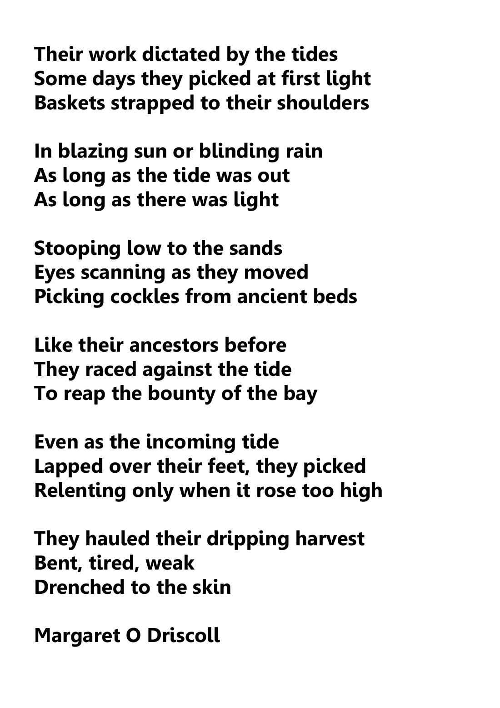

Using the above poem for reference, Sketch, Paint, Draw how you imagine the scene. If possible, photograph your art work and upload to your SWAY portfolio.

DJM

