Year 8 Remote Learning Activity: Population
All tasks to be completed on Word.

Task 1:
Create a fact file by researching the answers to the following questions:
- What was the world population is 1800?
- What is the world population today?
- How much as the world population increased since 1800?
- What is meant by the term “Birth Rate”
- What is meant by the term “Death Rate”

Task 2:
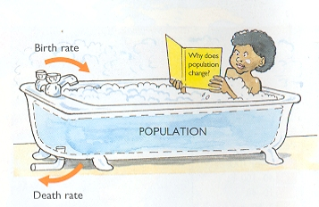
Research:
- A country which has a birth rate higher than its death rate (so population increasing)
- A country which has a death rate higher than its birth rate (so population decreasing)

Challenge:
Other than births and deaths, what other factors can affect the population of a country?
Image of a British Café in Benidorm

Task 3:
What factors can increase/decrease a country’s population?
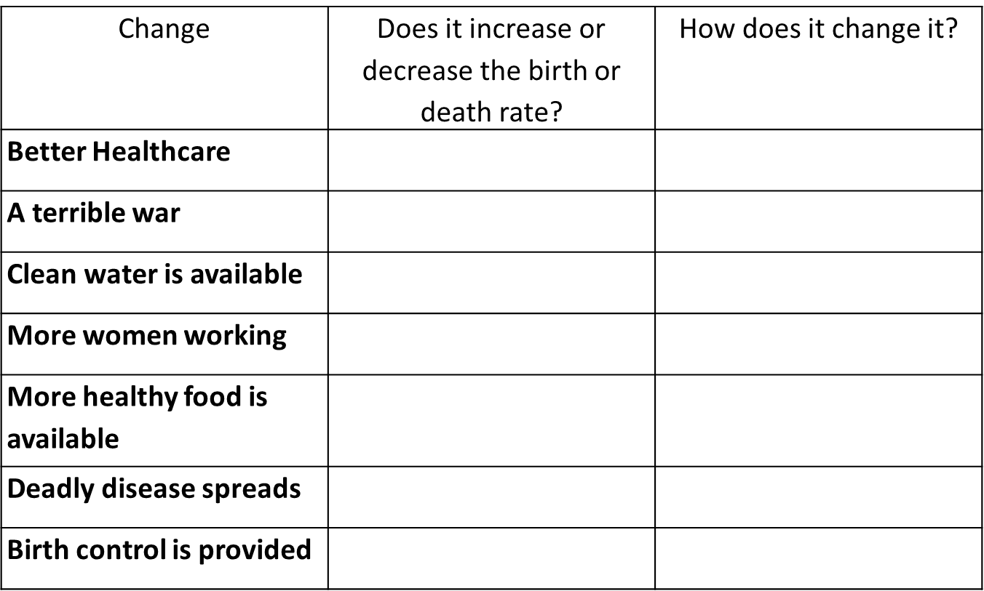

Task 4:
Find symbols for all factors that impact population size e.g for an increased birth rate. Then create a poster outlining all factors.

Task 5:
What is meant by the term “life expectancy”. Write a paragraph outlining why the UK may have a higher life expectancy than Yemen (please feel free to research – but DO NOT COPY AND PASTE).
Success Criteria:
- Mention the life expectancy rates of the UK and Yemen
- Suggest reasons why the UK has a higher life expectancy
- Use key terms to support your answer

