Year 7 Remote Learning – Leaders

All these tasks can be completed on Notebook in the file.
Task 1
Using the video, think about the leaders in your life. https://www.youtube.com/watch?v=tghjgOv4mKc
What do you think makes them leaders? (Characteristics, Personality traits)

Task 2
Think of a bad leader.
Can you think of any adjectives to describe a bad leader?

Task 3
The Island
You’ve survived a plane crash and have found yourself to be on a deserted Island with what seems to be no chance of rescue. There are 11 other strangers with you and you are in a hostile environment. You need to elect a leader quickly!

Role | Who have you chosen? | Why?
A Leader
Cook
Hunter
Builder
Protector
Teacher
Doctor
Entertainer

Your choices

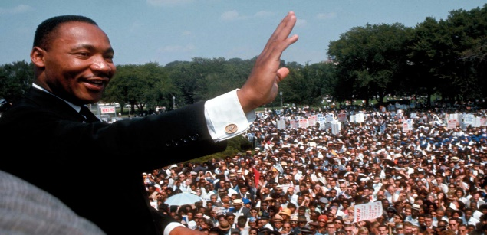  Martin Luther King Jr | - Motivational speaker  - His leadership led the civil rights movement  - Ended the legal segregation (separation) of African Americans  - Awarded the Nobel Peace Prise  - Led non-violent protests and marches
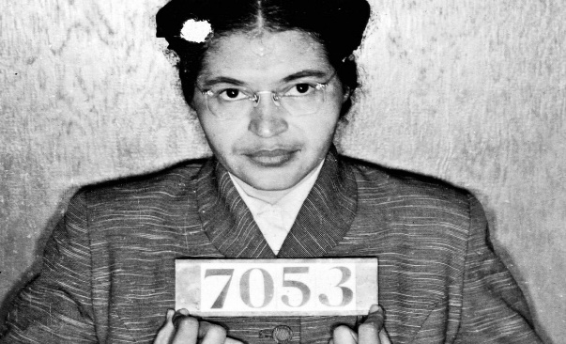  Rosa Parks | - Civil rights activist who refused to give up her seat on a bus for a white passenger  - This act started bus boycotts in Alabama and nationwide efforts to end racial segregation  - Extremely brave  - One small act led a nation to end racial segregation
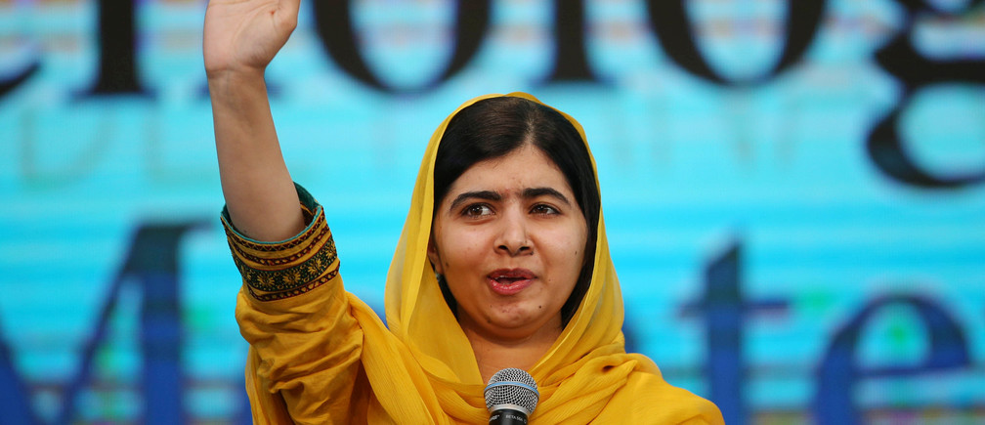  Malala | - Went to school even though education was illegal for females in Pakistan  - Bravely demanded that all girls receive an education  - Contacted other countries leaders to find help for the women of Pakistan  - Taliban shot Malala in the head and she continued her nonviolent protests  - Continues to fight for women’s rights and education today  - Did not surrender and led a lot of other women to protest
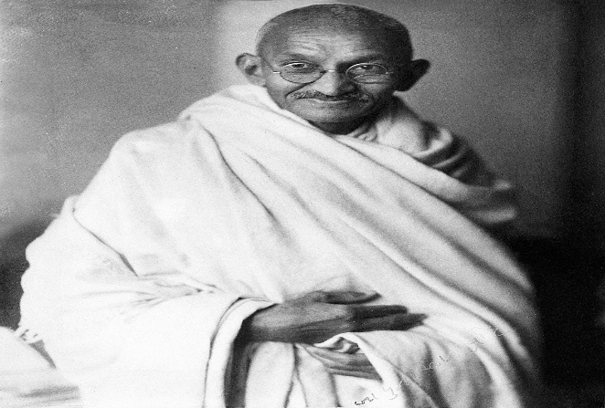  Ghandi | - Leader of India’s independence movement and held non-violent protests that influenced the world  - Fought against Britain ruling India  - Died because of his beliefs and peaceful protests  - Fought for what he believed in and his country  - “An eye for an eye will make the whole world blind”  - Lived in the rainforest
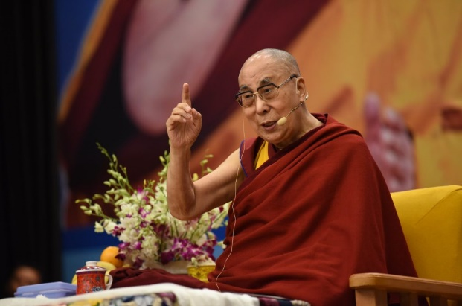  Dalai Lama | - Spiritual leader  - Compassionate  - Began his spiritual education at 6 years old  - Full political (prime minister) power of Tibet  - Help peaceful protests  - Taught others all his life and had a great education
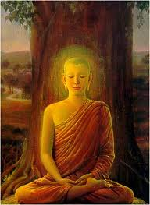  Buddha | - Born into a privileged family but wanted more  - Turned to religion where he found all the answers to every question he could ever wish to know  - Understood the world and everything in it  - Great teacher and influencer  - Lived in the wilderness for many years on his own
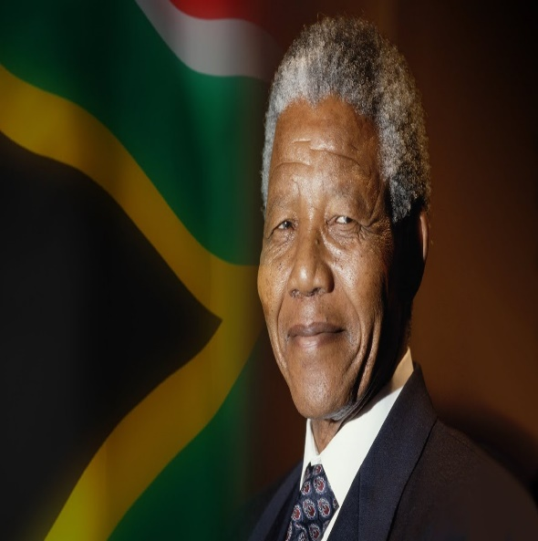  Nelson Mandela | - First Black President of South Africa  - Anti-apartheid work (fought for equal rights for black people)  - Won the Nobel Peace Prize  - Spent 27 years in prison for fighting for equal rights for all  - Never stopped protesting  - An inspiration to civil rights activist  - Built shelter for those who needed it during the racial struggle
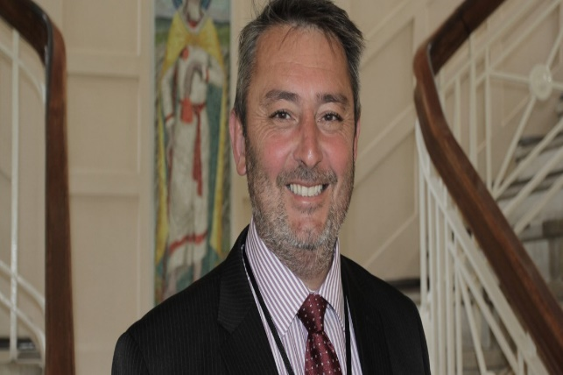  Mr. Jones (Headmaster of Gowerton School) | - Educates staff and pupils  - Good education  - Taught History  - Always tries his best  - Leads all staff to be the best they can be  - Trains staff to lead pupils to be the best they can be  - Very good teacher  - Leader, works well with others, motivational, good communicator, guides others
Gareth Bale | - Welsh football captain  - Leads strong men  - Leads by example  - Motivates others to do well  - Ensures everyone is happy and understands  - Keeps moral high  - Makes decisions for his team and not himself
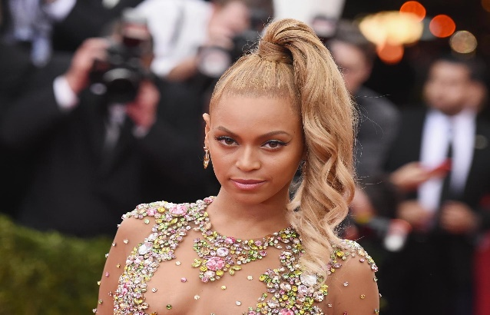  Beyoncé | - Motivational  - Fashion icon  - Queen  - Leads her Beyhive (fans)  - Strong independent women  - Entertainment  - Business women – leads her employees  - Has a husband and 3 kids (family orientated)
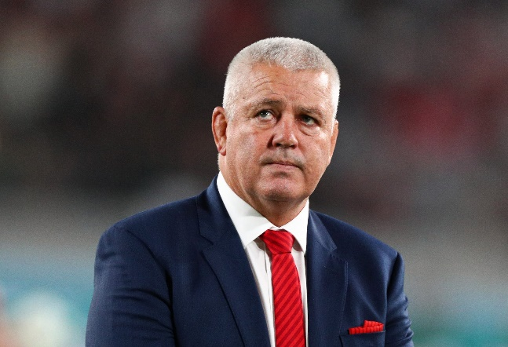  Warren Gatland | - Leads a large group of strong men  - Keeps moral high  - Led Wales to win 3 Grand Slams  - Makes good decisions fast  - Adapts to situations fast  - Controls himself and his team  - Makes decisions to improve the team  - Puts others before himself  - Proud  - Committed  - Believes in himself and his team
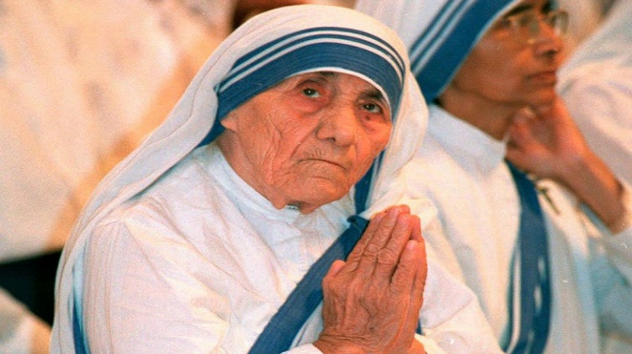  Mother Theresa | - Founded a charity  - Dedicated her life to helping the poor and sick  - Nun  - Teacher in India for 17 years  - Winner of Nobel Peace Prize  - Puts others before herself  - Educated by the Roman Catholic Church  - Cooks, nurses, educates, cleans and provides for others

Task 4
Create an acrostic to highlight the skills and qualities of a good leader.
L is for…
E
A
D
E
R
S
H
I
P

