Topic 6 - Defence against Disease
Keywords
- P_________________– a disease causing microbe e.g virus - flu
- First line of defense – S________ and b_________ clotting stops microbes entering your body.
- W________blood cells (protect you in three ways) – ingests bacteria, make antibodies and make antitoxins.
  - P__________________– a white blood cell that ingests bacteria.
  - L__________________– a white blood cell that produces antibodies and anti-toxins
  - A_________________(Y) – White blood cells make this chemical in response to pathogen. It is used to destroy pathogens.
  - A__________________– These work by neutralizing the toxins made by pathogens which make you ill.
- A__________________– the protein on the outside of a pathogen that causes your immune system to respond.
- V__________________ – You are given a small amount of the weakened disease to get your body to produce white blood cells and antibodies specific to the disease.
Pathogens a) b) c)
Starter questions
- What is the name of the hormone that is released when blood glucose levels are too high and what organ releases it? __________________________________________________
- What is the name of the insoluble form of glucose that is stored in the liver? _____________________________
- What is the difference between a heterozygous genotype and a homozygous genotype?
_________________________________________________________________________________________
_________________________________________________________________________________________
_________________________________________________________________________________________
_________________________________________________________________________________________
- Micro-organisms consist of b__________, f_________, v__________and protists.
- Some micro-organisms are h____________and perform vital functions such as E.coli naturally found in the human intestinal tract.
- Pathogens are micro-organisms that cause _______________ such as the pathogenic E.coli that causes diarrhoea. It is a different form of E.coli than the one naturally found in the intestines.

Bacterial cells
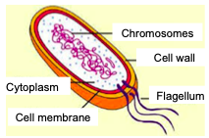
Consist of:
- Cell ___________
- Cell m_______________and c________________
- They have NO distinct nucleus just free genetic material

Genetic material

Virus
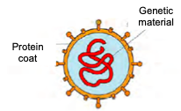
Consist of:
- G__________ material surrounded by a p___________ coat

Communicable diseases
These type of diseases are caused by pathogenic bacteria, viruses and fungi e.g. chicken pox.
They are spread through:-
- C______________, D______________/aerosol, w____________, contaminated food, b__________ fluids and i_____________
Our body’s defence d)e)
Starter questions
- Give two lifestyle choices which can result in type 2 diabetes.

- Name the two organs involved in regulating blood glucose levels.

- What is the name of the kingdom which has fish as one of its classes?

Intact Skin – defense barrier
Skin f_________– the natural community of micro-organisms that live on the skin make it difficult for pathogens to become established.
If the skin barrier is broken our b___________ is the next line of defence.
Blood defense
P_________________– they would cause the blood to c________ over the ‘cut’ forming a scab (seal).
W___________blood cells – there are two types of white blood cells – phagocytes and lymphoctyes - that would play a part.
- Phagocytes – i______________ the invading bacteria.
- Lymphocytes – produce a_____________ and a______________.
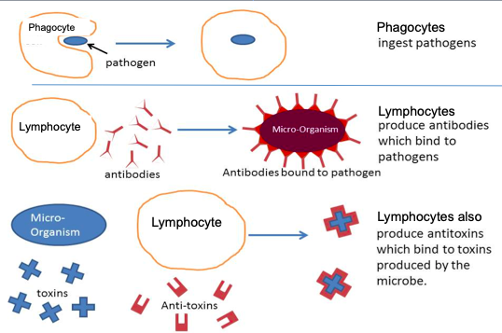
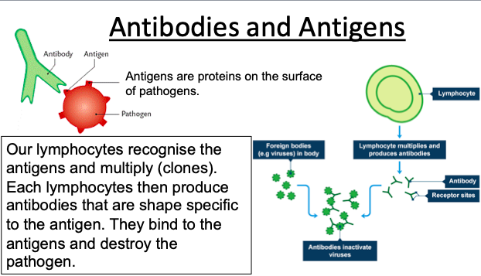
Antibodies and antigens

Vaccinations f) g) h)
Parental choice
- Vaccinations p___________ humans for infectious diseases. They p___________the individual from becoming ill as well as preventing s__________.
- The problems arise if a parent decides that their child will not have a vaccination for a specific disease due to unfounding a___________ over s______ effects.
- The M__________plays a huge role on whether parents decide their children will be vaccinated or not.
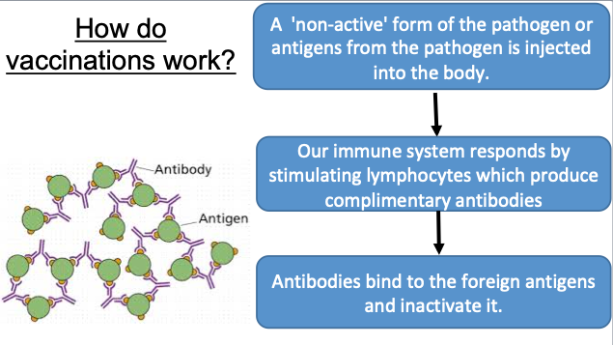
Immune response
- Following an antigen encounter m_________ cells remain in the body which will reproduce the specific antibody if the s________ antigen attacks again.
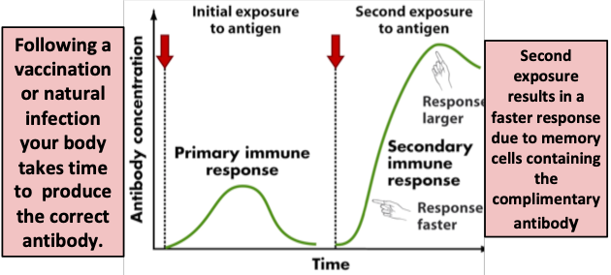
- These memory cells provide immunity against the pathogen whether it was a natural infection or a vaccination.
- The second response produces antibodies q_________ and in l__________numbers compared to the first response.

Antibiotics and Resistance i)j)
Starter questions
1. Name two differences between mitosis and meiosis.

2. What is a disease causing micro-organisms known as? ____________________________
3. What is the difference between a phagocyte and a lymphocyte?

Antibiotics
- The first antibiotic was p______________. Following this original medicines were made using living organisms.
- Many other antibiotics have now been discovered or developed (synthetic). Some have been altered chemically to make them safer for humans known as semi- synthetic antibiotics. All kill infecting b_____________.
- Do not work on v__________as they live inside our cells and we could damage our own tissue.

Antibiotic resistance - A bacterium is no longer destroyed by an antibiotic which was once used to kill it.
An example of a pathogen which is resistant to antibiotics is MRSA.
MRSA control measures could include:
• h__________washing
• thorough cleaning of hospital wards
• use of a___________ gels
• MRSA s___________

Treatments for Diseases k)l)
Starter
1.Name the four bases. _________________________________________________________________________
2.What forms a protein? ________________________________________________________________________
3.How many bases code for one amino acid? ___________
4.How many strands of DNA form a double helix? _______________
5.Write down the complementary base pairs _______________ and ______________

Disease can be due to many factors and the preventative measures are vital:-
- Good h____________
- Improved d_________
- Good s____________
- V_________________
If the above have been compromised then d_________
such as a_____________are used.

Drug Trials
- Drugs have to be tested before given to humans. These tests sometimes do not show s_________ e________ which can be seen once prescribed.
E.g Thalidamide was given to mothers to suffered from morning sickness. One side effect that was seen at birth was the underdevelopment of limbs in babies.

