SCIENCE DEPARTMENT
Double Year 11
Physics - Revision Questions
Name:

Topic 1 – Speed, Distance and Acceleration
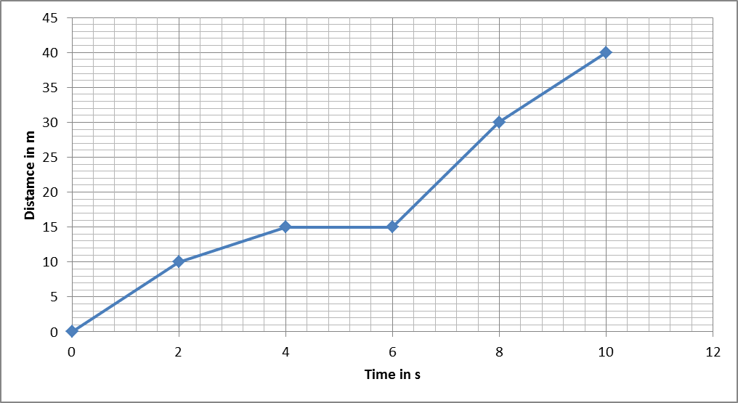
1.

- Find the speed between 0 and 2s.
- Where is the highest speed? How do you know?
- What is the speed between 8 and 10s?
- What is the mean speed?
- Between which times is the vehicle stopped?
2.
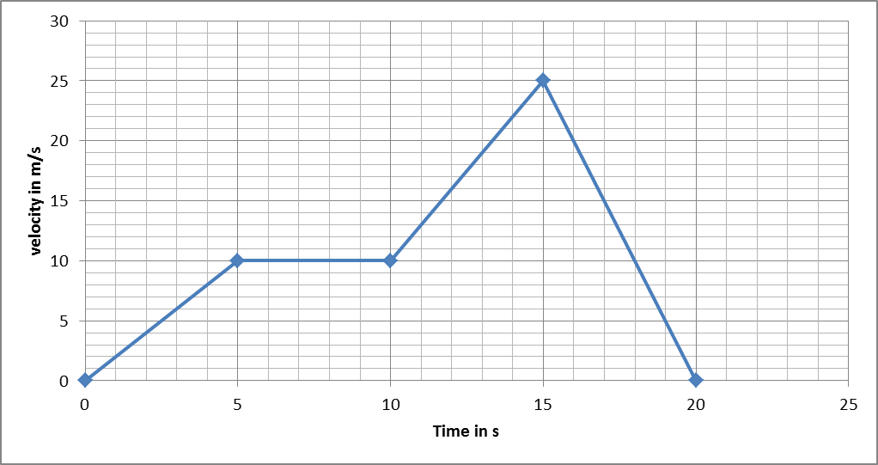
- What is the acceleration between 10 and 15s?
- Where is the acceleration the greatest?
- Where is the car moving at constant speed? What is the constant speed?
- What is the deceleration of the car?
- What is the distance travelled between 10 and 15s?

Stopping Distances
- What does stopping distance of a vehicle mean?
- What is the thinking distance and reaction time?
- What is the braking distance?
- Give 3 things that will affect the thinking distance.
- Give 3 things that will affect the braking distance of a vehicle.
- Name 4 ways that the car manufactures make cars safe.
- How does the law keep us safe when in a vehicle?

Topic 2 – Newton’s Laws
- What is inertia?
- What is Newton’s First Law of motion?
- What do unbalanced forces do to an object? (3 things)
- What is Newton’s Second Law of Motion?
- Using F=ma
- What is Newton’s Third Law of motion?
- Understanding the take-off of a rocket:
- A rocket has a mass of 75kg. the force needed for the rocket to take off is 1500N. (g = 10m/s²)
- Draw a rocket and label the forces on it at take-off.
- Calculate the initial acceleration of the rocket.
- Why does the acceleration of the rocket increase during the flight?
- Explain using Newton’s laws how a rocket takes off.
- Explain how a person falling out through the air reaches terminal velocity.
- Explain how opening a parachute can reduce the final velocity of a person so he is at a safe speed to land.

Topic 3 – Work and Energy
- State the law of conservation of energy.
- Using the equations for conservation of energy.
- A car is moving down a hill as shown. Find the Gravitational potential Energy at the top if the car’s mass is 10kg.
- Assuming there is no frictional forces on the slope, find the velocity at the bottom.

50m

- A car of mass 10kg is going down another slope where friction cannot be neglected as shown.
50m
- Find the gravitational Potential energy at the top.
- Find the kinetic energy at the bottom if the velocity is 15m/s.
- What is the work done on the car travelling down the slope?
- What is the average force against friction on the car if the length of the slope is 100m?

Safety Features of Cars

- What are aerodynamic losses and how can they be reduced?
- What are rolling losses and how can they be reduced?
- What are idling losses and how can they be reduced?
- What are inertial losses and how can they be reduced?
- Explain how airbags, crumple zones and seatbelts can reduce injury during a crash.
- What do headrests protect against?
- What is a roll cage used for?

Hooke’s Law
- Explain how you would find the spring constant of a spring. Draw a diagram to help you.
- Using a graph of Force and Extension.
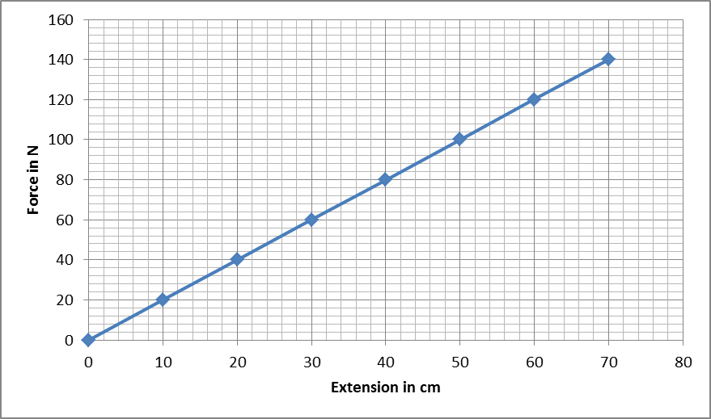

- Using the graph, what is the spring constant?
- Using the graph, find the energy stored in the spring.
- Add a line on in green that shows 2 of the same springs in parallel.
- Add a line on in red that shows 2 of the same springs in series.

Topic 4 – Stars and Planets

Solar System
- Describe the theory of how the solar system formed.
- Describe the object at the centre of our solar system.
- What is the order of the planets starting with the furthest from the Sun?
- Between which two planets is the asteroid belt located?
- What types of objects are located in the asteroid belt?
- Name the ‘rocky’ planets
- Name the ‘gas giant’ planets
- Describe the orbit of a comet
- What is the relationship between orbital time and distance from the Sun

Features of the Universe
- What is meant by the term ‘planetary system’?
- What is meant by the term ‘galaxy’?
- Place the following in order starting with the smallest:
Planetary system, moon, Universe, asteroid, planet, galaxy, star
- What is the meaning of 1 A.U.?
- What is a light year?
- What is 6 light years in meters?
- How long does it take light to travel 20 light minutes?

Life Cycle of Stars
- Describe star birth.
- What is the process that occurs in the core of a main sequence star and what are the conditions needed?
- If the star is not large enough to fulfil the conditions above then what type of star is formed?
- While a star is on the main sequence describe the forces acting on the star.
- What will happen to our Sun when fusion stops?
- Describe all possible star deaths from stars much larger than our Sun.
- Why does fusion stop when it reaches iron?
- How do elements heavier than iron get made?
- Explain why the planets orbit the Sun in their current order.

Topic 5 – Types of Radiation
- What is the nucleon number, proton number and the number of neutrons of the following nuclei:
  - ${}_{8}^{16}O$
  - ${}_{13}^{27}{Al}$
- What is an isotope?
- Why are some nuclei radioactive and some aren’t?
- Why must experiments using radioactive sources be done for long periods of time and repeated?
- Why is radioactive waste dangerous and expensive to dispose of?
- What is background radiation?
- What are the main parts of background radiation?
- How does radiation get into food and drink?
- What is radon gas?
- What does ‘correcting for background radiation’ mean and how do you do it?
- What are the 3 types of radiation?
- What are the 3 types of radiation stopped by?
- What is an alpha emitter?
- What is a beta emitter?
- Why is alpha radiation dangerous when ingested?
- Why is gamma the most dangerous outside the body?
- What is the symbol for alpha?
- What is the symbol for beta?
- What is the symbol for gamma?
- The following emits alpha radiation, balance the equation:
- The following is a beta emitter, balance the equation:

Topic 6 – Half Life
- What does half life mean?
- What is the unit of activity?
- Carbon-14 has a half life of 5700 years. It has a count of 6000Bq. What is the count rate after 22800 years?
- How long does it take the count to fall below 100Bq?
- What is the half life of this material?
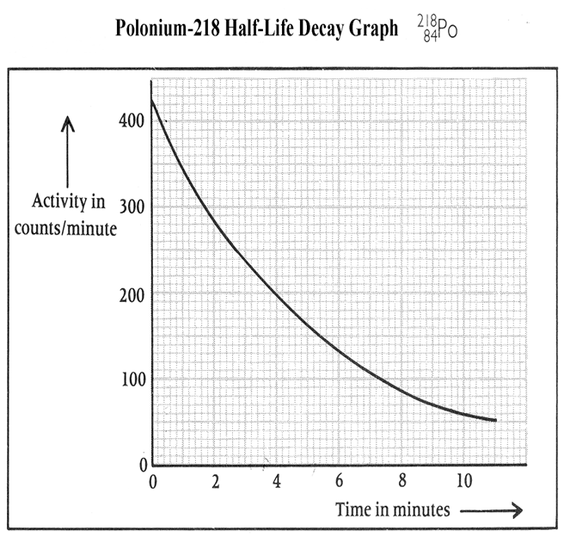
- Explain how a smoke alarm works.
- Explain how radioactivity can be used as a tracer in the human body and as a tracer in a pipe? What type of radiation is used and why?
- What type of radiation do we use to measure the thickness of steel and why? What type of half life is needed?
- Why don’t we use alpha radiation in the body for tracers?
- What length of half life is used when tracers are inside the body?
- What length of half life is used when radiation is used in machinery?
- Explain how carbon dating can be used to tell the age of old objects

