SCIENCE DEPARTMENT
Physics Year 9
Topic 3 - Waves

Topic 3 - Waves
Longitudinal and Transverse waves
1. Longitudinal
- A longitudinal wave has vibrations along the direction of the wave.
- Longitudinal waves need particles to move through such as air.
Examples
- Sound
- Earth quake waves
2. Transverse
- A transverse wave has vibrations at right angles to the direction of the wave.
- Transverse waves don’t need particles to move through.
Examples
- Light
- Electromagnetic radiation

Activity 1
- Watch the slinky spring demonstration by your teacher.
- Look at the cartoon on the next page, who do you think is correct?
- Decide with your partner and give reasons using knowledge of waves and you knowledge of space.
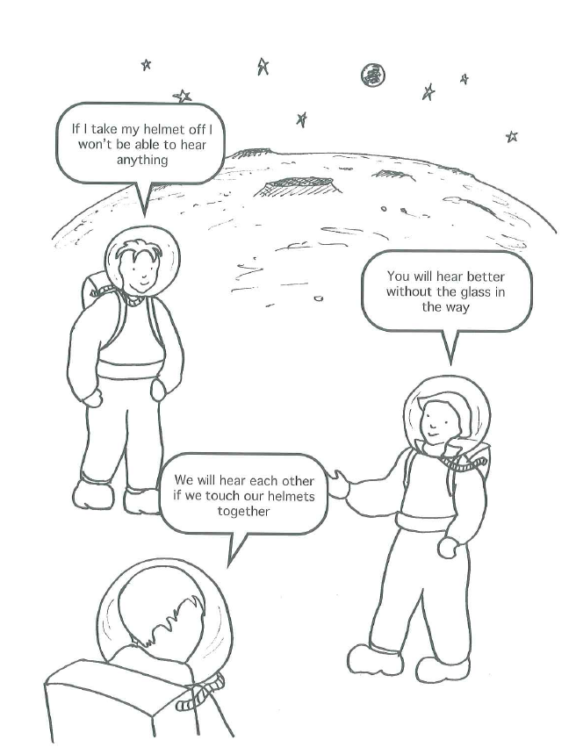

Parts of a Wave
A wave has parts that have names:
- A wave has 1 peak and 1 trough. The peak is the top and the trough is the bottom.
- A wavelength is the length of 1 wave.
- The period is the time for 1 wave.
- The amplitude is the distance to the top of the wave from the centre.
- The frequency of a wave is the number of waves that pass a point in
Activity 2
1. From this information, draw a wave with 2 complete waves and add on the:
- Wavelength
- Amplitude
- The period with a T on the time axis.
- A peak
- A trough
2. If this wave happens in 2s, what is the frequency?
3. If the wave happens in 1s, what is the frequency?
Check your answer with your teacher.

The Wave Equation
Wave Speed = Wavelength x Frequency
The following units must be used:
Wavelength is in m
Speed is in m/s
Frequency is in Hz
If you have a letter before these you need to use the multiplier for it before you add it into the equation this will change it into the unit you need:
Multipliers:

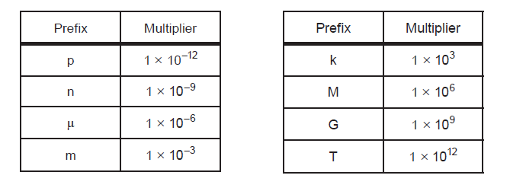

So for example:
3km = 3 x 10³m
Try the following:
6ms
20km
50nm
60THz
Using the steps on the front of your book, find the missing values in the table.
Example:
1. Write down any information from the question
Speed = 30m/s
Wavelength = 50km = 50 x 10³m [1] 2. Change any units
Frequency = f
3. Write down an equation as it appears is on page 2 of the exam paper
Wave Speed = Wavelength x Frequency
4. Write the numbers under the correct word in the equation
30 = 50 x 10³ x f [1]
5. Rearrange the equation if necessary
30 = f
50 x 10³
6. Use a calculator to find the answer and write it with a unit
F = 0.0006Hz [1]

Activity 3 – Now try these
 | Speed | Wavelength | Frequency
1 |  | 10km | 5MHz
2 |  | 2.5cm | 78kHz
3 | 3 x 10⁸m/s | 1 x 10⁻¹⁰m
4 | 3 x 10⁸m/s |  | 1.7 x 10¹⁴Hz
5 | 65m/s | 300km
6 |  | 70km | 3mHz

Using the Speed Equation
Speed = Distance
Time
Example:
1. Write down any information you know from the question
Speed = 550km/s = 550 x 10³m/s [1] 2. Change any units that you need to
Time = 345ms = 345 x 10⁻³s [1]
Distance = D
3. Write down an equation as it appears on page 2 of the exam paper
Speed = Distance
Time
550 x 10³ = D . [1]
345 x 10⁻³
4. Rearrange if necessary
550 x 10³ x 345 x 10⁻³ = D
5. Use a calculator to find the answer and write it with the unit.
189750m = D [1]

Activity 4 - Now Try these
Some of these units won’t need changing. Before you start see if you can see the ones you need to change.
 | Speed | Time | Distance
1 |  | 0.5s | 3.5m
2 | 60km/hr |  | 3km
3 |  | 6 x 10⁵s | 7000m
4 | 3 x 10⁸m/s (speed of light) |  | 1000m
5 | 330m/s (speed of sound) |  | 1000m
6 |  | 85000miles | 67hrs
7 | 579m/s | 600hrs
8 | 85mph | 3hrs

Questions 4 and 5 show how the time is different for a sound and light travelling 1000m.
Activity 5
Use your ideas about sound and light to decide who is correct in this cartoon.

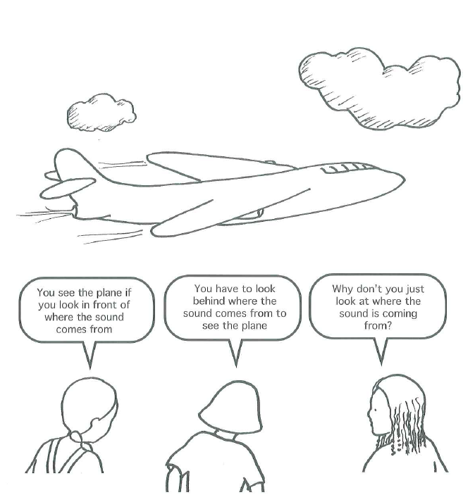
Activity 6 - The Water Wave Experiment
An investigation to find the relationship between depth of a wave and speed
You have the following equipment:
- A tray
- A Jug of water
- A meter rule
- A stop watch
Discuss in your groups how you will do this investigation.
Think about:
- How you are going to measure the depth of the water in the tray
- How you are going to create a wave
- What measurements are you going to take to find the speed e.g. what distance will you measure and what time.
- Will you repeat the experiment? Why?
- What will you do with the results once you have found the speed?
In your books, write a plan of this experiment.
- You will need a diagram and the plan must be written step by step.
- Draw a table of results to add your data to.
- You must ensure you have all the correct columns added. Think carefully about the columns you need, you will lose marks if your table is split.
- Once you have discussed this with your teacher, you can carry out the experiment.
- Draw your graph. What will you put on the y-axis and the x-axis?
- Now answer the following questions in complete sentences in your book.

Water Wave Practical Questions
- What was the independent variable?
- What was the dependent variable?
- Why did you repeat your experiment?
- Were your results repeatable?
- What does reproducible mean?
- Were your results reproducible?
- How did you ensure that the experiment was fair?
- Describe the relationship between depth of water and speed of waves.
- Did you identify any anomalies?
- What does the speed increase by when you double the depth from 0.5cm to 1cm?
- Is this the same if you double the depth from 1cm to 2cm?
- What errors could have occurred in this experiment?
- How could you make the experiment more accurate?

Reflection and Refraction of Waves
The law of reflection

r
i
Reflected Ray
Incident Ray

i = angle of incidence
r = angle of reflection
Activity 7
On a sheet of plain paper, draw a 3 of these diagrams as shown:

The dotted line is called the normal line because it is at right angles to the surface.
All angles are measured from the normal line.
Draw a line on each diagram at a different angle
Using the ray box, a single slit, a power supply and a mirror, draw a reflected ray on each of your diagrams.
Copy this table into your booklet
Angle of incidence | Angle of reflection

What do you think the law of reflection is?
Write a sentence in your book to day what the law of reflection is. Use Scientific language where needed.
Look at the Cartoon on the next page, who do you think is correct?

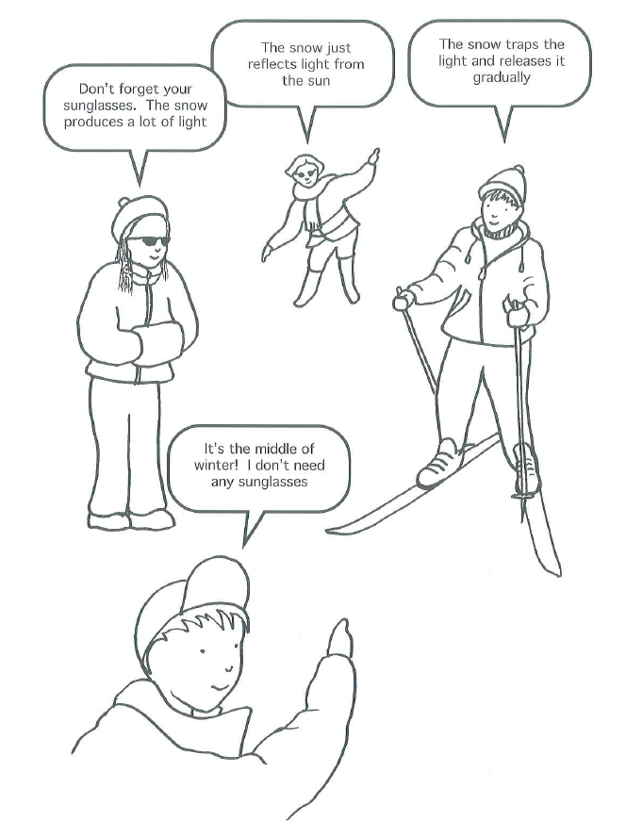
Refraction
Here are some facts about refraction:
- Refraction occurs because waves travel through different materials at different speeds.
- If the speed changes, refraction occurs.
- Refraction causes light to bend in materials that have different optical densities.
- The speed of light is largest in air (or a vacuum), there is no faster speed.
- When the speed of the wave decreases, the wavelength and the angle also decrease.
- The frequency is always the same.
- For a water wave, the speed is larger in deep water.

Investigating refraction of light
Activity 8
Using the following equipment, draw a diagram of refraction of light using a glass block.
- A glass block
- A ray box
- A power supply
- Plain paper
- Draw around the glass block on a piece of plain paper.
- Draw a normal line about 2cm in from the left of your glass block.
- Draw a line at an angle hitting the normal line (your teacher will demonstrate this if you are unsure.)
- Place the light from the ray box on your line you have just drawn.
- Draw the light coming out of (emerging) the glass block.
- Label on your diagram:
- The incident ray
- The incident angle
- The refracted ray
- The refracted angle
- The emergent ray
- The emergent angle
- The area where the speed is the greatest
- The area where the speed is the least
Copy and complete this table in your book:
Incident angle | Refracted angle | Emergent angle
- Write a sentence comparing the incident angle and the refracted angle
- Write a sentence comparing the incident angle with the emergent angle.
- Draw a diagram to show how the angles would change if a wave travelled from deep to shallow water.

The Electromagnetic Spectrum
Activity 9 - Finding Information and Presenting
Using the Chrome books, find out the following information about the Electromagnetic Spectrum:
- Why are they grouped in this way?
- What is the order? (there are 7 parts)
- What is the wavelength of each part?
- What is the frequency of each part?
- Give 3 uses of each part.
- Say if the part is dangerous and say what it can do to the body.
You are going to present this in groups to the class and each group will be marked on:
- The information given
- The presentation skills of the group
- The software used (Sway or PowerPoint)
- Videos and diagrams used.

Making a data base
With the information you have found from your group and other groups, use J2E to create a data base for the Electromagnetic Spectrum.
- You are going to do this individually.
- You can decide what information you are putting in it.
- Create 5 questions for someone in the class to answer using your data base.

