New 12-sided pound coin to be unveiled ahead of budget announcement
Featuring a rose, leek, thistle and shamrock, the Royal Mint believes the new coin will be the most secure in the world against counterfeiting.

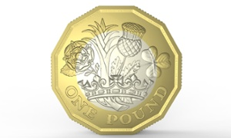
The design on the tails side of the new coin is the work of West Midlands teenager David Pearce, who won a competition to create the image on the new money.
Chancellor George Osborne will unveil a new 12-sided pound coin featuring the four symbols of the UK – a rose, leek, thistle and shamrock – emerging from a royal coronet, ahead of his budget on Wednesday.
The new coin, which will be introduced in 2017, is the same shape as the old threepenny bit, which was withdrawn in 1971.
While the shape of the new coin will evoke the pre-decimalisation period (before 1971), it masks cutting-edge anti-forgery technology. The Royal Mint says the new pound will combine three features to make it the most secure coin in the world. It uses two colours of metal, has 12 sides and includes the Royal Mint’s anti-counterfeiting technology, adapted from banknotes and embedded in coins for the first time.
The design by Pearce, 15, a pupil at Queen Mary’s Grammar School in Walsall, was chosen from more than 6,000 entries in a public competition. The brief was to create a tails side which symbolises Britain. Entries included cups of tea, the weather, famous writers, seaside piers and the Rolling Stones tongue motif.
The Royal Mint estimates that about 3% of all £1 coins, some 45m, are now forgeries.
Osborne said last year that the threepenny bit shape was chosen in honour of the Queen, given that 12-sided coin was the first she appeared on.
Over the past few years, around 2 million counterfeit £1 coins have been removed from circulation each year and the Treasury hopes the new secure coins will reduce costs to businesses and taxpayers.

