Nervous system Summary Notes

The Central Nervous System (CNS)
The CNS is composed of the brain and the spinal cord. It processes information sent provided by a stimulus. The brain and spinal cord are both protected by membranes called the meninges (dura mater (outside), pia mater (inside)).

The spinal cord
The white matter contains nerve fibres surrounded by myelin, which is fatty and so looks white. The grey matter is ‘butterfly shaped’ and is largely the nerve fibres of relay neurons and the cell bodies of relay and motor neurones so looks grey.
At the centre of the spinal cord is the central canal.

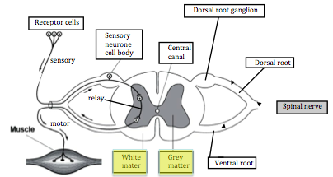
Ventral median fissure (gap)

A reflex is fast, automatic and beneficial.
- Sensory neurones transmit impulses from the receptors to the CNS. They enter via the dorsal root and have their cell body in the dorsal root ganglion.
- Motor neurones transmit impulses from the CNS to effectors. They leave via the ventral root.

There are three types of neurones but only motor neurone structure (below) needs to be learned for the exam.
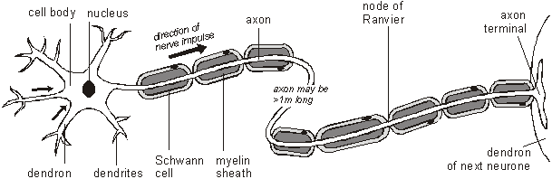

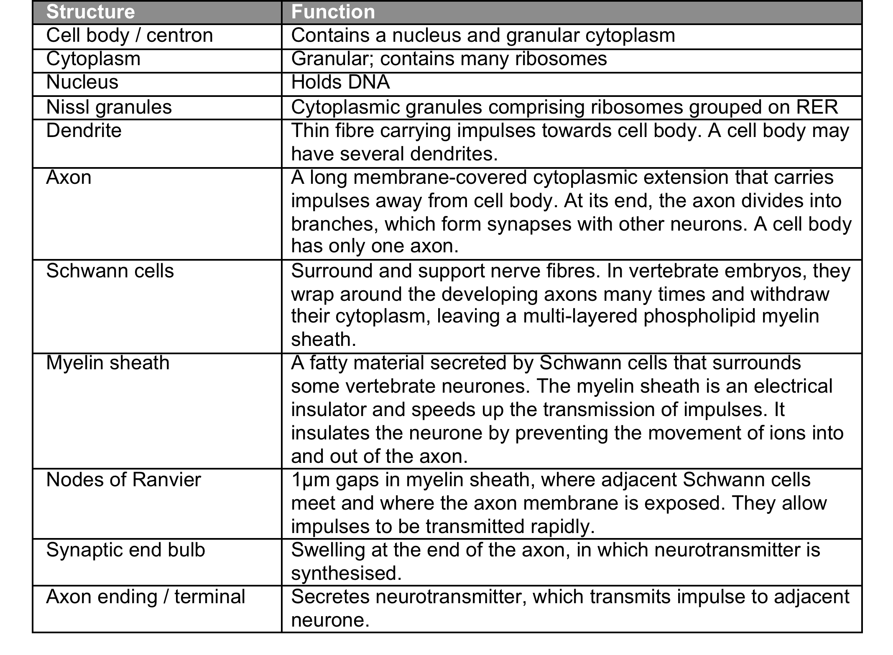
Sensory neurones have long axons and transmit nerve impulses from the sensory receptors or sense organs all over the body into the CNS.

Motor neurones also have long axons and transmit nerve impulses from the CNS to the effector organs (muscles and glands) all over the body.

Relay neurones (also called connector neurones or association neurones) are usually much smaller cells, with many interconnections. They receive impulses from sensory neurons or other relay neurones and transmit them to motor neurones or other relay neurones.

A nerve net is the simplest form of nervous system. It does not have a CNS instead it has a diffuse network of cells that group into ganglia, but do not form a brain. It has fewer types of receptor cells and therefore responds to a limited number of stimuli.
You must be able to compare a nerve net with the mammalian neurone system:
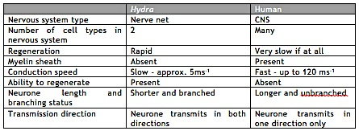

You must be able to explain the passage of an action potential by an oscilloscope trace:

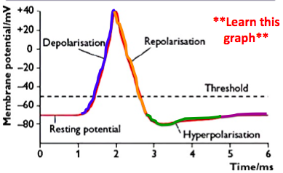
Resting Potential -70mV
- To maintain the resting potential, sodium-potassium pumps actively transport sodium ions out of the neurone and potassium ions into the neurone: 3Na+ out for each 2K+ in, per ATP hydrolysed.
- Voltage-gated Na+ channels are closed but some K+ channels allow K+ to ‘leak’ out of the action
- Large protein anions and organic phosphates (e.g.ATP₄₋) remain in the axon’s cytoplasm producing a negative potential difference across the membrane at around -70mV relative to the exterior of the axon.

Depolarsiation +40mV
- A change in the voltage across the axon membrane (a stimulus) opens the Na+ channels so that Na+
flood in by diffusion and depolarise the axon to about +40mV this is the action potential

Repolarsiation
- Repolarisation occurs as the Na+ channels close and K+ channels open resulting in K+ flooding out of the axon and reducing the potential difference across the axon membrane

Hyperpolarsiation -80mV
- An overshoot of K+ diffusing out of the axon results in the membrane being hyperpolarized and reaches -80mV

Refractory Period
- The concentrations of K+ and Na+ ions are restored to that of the resting potential by the Na+/K+ pump. The K+ channels are now closed and Na+ channels are inactived. During the refractory period the axon cannot transmit another action potential this is called the absolute refractory period and lasts about 1ms and that this ensures that transmission is in one direction only.

An action potential is propagated along the length of the neurone by local currents.
Make sure you can draw an action potential on a graph axes. Learn how many milliseconds each part should last.

Maintaining resting potential
- The Na+/K+ pump actively transports 3Na+ ions out of the axon in exchange for 2K+ions in. This uses one ATP molecule.
- Voltage gated Na+ channels are closed and the membrane is more permeable to K+ ions so they diffuse out more rapidly than Na+ ions. There is also K+ leakage
- Large protein anions and organic phosphates (e.g.ATP₄₋) remain in the cytoplasm
- Thus this creates an uneven distribution of charge with a negative potential difference across the membrane of -70mV
The ‘All or Nothing Law’
A stimulus must exceed the -50mV threshold value to be initiated, this allows low level stimuli to be filtered out. An action potential is always the same size (+40mV). An increase in the intensity of the stimulus increases the frequency of action potentials.
3 factors that affect the speed of impulse transmission:
- Temperature – the higher the temperature, the faster the transmission speed because there is increased kinetic energy of ions
- Axon diameter – the larger the diameter, the faster the transmission speed because the lower the resistance to the movement of ions and the greater its volume in relation to the area of the membrane.
- Myelin sheath – myelination increases speed. The myelin sheath Is an electrical insulator and forces the action potential to jump from Node of Ranvier to Node (gaps in the myelin sheath) by saltatory conduction. Only the nodes have voltage gated Na+ channels and can become depolarised.

The Synapse

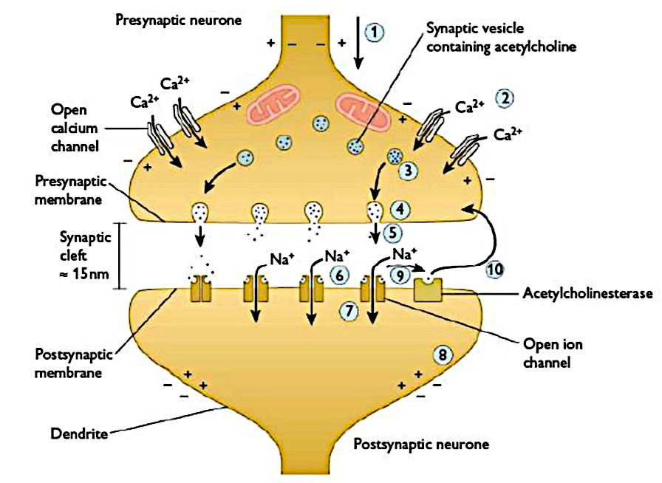
The junction between two neurones is called a synapse. An action potential cannot cross the synaptic cleft instead the nerve impulse is carried by chemicals called neurotransmitters.

- An action potential depolarises the pre-synaptic neurone
- This causes the voltage-gated calcium channels in the pre-synaptic neurone to open, resulting in the membrane becoming permeable to calcium ions (Ca²⁺).
- So calcium ions diffuse rapidly into the axon bulb, down their concentration gradient.
- The Ca²⁺ influx causes the synaptic vesicles to move towards and fuse with the pre-synaptic membrane, releasing the neurotransmitter acetylcholine into the synaptic cleft by exocytosis.
- The acetylcholine neurotransmitters diffuse across the synaptic cleft.
- The acetylcholine neurotransmitter binds to the neuroreceptors (an intrinsic protein) in the post-synaptic membrane.
- When acetylcholine molecules bind with the neuroreceptor (an intrinsic protein) it changes shape. This opens up the sodium channels and sodium ions diffuse into the post-synaptic neurone, down their concentration gradient.
- This causes a depolarisation of the post-synaptic neurone membrane, which may initiate an action potential if the threshold value is exceeded. If the threshold is exceeded an action potential will be initiated in the post-synaptic neurone.
- Once acetylcholine has depolarised the post-synaptic neurone it is hydrolysed by acetylcholinesterase enzyme in the synaptic cleft.

Acetylcholine acetylcholinesterase ethanoic acid + choline

- The breakdown products ethanoic acid and choline are actively transported back into the pre-synaptic neurone by endocytosis and used to re-synthesise more neurotransmitter, using energy from the mitochondria located in the synaptic end bulb. This stops the synapse being permanently ‘on’ and constantly initiating action potentials in the post-synaptic neurone.

If acetylcholine were to remain in the synaptic cleft, it would constantly initiate new impulses in the post-synaptic neurone this is prevented in three ways:
- direct uptake of acetylcholine into the pre-synaptic neurone, so none remains in the synaptic cleft to bind to the post-synaptic neuroreceptor.
- active transport of calcium ions out of the synaptic end bulb, so no more exocytosis of acetylcholine occurs.
- Hydrolysis of acetylcholine by acteylcholinesterase as previously described above.

Neurones transmit impulses in one direction only because:

- Repolarisation happens behind the action potential and so depolarization could not happen at that point

- Synaptic vesicles only occur in the synaptic end bulb of the pre-synaptic neurone

- Neurotransmitter neuroreceptors only occur on the post-synaptic membrane.

Properties of synapses

- They transmit information between neurones

- Pass impulses in one direction, generating precision within the nervous system

- Act as junctions

- Prevent over-stimulation because the impulse is always the same size whatever the size of the stimulus

- Filter out low-level stimuli: an action potential is only initiated when the depolarisation is large enough to exceed the threshold value, about -55mV. It can be built by temporal summation or spatial summation.
- Temporal summation – depolarisation builds up over time to reach the threshold value at which point the action potential is initiated.
- Spatial summation – several pre-synaptic neurons synapse with the same post-synaptic neurone and all contribute to the growing depolarisation, which generates and action potential when it is large enough.

Effect of drugs on synapses
Excitatory drugs:
- Mimic NT
- Inhibit breakdown of NT / cholinesterase
- Block uptake back into pre-synaptic end bulb
- Increase number of neuroreceptors on post-synaptic neurone

Inhibitory drugs:
- Prevent exocytosis / stop release of NT
- Bind with neuro-receptors on post-synaptic membrane and block it
- Prevent Ca2+ entry into presynaptic end bulb

