Examination of prepared kidney slides
Aim: To view and identify the structures which make up the nephrons and the blood vessels in the kidney.
Glomerulus
Look at the stained slide of the kidney. Hold it up to the light to distinguish the CORTEX from the MEDULLA. Note the blue-stained CAPSULE covering the surface.
View the same regions with the low magnification of the microscope.
The outer regions, called the cortex are distinguished by numerous transverse sections (TS) profiles of tubules and glomeruli.
Identify the capsule and look at a glomerulus with a higher magnification. It is essentially a tuft of capillaries embedded in a double-walled epithelium (like a fist in a balloon). The epithelium is called "Bowman's capsule".
The filtration membrane is formed from the endothelial cells of the capillaries, basement membrane, and epithelium.
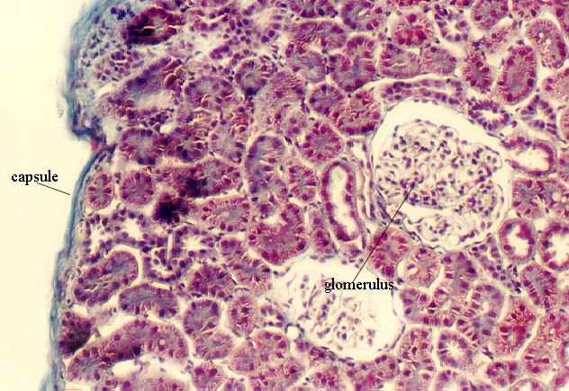1. Draw a quick sketch to show how the glomerulus and the Bowman’s capsule fit together.

2. Find a Bowman’s Capsule on your slide. Ask your neighbour over to see your slide for assessment. Get them to ‘check off’ this section of the practical by placing a tick in the box below. If your struggle Mrs. Thomas will be more than happy to come and check you are looking at the right bit!
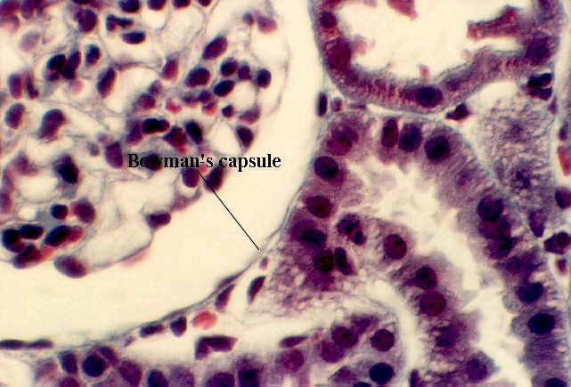
Completed
The image opposite shows a higher magnification of the glomerulus in Bowman's capsule. Note the blood capillaries in the glomerulus. The space between the two epithelia is called Bowman's space.
3. Draw small arrows on the photo above showing the route and direction of the ultra-filtrate across the filtration membrane.
4.Where does the filtrate go after it passes the filtration membrane?
___________________________________________________

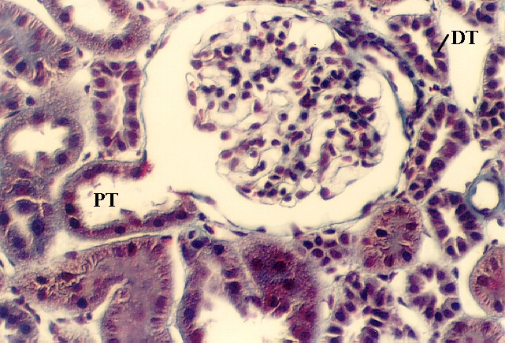
The opposite micrograph shows cells of the Proximal tubule (PT) beginning and joining with the cells of the Bowman's capsule.
5. Draw a labelled sketch diagram which shows how this Bowman's capsule is connected to the proximal tubule.

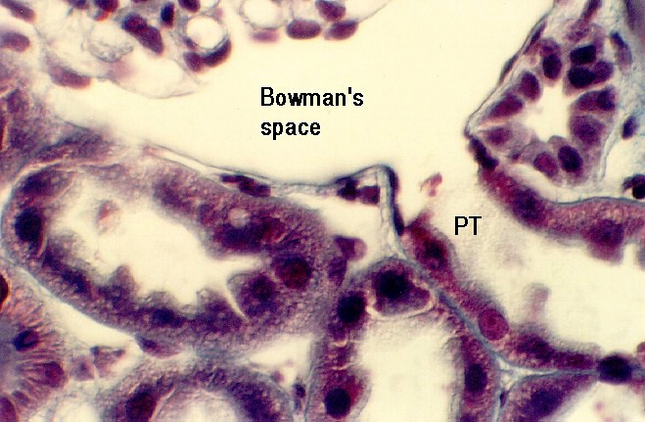
The opposite micrograph shows the transition between Bowman's Space and the Proximal Convoluted tubule.
Note that the cells show an abrupt transition from simple squamous (squashed) to simple cuboidal (cube shaped) in the proximal tubule (PT).
Note also that the connective tissue supporting the tubules are stained bright blue.

Kidney Nephron
The nephron is the basic structural unit of the kidney. It is a tubule that consists of different regions which handle the glomerular filtrate conserving valuable solutes, water and proteins. Each region is a simple epithelium that is specialised to handle its unique functions.
It begins with the PROXMAL CONVOLUTED TUBULE which is made of cuboidal epithelium. These are very long and tortuous and remain in the cortex.
The proximal tubule then changes to squamous epithelium which passes down to the medulla and then loops back up to the cortex. The thin part of the nephron is called the " DESCENDING LIMB of the LOOP OF HENLE". As it ascends to the cortex again, it thickens to form the "THICK ASCENDING LIMB" of the Loop of Henle. Then, it becomes cuboidal and forms the DISTAL CONVOLUTED TUBULE. This part of the nephron joins with the COLLECTING TUBULES which then descend to the medulla in the medullary rays.
The profiles of the cortex will show proximal and distal tubules. They are supplied by a capillary network.
In the above photograph, numerous proximal tubules are seen (PT). The cells are distinguished by an uneven apical border (because it is a brush border). Also, the base of the cells have many interdigitating processes that are filled with mitochondria (used in active uptake, which needs energy). These can be visualised in the section, shown above, as "ridges" running through the cells.
In contrast, distal tubules have no brush border (DT). They have lateral interdigitations, however. They are distinguished from proximal tubules by the fact that they have a smoother apical surface. Also, the cells are smaller. Therefore, it is likely that one will see a nucleus in every profile. In contrast, the proximal tubule cell profiles may not show as many nuclei.
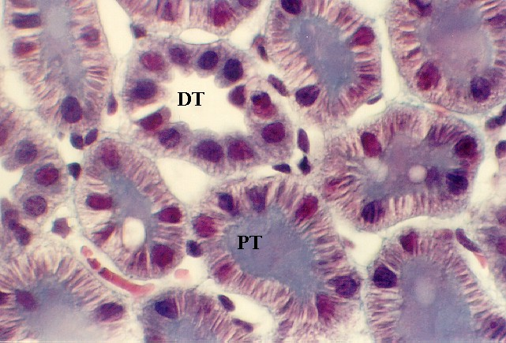
6. Find a Proximal & a Distal Tubule on your slide. Call your neighbour / teacher over to see your slide for assessment and get the box below checked off.
Completed
7. Now you are starting to get better at recognising the parts, make sure you can easily identify them on the following pictures (they are labeled but in your exam they won’t be!!!)
You should be able to identify:
- Glomerulus
- Bowman’s capsule
- A proximal convoluted tubule
- A Distal Convoluted tubule
- Collecting ducts - have cuboidal and columnar epithelium. They grow thicker as they descend into the medulla.
- Loop of Henle – has squamous (squashed) epithelium


