Cell Division Summary Notes

There are two types of cell division:
  - Mitosis occurs in body cells (somatic cells).
  - Meiosis occurs in the sex organs (testes and ovaries) and produces gametes

Uncondensed genetic material is called chromatin
Condensed genetic material is called a chromosome
Homologous chromosomes have the same size, shape and gene location – one chromosome is from the mother and one from the father
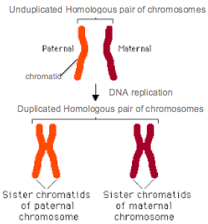

DNA Replication

Mitosis and the Cell Cycle
Mitosis has one cell division and produces two diploid daughter cells (2n) that are genetically identical to the parent cell (2n). One Cell Cycle lasts 24 hours and the cell will spend 80% in Interphase and the rest in the Mitotic phase (Mitosis (PMAT) and Cytokinesis).
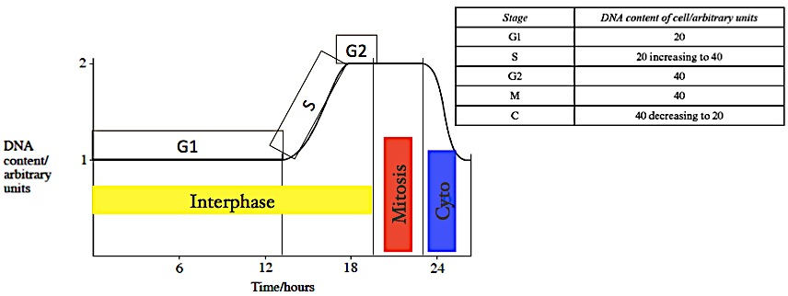
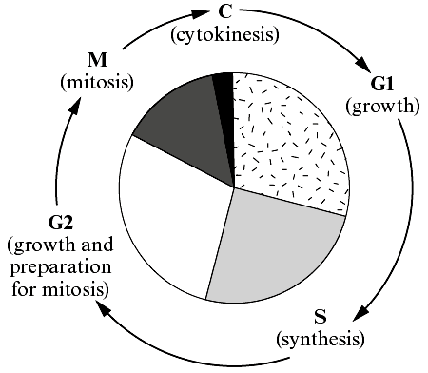

Notice: DNA content double in S phase when DNA replicates. DNA content then stays constant until Cytokinesis when the cytoplasm halves returning the DNA content to normal.

Interphase
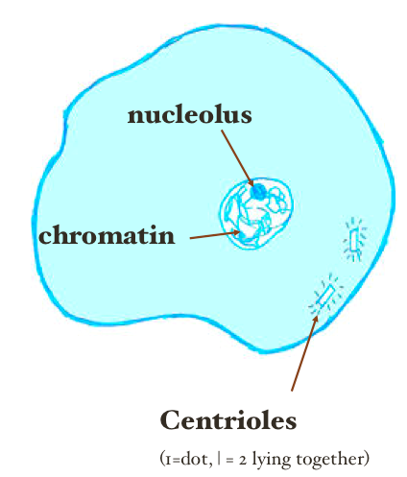
First part of the cell cycle - consists of G1, Synthesis and G2
- In G1 the cell increases in size as it is synthesising new organelles
- In S Synthesis the nuclear DNA replicates (but the chromosome number remains the same).
- In G2 the cell increases in size again and synthesises more organelles, proteins, ribosomal material and ATP
- A cell in interphase has a nucleolus, nuclear membrane and the DNA is visible as chromatin

Mitotic Phase
The second part of the Cell Cycle and has two parts – mitosis and cytokinesis

Mitosis
Takes place in 4 stages – PMAT – Prophase, Metaphase, Anaphase and Telophase

Prophase
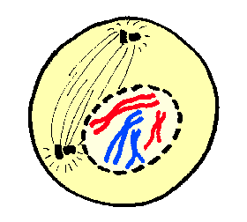
- Longest stage
- Chromatin condenses so chromosomes visible as two sister chromatids joined by a centromere
- Centrioles move to poles and form microtubule spindle
- Nuclear membrane and nucleolus disintegrate

Metaphase (Middle)
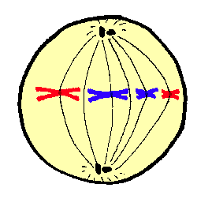
- Chromosomes line up in middle of the cell
- Attach to spindle by centromere
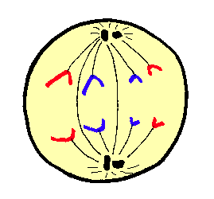
Anaphase (Apart)
- Fastest stage
- Spindle contracts splitting the centromere
- Chromatids pulled apart to opposite poles (centromere leads the way)
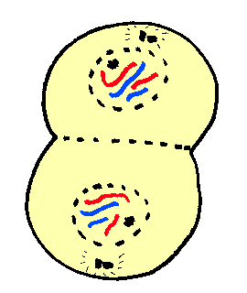

Telophase (Two)
- Chromosomes de-condense to chromatin
- Spindle breaks down
- Nucleolus and nuclear membrane reform

Cytokinesis (division of cytoplasm)
- Animals: cell membrane pinches outsidein, forming a cleavage furrow
- Plants: cell plate laid down insideout
- Two cells are now separate in their own right

The significance of Mitosis
- Important for growth, repeated cell renewal, damage repair and healing.
- Unrestricted mitosis leads to cancer and an irregular mass of cells called a tumour. Tumours prevent normal functioning of the body organs. A mutation in the cell division gene causes cancer.
- Asexual reproduction: allows numbers to increase rapidly and provides genetic stability, however this lack of genetic variation can lead to an inability to adapt if the environment changes.

Calculating the mitotic number (the percentage of cells in mitosis)

No of cells in prophase + metaphase + anaphase + telophase x100
Total no of cells

Calculating the percentage of the cell cycle spent in one stage

No of cells in desired stage x 100
Total number of cells on slide

You may be expected to use this figure to estimate how much time the cell would spend in this stage of the cycle (remember one cell cycle lasts 24 hours)

Percentage of time spent in stage x 24
100

Comparing mitosis in animal and plant cells

Plant Mitosis | Animal Mitosis
No centriole but spindle forms | Centrioles involved in spindle formation
Cell plate formed from inside outwards by the fusion of Golgi body vesicles | Cleavage furrow formed from the cell membrane pinching outside inwards
Only occurs in meristems in root and shoot tips | All cells except red blood cells (as they have no nucleus)

Meiosis

Meiosis occurs during gamete formation in sexually reproducing organisms. It takes place in the reproductive organs - ovaries and testes - of both plant and animals.
During Meiosis the diploid number of chromosomes (2n) is reduced to the haploid (n) and the resulting gametes are genetically different.

Meiosis has two divisions but only one Interphase.

- You are not expected to describe the complete process of Meiosis but you are expected to describe the significance of differences between mitosis and meiosis

Interphase
Occurs before meiosis I and is the same as interphase of mitosis – DNA replication, synthesis of organelles, ribosome subunits, ATP and cell increases in size.

Meiosis I – the reduction division (2nn)
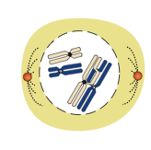
Prophase I
- chromatin condenses
- centrioles move to poles and spindle develops
- nucleolus and nuclear envelope disintegrate
- maternal and paternal chromosomes associate as homologous pairs (also called homologs or bivalents)
- Crossing over and recombination occur at chiasmata
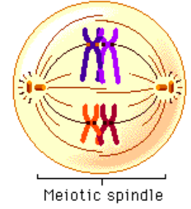

Metaphase I
- Bivalents are randomly distributed at the equator

Anaphase I
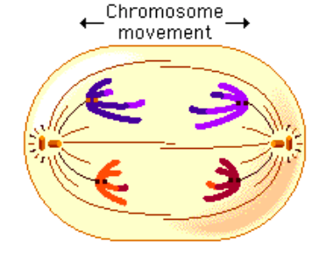
- Spindle fibres contract pulling chromosomes to poles, centromere remains intact
- Chromosomes are randomly, independently assorted at the poles producing new genetic combinations

Telophase I
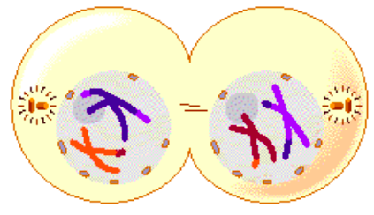
  - When the chromosomes reach the opposite pole, the cell starts to divide across its middle.
  - Nuclear envelope and nucleolus reform around each group of haploid chromosomes
  - Spindle breaks down.
  - Cytokinesis occurs.
  - Meiosis II follows on immediately.

Meiosis II – the mitotic division

The second division of meiosis is called a ‘mitotic’ division, because it is similar to mitosis BUT there is no DNA replication - no interphase.
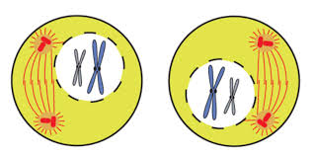
Prophase II
- centrioles move to poles and new spindle develops at right angles to the old spindle
- chromatin condenses
- nucleolus and nuclear envelope disintegrate
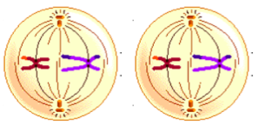

Metaphase II
- Single chromosomes line up at equator and attach to spindle by the centromere
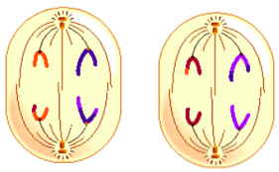

Anaphase II
- Spindle fibres contract pulling chromatids to poles, centromere splits
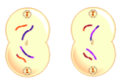

Telophase II
  - At the poles chromatids de-condense
  - Nuclear envelope and nucleolus reform
  - Spindle breaks down
  - Cytokinesis occurs producing 4 haploid daughter cells.

Meiosis promotes genetic variation in 3 ways:
- During sexual reproduction the genotype of one parent is mixed with that of the other when haploid gametes fuse.
- Crossing over and recombination of homologous chromosomes during prophase I.
- Independent/random assortment: When homologous chromosomes separate in anaphase I they do so entirely independently of each other, so that the resulting daughter cells contain different combinations of chromosomes.

Comparing mitosis and meiosis

Feature | Mitosis | Meiosis
Number of divisions and resulting daughter cells | One division resulting in 2 daughter cells | Two divisions resulting in 4 daughter cells
Ploidy of cells | Parent cell – diploid 2n  Daughter cells – diploid 2n | Parent cell – diploid 2n  Daughter cells – haploid n
Genetic nature of daughter cells | Genetically identical (genetic stability) | Not genetically identical (genetic variation)
Pairing of homologous chromosomes | No | Yes
Crossing over and recombination | No | Yes in Prophase I
Random distribution of homologous chromosomes on equator | No | Yes in Metaphase I
Segregation of homologous chromosomes | No | Yes in Anaphase I

