

**Practice questions**

**Key points to remember:**

* Highlight what is asked for in question;
* Comment on what is said and explain how the quote/ language works/ answer the question is the most important element of this response.
* Systematically work through – evidence /effect
* Integrate technique reference into answer… the choice of emotive language here…’quote’….. Persuades…..
* Consider **title/ tone/ language choices/ images/ presentational devices and structure** in the text and respond to these ideas in your answer. (consider the whole text)
* **Time and marks:**

**\* 5 marks = 7-8 minutes reading and answering the question;**

**\* 10 marks = 15 minutes reading and answering the question;**

* Use terms such as: ‘the writer/ author’ and ‘the reader’

Q: How does the Dog Rescue Federation try to persuade support them? (10 marks)



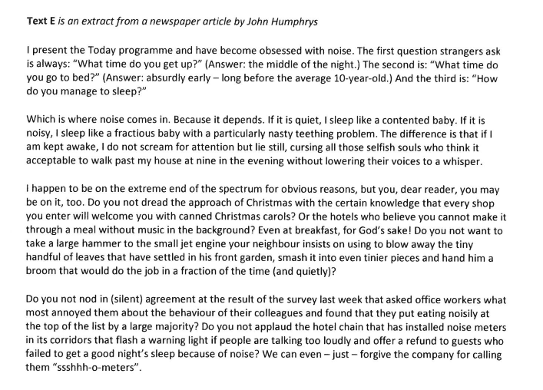

Q: How does John Humphrys persuade the reader he hates noise? (10 marks)

Q: How does Gerardo Arias Camacho convince the reader of the benefits of Fairtrade? (10 marks)

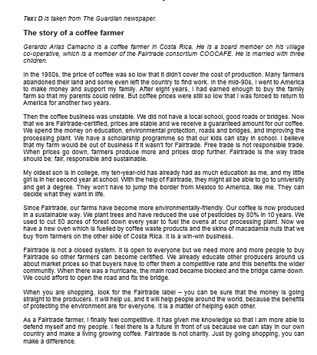

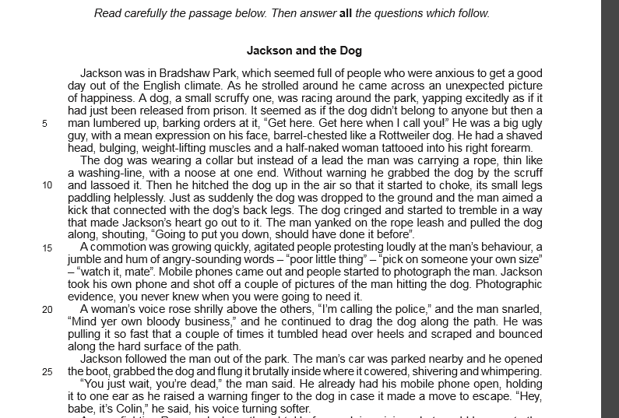

Q: How does the writer try to show the nastiness and cruelty of the dog owner? (10 marks)

Q: How does Angela Epstein try to show that ‘life is not easy for a working mother’? (10 marks)

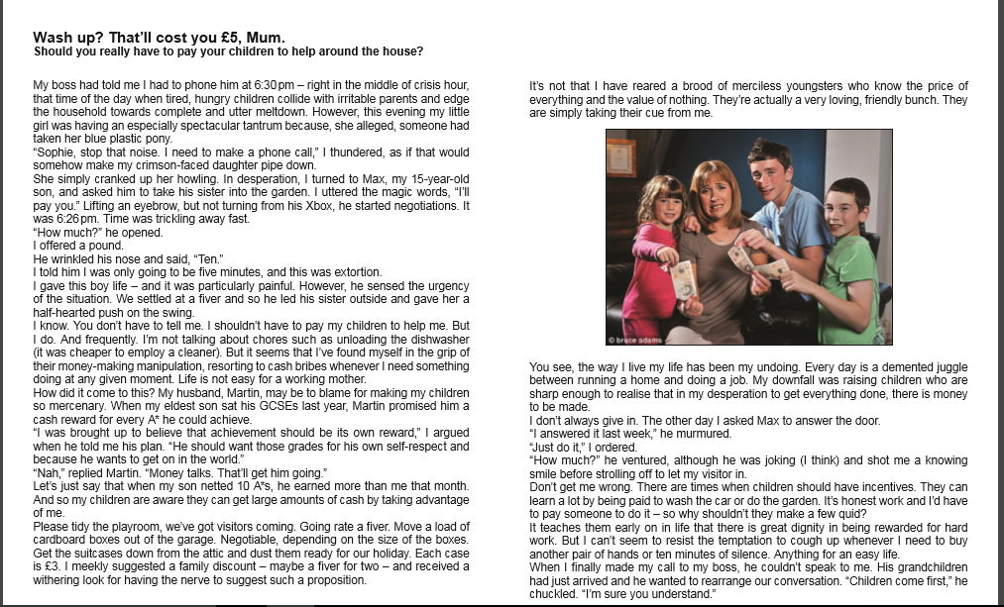



Q: How does the writer try to show that Agbo is “not a good place to live”? (10 marks)

Q: How does the writer make these lines interesting and dramatic? [10 marks]

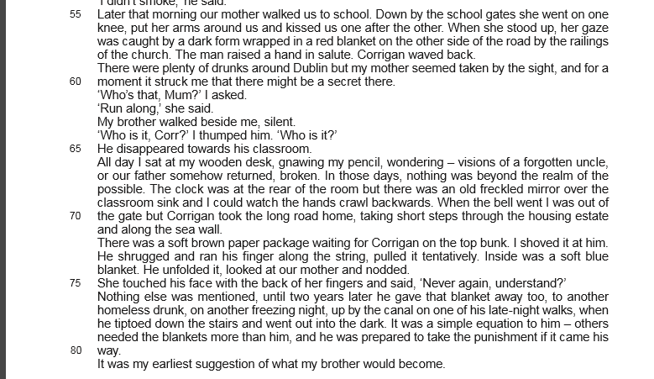

Q: How does the writer, Emma Cowing, show the dangers and problems faced by Fogle and Cracknell during the race? [10 marks]

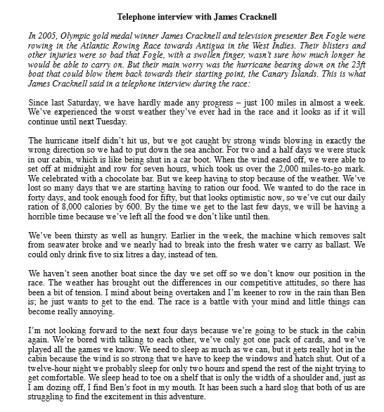

Q: How does Professor Stephen Harris try to prove that the urban fox has found ‘a place in our hearts’? [10 marks]

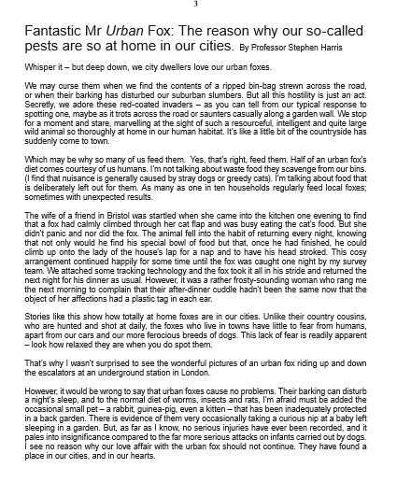

Q: How does Max Davidson try to prove that Manchester is ‘a perfect place for a city break’? [10 marks]



Q: How does Deborah Moggach try to prove that ‘anyone with any sense’ cycles in London? [10 marks]

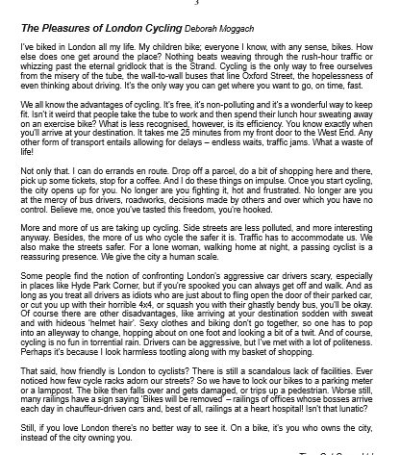

Q: How does the writer show the suffering of the deer? [10 marks]

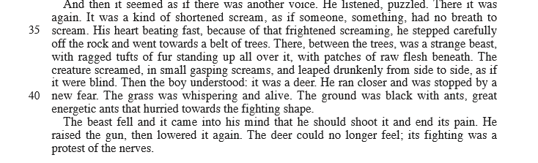

Q: How does the writer show that Mike is frightened in these lines? [10 marks]

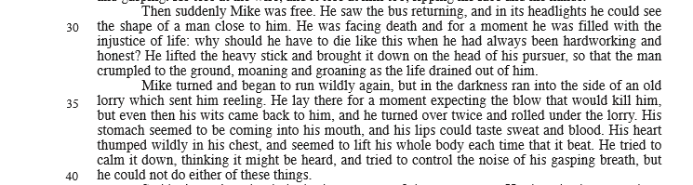

Q: How does the writer show that the policemen’s behaviour is unpleasant and threatening? [10 marks]

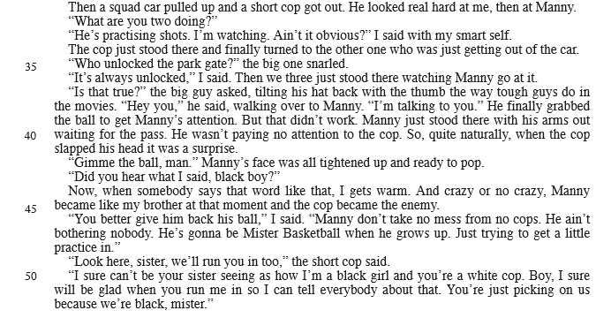

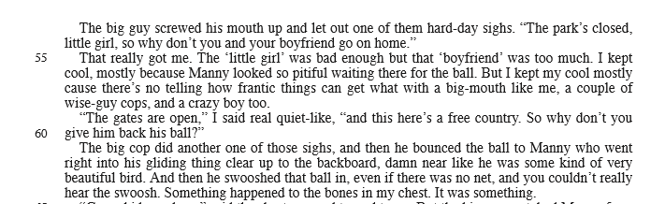

Q: How does the writer of this article try to convince you that seagulls have become a serious problem?

[10 marks]

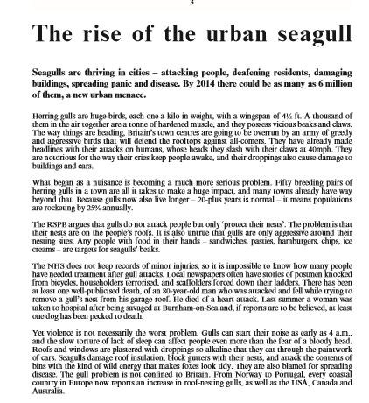

Q: How does Ben Fogle show the problems he had coping with the extreme conditions of the expedition? [10 marks]

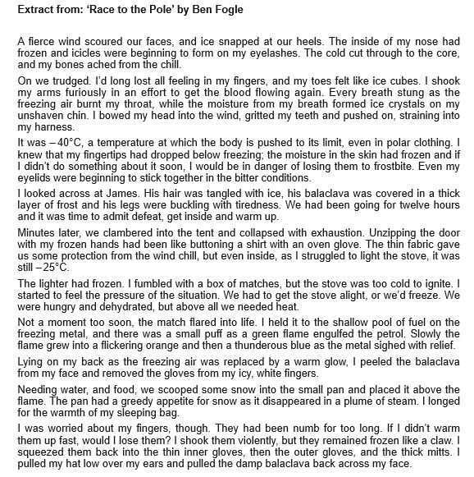

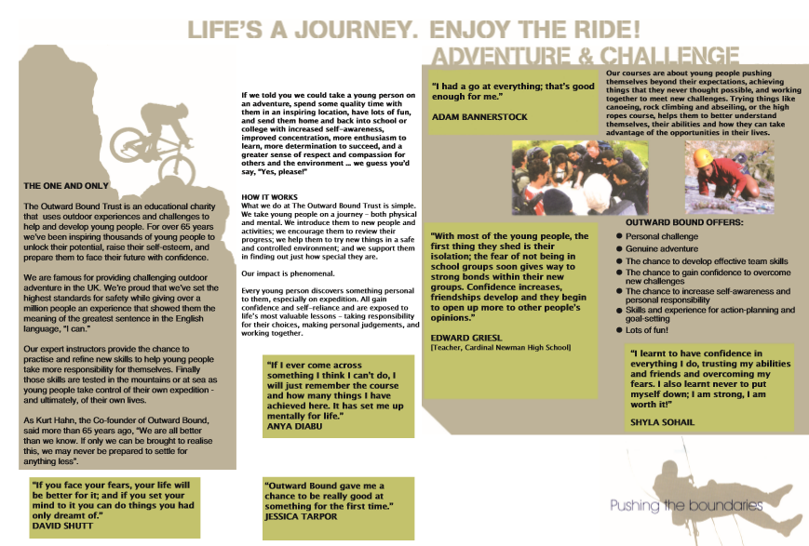

Q: How does Outward Bound try to persuade readers that their courses will help to develop important skills and abilities in young people? [10 marks]

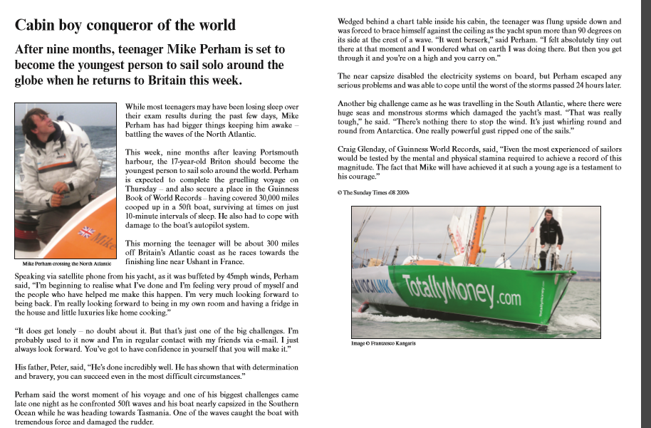

Q: How does the writer try to show that Mike Perham’s voyage was really tough? [10 marks]

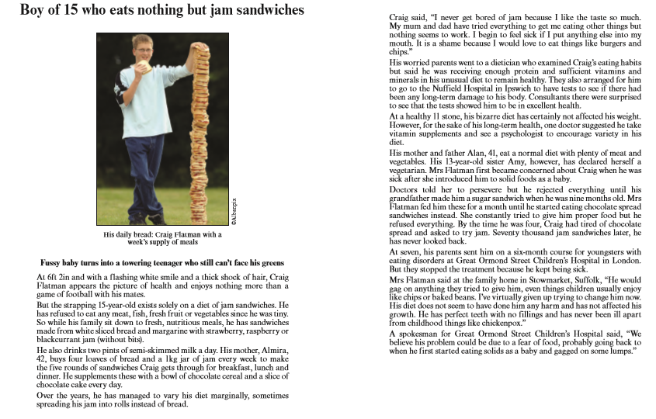

QHow has the writer tried to make this newspaper article interesting? [10 marks]

Q: How does the writer try to persuade the reader to support the charity? [10 marks]



Q: How does Liz Jones try to show that the village and mine at Santa Filomena are examples of the benefits of Fairtrade? [10 marks]



Q: How does the writer try to make the story of Jessica Stilwell’s strike interesting?? [10 marks]



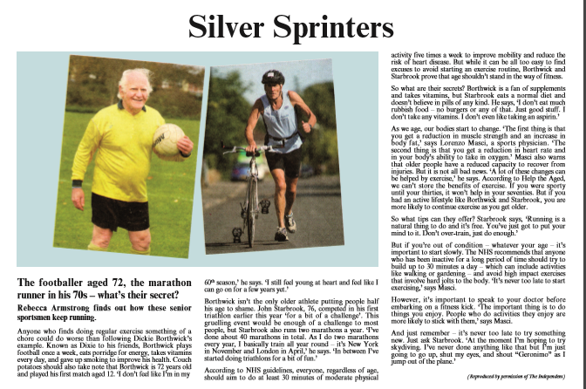

Q: How does Rebecca Armstrong’s article try to persuade people to take up, and continue with, exercise? [10 marks]