Completed version

AO4
Know how food can cause ill health
LEVEL 1 / 2 AWARD IN
HOSPITALITY AND CATERING unit 1

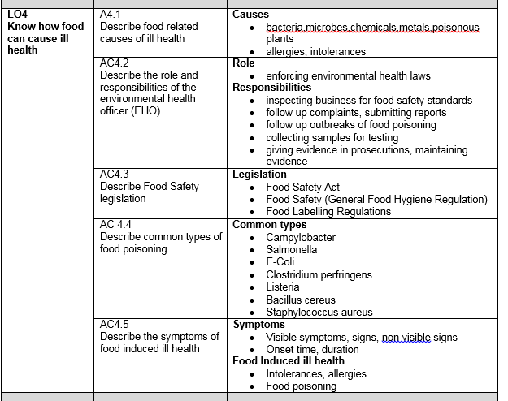

AC 4.1 Food related causes of ill health

Sources of food poisoning bacteria
- People/sewage
- Raw food
- Insects
- Rodents
- Soil/dust
- Refuse/waste
- Animals/birds
- Contaminated packaging
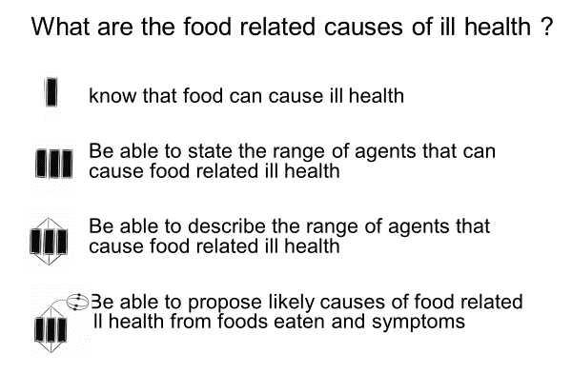

Temp | Effect on bacteria
100 | Spores are destroyed boiling point of water
75 | Bacteria are killed by 75C or higher
63 | Hot holding temperature, bacteria start to die
37 | Human body temp. rapid growth of bacteria
5 | Start to multiply at 5C
0 | Slow or no growth of bacteria
-18 | Dormant, no growth of any bacteria

List the symptoms of food poisoning below
Mouth increase in saliva
Head headache
Skin fever, shivering
Gut abdominal pain, nausea vomiting, diarrhoea
Circulation, low blood pressure, weak pulse, fatigue

Non bacterial causes of food related ill health

 | Chemicals in food that cause illness
Hormones | Oestrogens could have effects on reproductive system (male and female) possibly cancers Banned except USA
pesticides | crops in EU tested for residues. could cause nerve damage, , dermatitis, cancers. dizziness, headaches, nausea and vomiting
fertilizers | all toxic to humans in higher amounts, pollution of water table, effects on other organisms eg fish
Packaging | chemicals can migrate from the packaging into the food if they are stored badly affect the endocrine system which produces hormones in the body such as reproductive hormones and insulin
Additives | Not all are harmful such as cancers and nerve damage allergies and hyperactivity in children
Cleaning chemicals | chemicals which may stay on the food afterwards , vomiting, diarrhoea headaches

 | Metals in food that cause illness
Naturally occurring | Iron, zinc, sodium Some needed as minerals but others such as lead and mercury can build up in the brain and cause damage
Residues | From farming, industry or car exhausts . brain damage, nerve damage and problems with digestion
Food chain metals | Low concentration at the bottome of the food chain get more concentrated up and toxic to the end consumer pb, hg
 | Poisonous plants
Naturally occuring | Solanine in potatoes, rhubarb leaves, kidney beans. All contain toxins and have to be processed before eating. Vomiting, diarrhoea, possibly death
Contamination | Eg poisonous weeds in plant crops or aflatoxin growing on peanuts in storage

Where am I now?

Allergies and intolerances to food

Intolerance |  | Lactose (dairy products) | Coeliac (gluten products) | Yeast
Symptoms |  | Nausea, bloating , abdominal pain | Diarrhoea, anaemia, weight loss | Flatulence fatigue, irritability, cravings for sugary foods
Found in which ingredients |  | Milk and milk products, cheese, cream, yoghurt, | Cereals, wheat rye barley, some oats | Brewed and fermented foods
Foods to avoid |  | Any dairy products | Pasta, bread, cereals, flour based products | Ripe fruit, vinegar, beer, bread
Alternatives you can use | Goats milk, soya, rice milk, plant milks |  | Gluten free flours eg rice flour | Alcohol free beer, baking powder as a raising agent

A food allergy is a particular type of food intolerance that involves the body’s immune system. Food intolerances may cause uncomfortable symptoms, but only true allergies involve the immune system
- Symptoms of allergies include
- • coughing;
- • dry, itchy throat and tongue;
- • nausea and feeling bloated;
- • wheezing and shortness of breath;
- • swelling of the lips and throat;
- • runny or blocked nose;
- • sore, red and itchy eyes.
- ANAPHYLAXIS is a severe allergic reaction where the person may have tingling lips and tongue, swelling in the throat and difficulty breathing….people die from this.
- Most common foods causing anaphylaxis are……………………..
………………., ……………………., ……………….
The most common allergens in food are
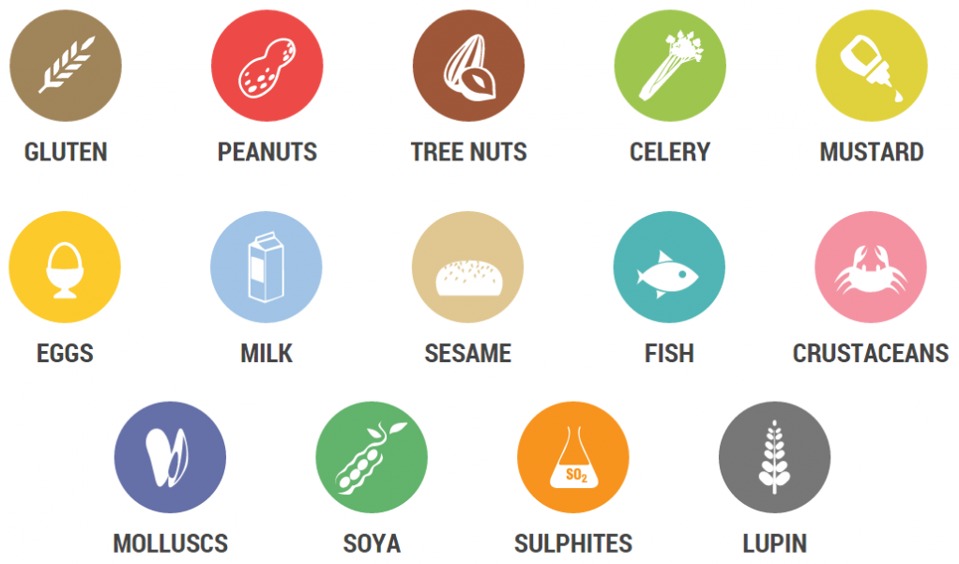

What are the allergenic ingredients in the following?
Special fried rice | Crustacea, soya, wheat, eggs, molluscs, sesame
Chicken korma | Milk, sesame, mustard, almonds, cooking oil- nuts, soya
Lasagne | Milk, sulphites, wheat, stock cubes- mustard and celery
Paella | Crustacea, soya, cooking oil molluscs, sulphites, stock cubes
Pizza | Milk, sulphites, wheat, yeast fish (anchovy|)

Why do food establishments need to provide allergy information on their menus?
…………………………………………………………………………………………………
…………………………………………………………………………………………………
…………………………………………………………………………………………………

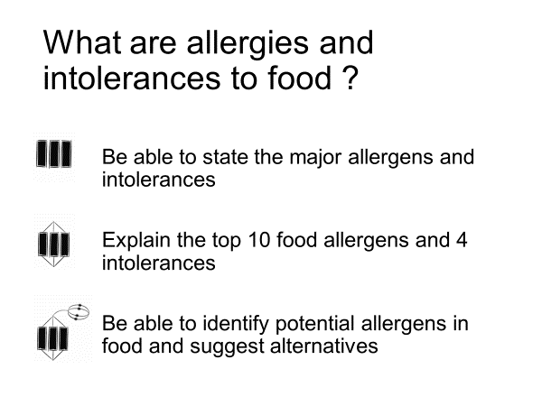

Where am I now?

AC 4.2 Environmental Health Officer- roles and responsibilities

Responsibilities of Environmental Health Officers
- food safety
- Infectious diseases
- environmental protection
- noise, radiation & pollution control
- water standards
- health and safety at work
- animal welfare
- waste management
- housing standards

Role of EHOs in the Hospitality and Catering industry.
Legislation enforced by EHOs
The Food Safety Act.
Food safety from the manufacturer or producer to the point of sale. Might involve different companies or premises e.g. suppliers, manufacturers or kitchens, shops or restaurants.

The Food Safety Act (General Food Hygiene) Regulations.
Ensures food producers HANDLE all food hygienically.

The Food Safety Act (Temperature Control) Regulations.
Temperatures at which to store or hold food.
- Freezers from –18°C to –24°C
- Chillers from 3°C to 8°C
- Fridges from 1°C to 5°C
- Cooked core temperature at 75°C or above
- Hot holding above 63°C

The Food Composition Regulations.
Specifies what ingredients CAN or CANNOT be used in the manufacture of foods e.g. bread, breakfast cereals and use of additives

3 main areas inspected by EHOs

EHOs have the following powers:

Powers of entry at any reasonable time
Inspect food and premises
Power to seize and detain food
Serve notices
Power to close
Prosecute

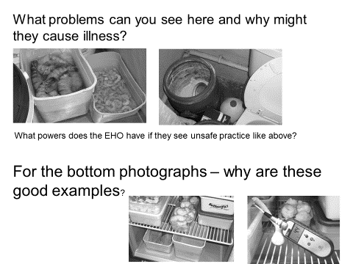
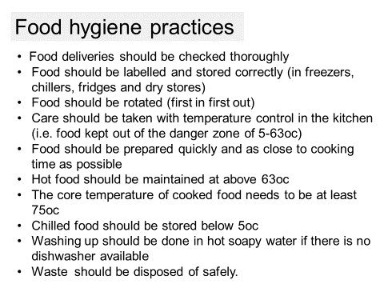
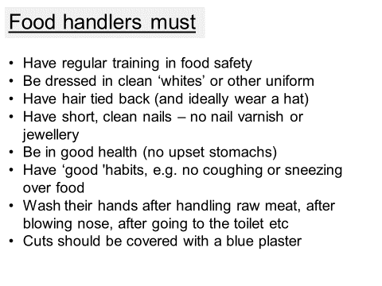
Answers to questions on slide Accumulation of dirt under tables etc, harbours germs and encourages mice and maggots
Dirt and bird poo on the windows contain bacterisa. Scummy areas round the taps bacteria can get onto hands
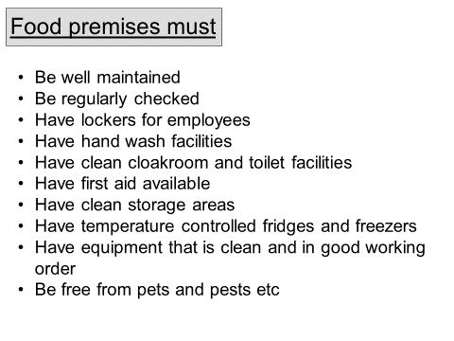

Explain how an EHO would investigate an outbreak of food poisoning (6 marks)
- The EHO coordinates with doctors, hospitals, victims and food suppliers to trace and identify sources of food poisoning outbreaks (and single cases)
- They take samples of food, faecal samples, swabs of kitchens and production areas and these are analysed by the Public Health laboratory service to identify the species and likely causes
- EHOs publish a report on the outbreak that gives the timeline and how the outbreak could have happened – publicly available

What are the consequences of poor inspection results?
- Can close dirty premises at no notice
- Notice to improve and re inspection
- Can impose fines of £20,000 or six months imprisonment
- Can take legal action for manslaughter
All premises must be registered with the local authority and can be inspected at any time by an EHO.
A Hygiene Improvement Notice is used to require food businesses to improve something sub-standard

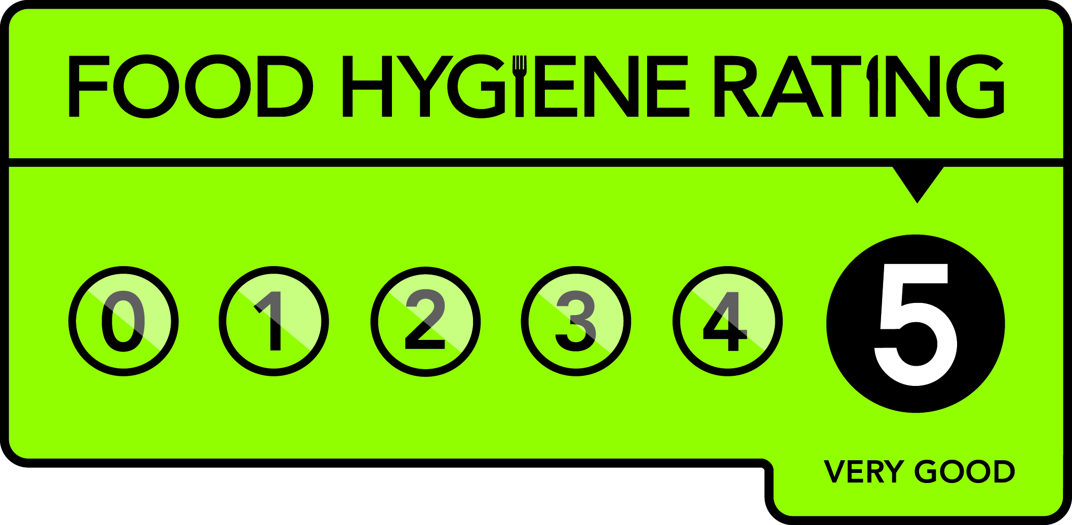
Explain the use of the Food Hygiene rating scheme
- EHOs issue a rating between 0 and 5 when conducting inspections
- Issued to restaurants, pubs, cafes, mobile catering etc
- Displaying them isn’t a requirement yet

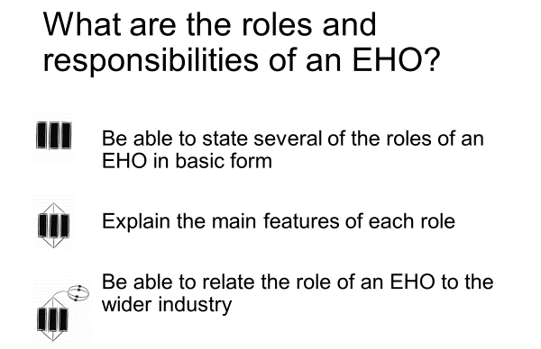
Where am I now?

At the start of this section I am at…
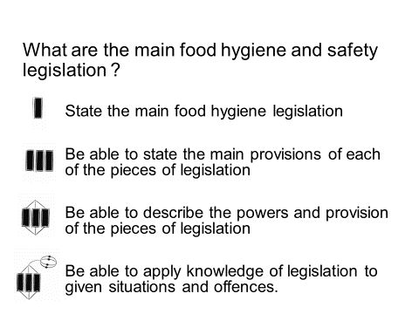

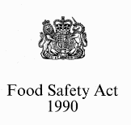
The Food safety Act 1990

- Food businesses must: Must ensure that the food served or sold is of the nature, substance or quality which consumers would expect, e.g. :
    - Nature - pollock rather than cod;
    - Substance - contains foreign material including glass or packaging;
    - Quality – mouldy bread or stale cake.
- Ensure that the food is labelled, advertised and presented in a way that is not false or misleading, e.g. photos on menus that do not look like the dishes served to customers.

- Main provisions of the Food Safety Act 1990
- It is an offence to supply food that fails to comply with food safety requirements
- Strengthened powers of enforcement including detention and seizure of food
- It requires training in basic food hygiene for all food handlers
- All food premises must be registered
- Authorises EHOs to issue improvement notices if there is a potential risk
- EHOs can issue emergency prohibition notices to force caterers to stop their business immediately
.
What does the defence of Due Dilligence mean?
- The principal of defence under The Food Safety Act 1990
- A business must be able to demonstrate that it has done everything within its power to safeguard consumer health

What would the caterer have to provide to prove they were exercising due diligence
- Temperature control records delivery/storage/cooking
- Microbiological records
- Hygiene training for staff
- Use of HACCP system
- Pest control records
- Hygiene manuals, cleaning schedules
- Hygiene policy

 | Magistrates court | Crown court
Selling food that does not comply with the Food Safety Act | 6 months in prison or max £20,000 fine | 2 years in prison  Unlimited £ fine
Obstructing an Environmental health Officer | 3 months in prison or max £2,000 fine | 2 years in prison or £ unlimited fine
Other serious offences | 6 months in prison or max £20,000 fine | 2 years in prison or £ unlimited fine

Food Safety (General food hygiene) regulations 1995

- Main provisions of the Food Safety regulations 1995 make sure food is supplied or sold in a hygienic way;
- identify food safety hazards;
- know which steps in your activities are critical for food safety;
- ensure safety controls are in place, maintained and reviewed.
……………………………………………………………………………………………………..

Food premises
- be clean and in good condition, made from easy to clean materials
- have potable (drinking) water;
- have pest control measures
- have adequate lighting and ventilation ;
- clean lavatories which do not lead directly into food rooms;
- have adequate hand washing facilities and drainage
- facilities for washing food and equipment;
- facilities for the storage and removal of food waste.

Food Handler requirements

- Keep yourself clean
- Keep your workplace clean
- Protect food from contamination or anything that could cause harm
- Follow good personal hygiene practices
- Wear appropriate protective clothing
- Sell food with an expired date mark
- Work with food if they have symptoms of food poisoning or had diarrhoea and sickness in the last 48 hours.

Food safety training

- . Food handlers must receive adequate supervision, instruction and/or training in food hygiene. Each food business must decide what training is needed
- Legal requirement
- Appropriate to tasks undertaken
- Recorded
- Refreshed at given intervals eg yearly

HACCP
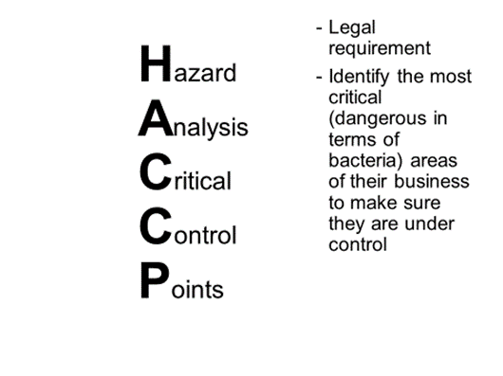

Food companies need to:
Analyse the hazards to food safety
Assess the level of risk from each hazard
Decide the most critical points that require controls
Implement appropriate controls
Establish a monitoring system
Set up procedures to correct problems (corrective action)
Review the system when operations change

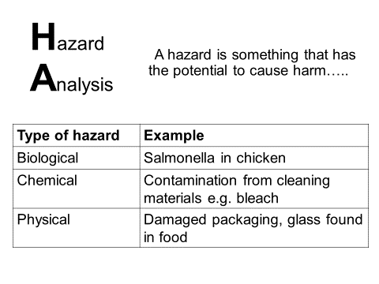
Setting up HACCP system

Legal requirement that certain records are kept as part of the HACCP-based food safety management system, eg:
- Fridge/freezer records
- Cooking/hot-holding temperatures
- Cleaning records
- Training records
- Pest control checks
Using HACCP
Fill in the chart, stating what the hazards/ dangers might be at every stage and what action you would take to ensure your customers do not suffer from food poisoning

Stage | Hazard | Action
Buying
Delivery
Storage
Preparation
Cooking
Chilling
High risk foods
Cold foods- store below 5 C
Hot foods – store above 63C
Cold foods max of 4hrs at room temperature then discard or refrigerate
Hot food max of 2hrs at room temperature
Buffet food max of 90 mins at room temperature

 | Information that must appear on food labels
Name of the food | It is important that the name of the food must be clearly stated and not be ambiguous or misleading with a description if needed.
Weight or volume | The weight or volume of the food must be shown on the label. By comparing the weight with the price, consumers can make sure that they are getting value for money.  Some foods such as bread, tea and butter are only sold in standard amounts
Ingredient list | Ingredients are listed in order of weight, according to the amounts that were used to make the food, starting with the largest ingredient and ending with the smallest.
Allergen information
Genetically modified ingredients | The presence of genetically modified organisms (GMOs) or ingredients produced from GMOs must be indicated on the label
Date mark and storage condition s
Preparation instruction
Name and address of manufacturer
Place of origin
Lot or batch mark
Nutrition information
The Food labelling regulations 2006

At the end of this section I am at

Campylobacter jejuni
Foods it is found in
Symptoms
Onset
Duration
Effects on body
Special points
Salmonella
Foods it is found in
Symptoms
Onset
Duration
Effects on body
Special points
Escherichia coli 0157
Foods it is found in
Symptoms
Onset
Duration
Effects on body
Special points

Clostridium perfringens
Foods it is found in
Symptoms
Onset
Duration
Effects on body
Special points
Listeria monocytogenes
Foods it is found in
Symptoms
Onset
Duration
Effects on body
Special points
Bacillus cereus
Foods it is found in
Symptoms
Onset
Duration
Effects on body
Special points
Staphylococcus aureus
Foods it is found in
Symptoms
Onset
Duration
Effects on body
Special points

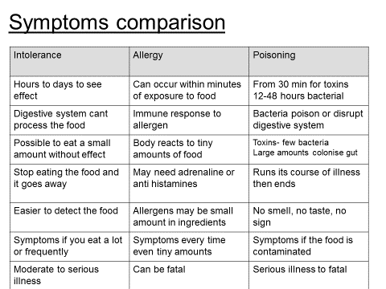

Food intolerance symptoms ………………………………………………………………………………………………………………………………………………………………………………………………………………………………………………………………………………………………………………………………………………………………………………………………………………………………………………………………………………………………………………………………………………………………………………………………………………………………………………………………………………………………………………………………………………………………………

Food allergy symptoms ………………………………………………………………………………………………………………………………………………………………………………………………………………………………………………………………………………………………………………………………………………………………………………………………………………………………………………………………………………………………………………………………………………………………………………………………………………………………………………………………………………………………………………………………………………………………………

Food poisoning symptoms ………………………………………………………………………………………………………………………………………………………………………………………………………………………………………………………………………………………………………………………………………………………………………………………………………………………………………………………………………………………………………………………………………………………………………………………………………………………………………………………………………………………………………………………………………………………………………

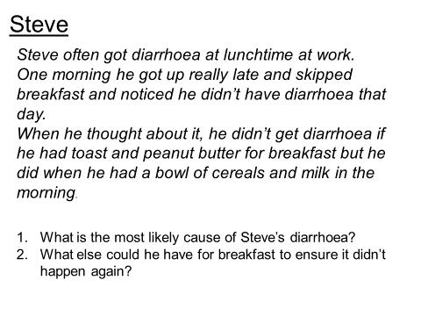
..................................................................................................................................................................................................................................................................................................................................................................

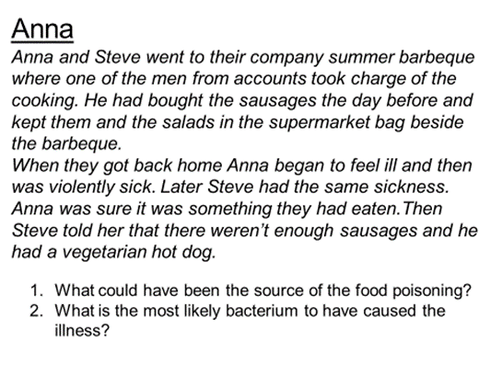
..................................................................................................................................................................................................................................................................................................................................................................

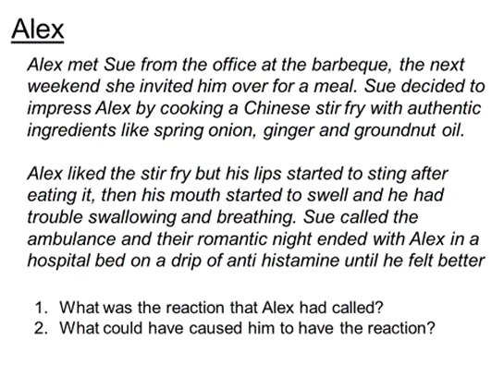
..................................................................................................................................................................................................................................................................................................................................................................

..................................................................................................................................................................................................................................................................................................................................................................

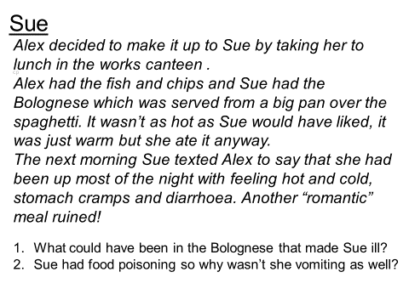

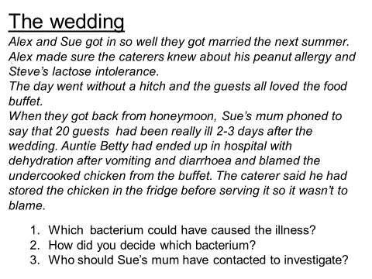
..................................................................................................................................................................................................................................................................................................................................................................

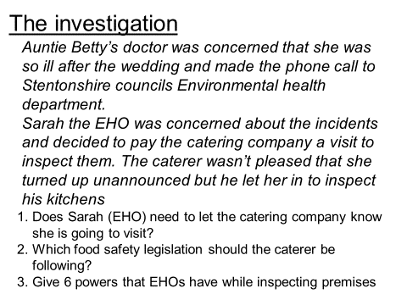
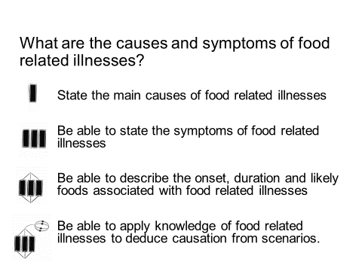
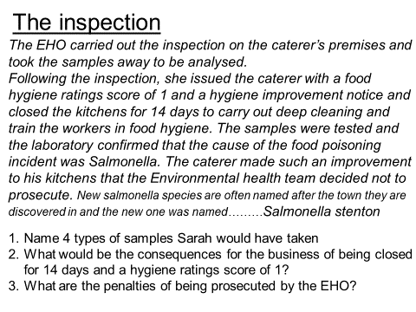
Where am I now?
..................................................................................................................................................................................................................................................................................................................................................................
..................................................................................................................................................................................................................................................................................................................................................................

