AC 4.1 **Food related causes of ill health**

Some bacteria have to be **INSIDE** your body to make you ill. These are consumed in the food

Once inside you, the bacteria attack your body causing illness, some such as Salmonella cling to the gut wall preventing absorbtion of water and nutrients- this type take hours even days to colonise the gut so symptoms may not show for a few days

Some produce a **TOXIN** (poison) on the food which makes you ill when you eat it. Toxins act on the body rapidly so this type make you ill within minutes to hours of eating them

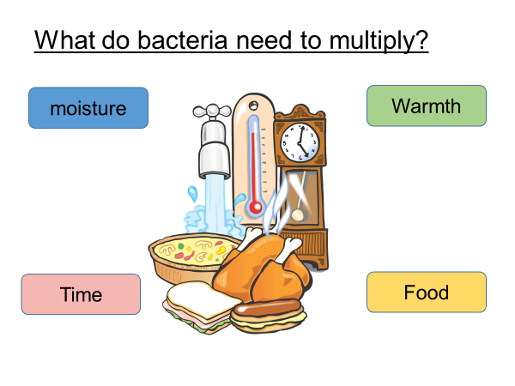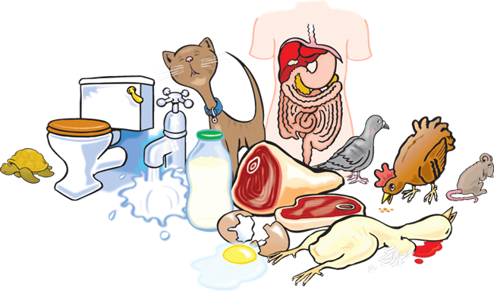

* People/sewage
* Raw food
* Insects
* Rodents
* Soil/dust
* Refuse/waste
* Animals/birds
* Contaminated packaging.

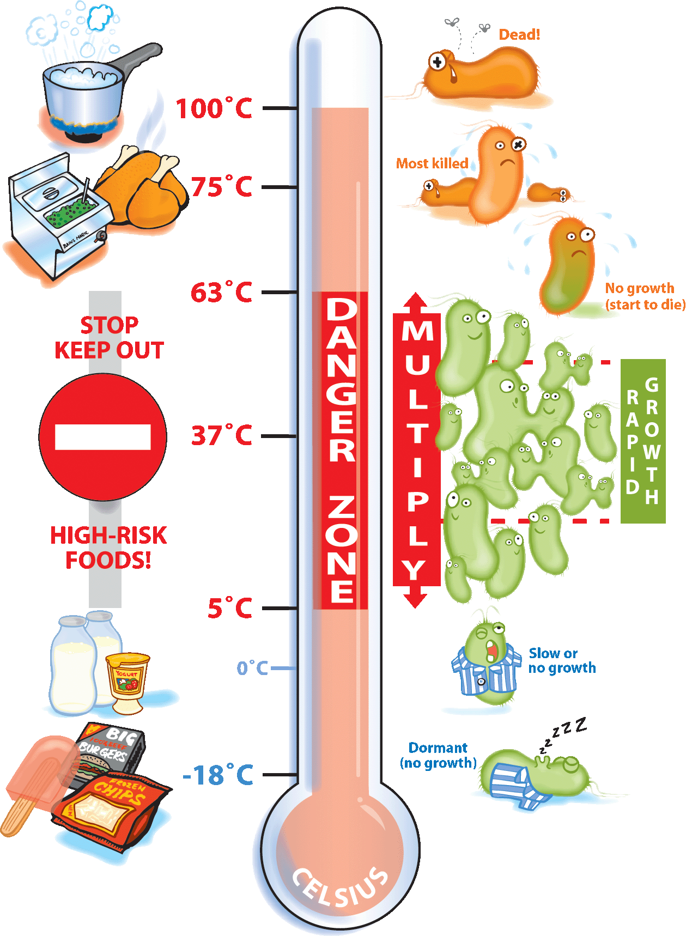

Dead!.

Too hot (start to die 63°C)

Multiply rapidly

most pathogens no growth (<5°C)

Dormant (no growth – spoilage or pathogens).

Destroys most pathogens

Hormones

Animals can be injected with growth hormones and antibiotics to give larger muscle development and higher milk production Oestrogens could have effects on reproductive system (male and female) possibly cancers.

BANNED- except for the USA

Pesticides

Crops are sprayed with herbicides and pesticides to prevent being eaten by insects.

All crops in EU tested for pesticide residues. Higher levels of exposure could cause nerve damage, damage to foetus, dermatitis, possibly cancers. dizziness, headaches, nausea and vomiting in people who are sensitive. NONE IN ORGANIC

packaging

Fertilizer

Plants are fertilized to keep the soil fertile and to give a higher yield of crops for the farmer. NOT IN ORGANIC FERTILIZERS

Nitrates, phosphates and potassium are all toxic to humans in higher amounts, pollution of water table, effects on other organisms eg fish that could then be eaten by humans

During storage, chemicals can migrate from the such as reproductive hormones and insulinpackaging into the food if they are stored badly

Under some conditions chemicals such as BPA and Phthlates can leech into foods from packaging. They can affect the endocrine system which produces hormones in the body

Additives

Additives in food can be chemical or natural. Give food characteristics like long shelf life or colour or flavour. Used to stop crystallization of sugars, to soften foods etc

Not all food additives are harmful chemicals but some are. Long term effects such as cancers and nerve damage Short term effects like allergies and hyperactivity in children

cleaning

Foods and equipment are cleaned with chemicals which may stay on the food afterwards. some industrial cleaning chemicals are harsh on machines

Poisoning like symptoms, vomiting, diarrhoea headaches. Could build up with long term exposure such as jobs like cleaners

Some microorganisms cause food borne illness which is not classified as food poisoning because of other symptoms they cause

Norovirus

From leafy greens such as lettuce, fresh fruits and foods that are not washed before eating

Causes Diarrhoea, vomiting, fever, body aches, headaches

Toxoplasmosis

From infected meat (also cat poo but you wouldn’t eat that)

Causes fever, muscle pain, sore throat, tiredness

Long term the Toxoplasma parasite can invade the eyes causing blindess . Damages unborn baby

Metals such as iron, zinc, sodium are naturally present in foods and we need them as minerals for good health. Others such as Arsenic, cadmium, lead and mercury are naturally in the environment and get into food Toxic metals such as Arsenic and cadmium could build up in the body Lead and Mercury cause brain damage

Small amounts of mineral metals are needed for GOOD health.

Human activities such as farming, industry or car exhausts could cause metals to remain in the environment and get into food. Long term effects from build up of residues such as brain damage, nerve damage and problems with digestion and body functions

Naturally occurring

Food chain

Residues

Metals in low concentrations at the bottom of the food chain are concentrated as they go up the chain and can be toxic to the end consumer Concentrated lead and mercury can cause brain damage and damage to unborn babies. Can cause nerve damage and muscle problems

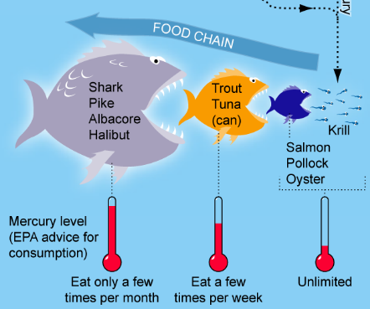

Some plants we eat are naturally poisonous and have to be treated or have the poisonous part removed before we eat them.

Rhubarb leaves

Solanine on potatoes

Kidney beans

Can cause vomiting, diarrhoea and possibly toxic to humans causing death (but not likely)

Poisonous plants such as some weeds could get into food when being harvested or when eaten by animals

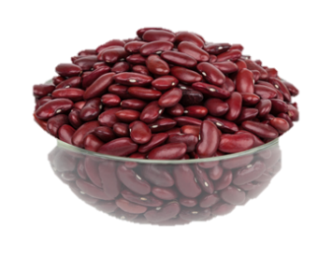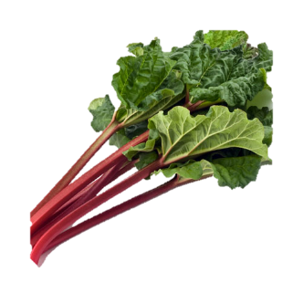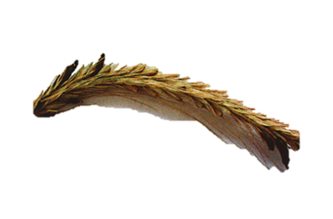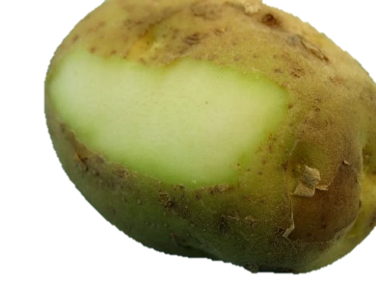

AC 4.1 **Allergies and intolerances**

* Food intolerances are more common than food allergies. The symptoms of food intolerance tend to come on more slowly, often many hours after eating the problem food. Typical symptoms include bloating and stomach cramps.
* A food allergy  is a rapid and potentially serious response to a food by your immune system. It can trigger classic allergy symptoms such as a rash, wheezing and itching.
* Genuine food allergy is rare. About 2% of the population and 8% of children under the age of three are affected. (www.nhs.uk)

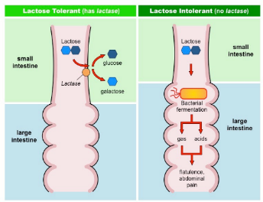

* some people react to certain foods and eating them may cause uncomfortable symptoms or, in rare cases, a severe illness.
* Food intolerance is more common in children than in adults. Children often grow out of the intolerance before they go to school.

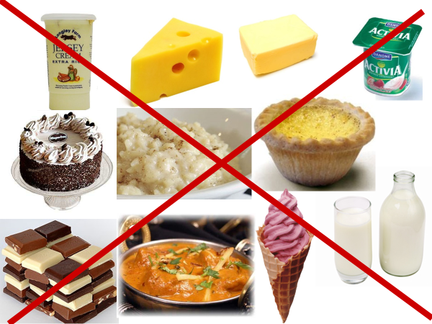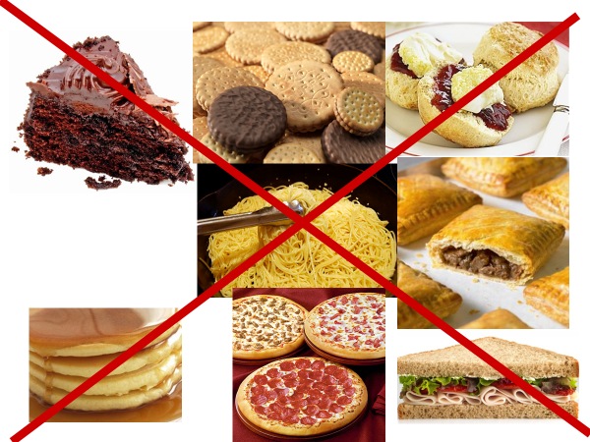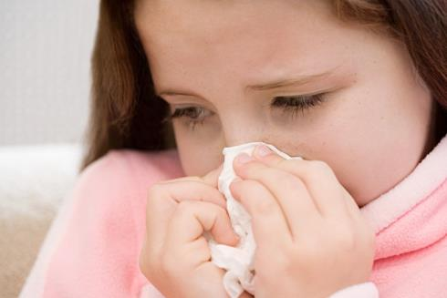

* *Feeling lightheaded or faint.*
* *fast, shallow breathing,wheezing*
* *a fast heartbeat*
* *clammy skin*
* *Confusion and anxiety*
* *collapsing or losing consciousness*

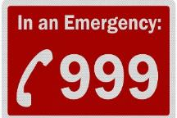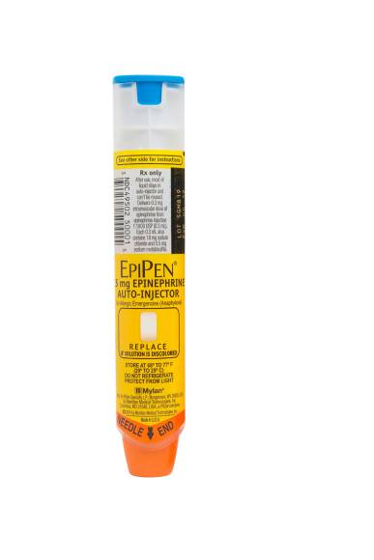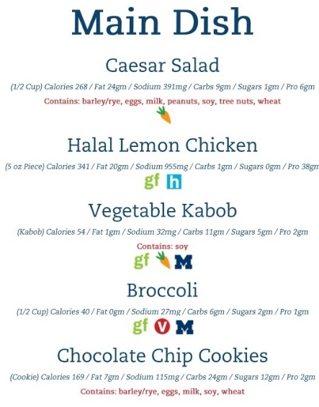

All menu items must be marked with any of the 14 major allergens they contain

Wait staff should have a good knowledge of which allergens are present

Complete allergen check sheet for new menu items

When using pre prepared ingredients, kitchen staff should check the labels carefully to identify any allergens eg

Peanut flour used to thicken the sauce in a takeaway curry;

Milk present in a minor ingredient in a pre-packed or catered food.

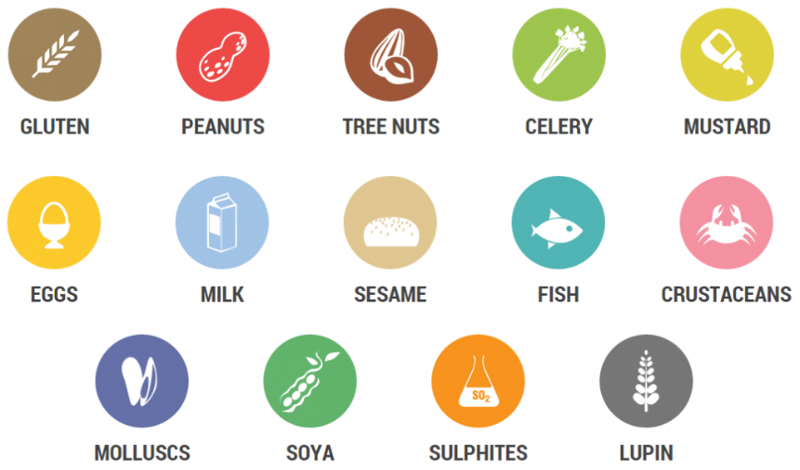

* Anaphylaxis is most commonly caused by food allergies, but can also be caused by other things, such as insect bites and drug allergies.
* Peanuts, milk, eggs and fish are the most common foods to cause anaphylaxis in the UK.

These ingredients must be labelled on menus and packaging

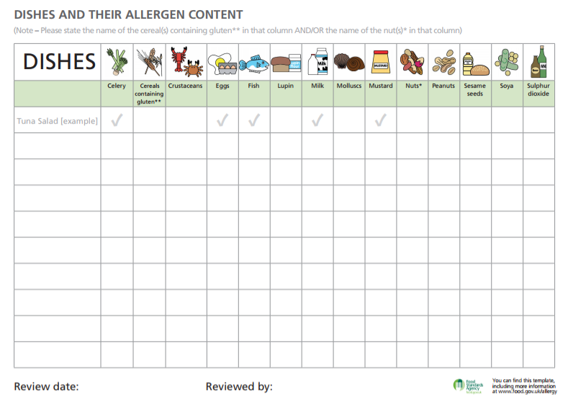

1. Special fried rice
2. Sweet and sour prawn balls
3. Chicken korma
4. Prawn samosas
5. Lasagne
6. Paella
7. Four seasons pizza
8. Crumbed ham
9. Scotch egg

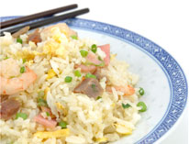

**The allergenic ingredients in special fried rice are:**

* Crustacea – prawns
* Soya – in the light soy sauce and in the Chinese roast pork
* Wheat – in the light soy sauce and in the Chinese roast pork
* Eggs
* Molluscs – in the oyster sauce
* Sesame – in the sesame oil

AC 4.2 **Environmental health officer- Roles and responsibilities**

What do EHOs do?

* EHOs deal with a variety of different legislation and enforcement not just related to food.
* EHOs tend to specialise in an particular area of work once qualified-
* food safety
* Infectious diseases
* environmental protection
* noise, radiation & pollution control
* water standards
* health and safety at work
* animal welfare
* waste management
* housing standards

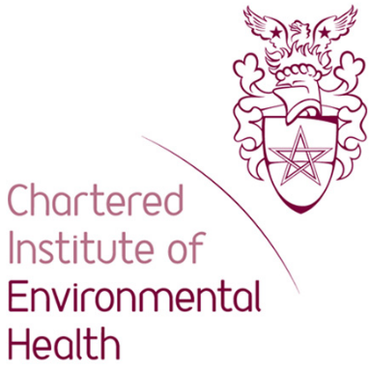

***The Food Safety Act.***

Food safety from the manufacturer or producer to the point of sale. Might involve different companies or premises e.g. suppliers, manufacturers or kitchens, shops or restaurants.

***The Food Safety Act (General Food Hygiene) Regulations.***

Ensures food producers **HANDLE** all food hygienically.

***The Food Safety Act (Temperature Control) Regulations***.

Temperatures at which to store or hold food.

* Freezers from –18°C to –24°C
* Chillers from 3°C to 8°C
* Fridges from 1°C to 5°C
* Cooked core temperature at 75°C or above
* Hot holding above 63°C

***The Food Composition Regulations.***

***S***pecifies what ingredients **CAN** or **CANNOT** be used in the manufacture of foods e.g. bread, breakfast cereals and use of additives

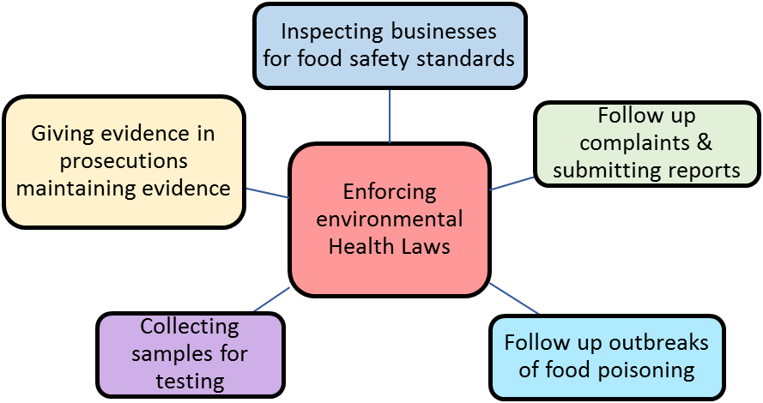

**Inspecting businesses for food safety standards**

* Powers of entry at any reasonable time
* Inspect food and premises
* Power to seize and detain food
* Serve notices
* Power to close
* Prosecute

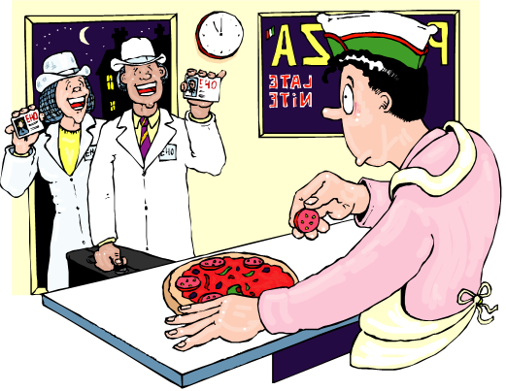

* Be well maintained
* Be regularly checked
* Have lockers for employees
* Have hand wash facilities
* Have clean cloakroom and toilet facilities
* Have first aid available
* Have clean storage areas
* Have temperature controlled fridges and freezers
* Have equipment that is clean and in good working order
* Be free from pets and pests etc

Food premises must..

Food handlers must …

* Have regular training in food safety
* Be dressed in clean ‘whites’ or other uniform
* Have hair tied back (and ideally wear a hat)
* Have short, clean nails – no nail varnish or jewellery
* Be in good health (no upset stomachs)
* Have ‘good 'habits, e.g. no coughing or sneezing over food
* Wash their hands after handling raw meat, after blowing nose, after going to the toilet etc
* Cuts should be covered with a blue plaster

Food Hygiene practices …

* Food deliveries should be checked thoroughly
* Food should be labelled and stored correctly (in freezers, chillers, fridges and dry stores)
* Food should be rotated (first in first out)
* Care should be taken with temperature control in the kitchen (i.e. food kept out of the danger zone of 5-63oc)
* Food should be prepared quickly and as close to cooking time as possible
* Hot food should be maintained at above 63oc
* The core temperature of cooked food needs to be at least 75oc
* Chilled food should be stored below 5oc
* Washing up should be done in hot soapy water if there is no dishwasher available
* Waste should be disposed of safely.

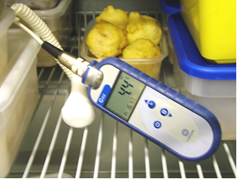

Documentation …

The EHO has to make staff know and carry out food preparation safely and hygienically. How might they do this?

All food businesses must have a food safety management system

Includes safe working methods, critical control points and monitoring

The Food Standards Agency publishes a file which contains check lists and guides for food businesses. If the business completes all parts of it they comply with the law

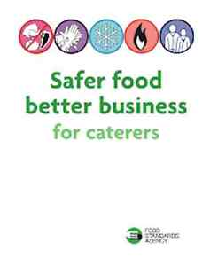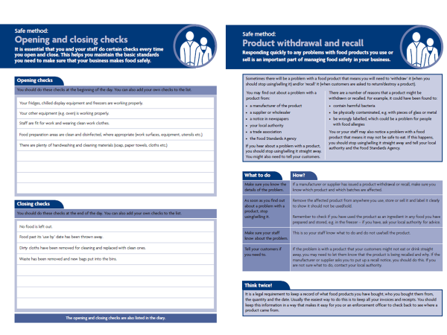

Record keeping

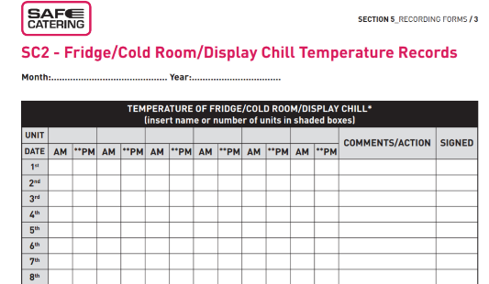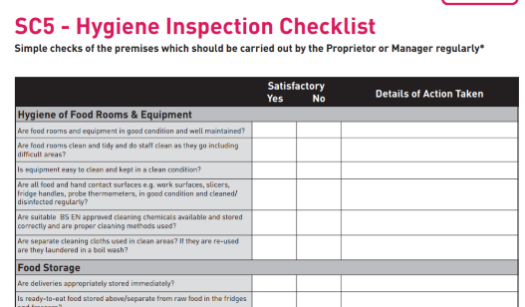

Training

Dependant on the type of business and risk involved.

* All food handlers must receive food hygiene training by law and the business must keep records of the training.
* EHOs check the records of training to make sure they are complete
* EHOs can also provide food Hygiene training to businesses either as part of their job or for a small fee

Levels 1 – 4 are available. Recommended it is updated every 3 years

Food Hygiene Rating Scheme



Although its not compulsory to display the ratings in England YET do you think it is a good idea for businesses to display them?



* Can close dirty premises at no notice
* Notice to improve and re inspection
* Can impose fines of £20,000 or six months imprisonment
* Can take legal action for manslaughter

All premises must be registered with the local authority and can be inspected at any time by an EHO.

A Hygiene Improvement Notice is used to require food businesses to improve something sub-standard

**Follow up complaints & submitting reports**

The EHO investigates complaints from the public about problems when with food/drink. These can be

Physical

Chemical

Biological

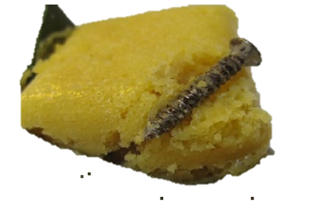

**Follow up outbreaks of food poisoning**

* The EHO coordinates with doctors, hospitals, victims and food suppliers to trace and identify sources of food poisoning outbreaks (and single cases)
* They take samples of food, faecal samples, swabs of kitchens and production areas and these are analysed by the Public Health laboratory service to identify the species and likely causes
* EHOs publish a report on the outbreak that gives the timeline and how the outbreak could have happened – publicly available

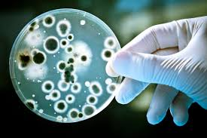

**Collecting samples for testing**

EHOs collect samples for testing using *aseptic* methods so no bacteria contaminate the sample

* Foods
* Faecal
* Swabs of surfaces or workers
* Foods (for composition testing)
* ATP swab testing

In cases where there could be a prosecution the sample is divided so that there is a reference to use if it goes to court

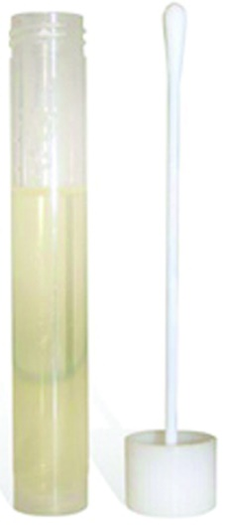

**Giving evidence in prosecutions maintaining evidence**

* Prosecutions under food safety laws are serious, people can get injured or even die .
* The EHO writes a report for the prosecution service who decide if it is serious enough to take to trial
* The EHO who conducted the investigation gives evidence as an expert witness and explains where the defending party has broken the law
* Evidence is submitted in the form of photos, lab results, and the EHO notes from the investigation

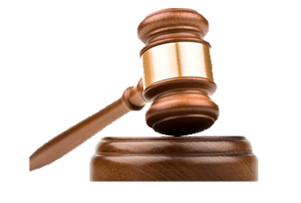

The EHO reports back to the customer and the provider – can prosecute supplier if negligent

Doctors notify environmental health of suspected cases of **infectious disease.**

* EHO then visits the person to complete a questionnaire.sent to PHE who analyse the data
* EHO would investigate any source of infection locally

**Campylobacter** – Most common cause of food poisoning in the UK

**Cryptosporidium** – Is a microscopic parasite that causes Cryptosporidiosis

**Ecoli 0157** - Is found in the gut of animals; it is a bacterial infection that causes severe stomach pain that can lead to kidney failure

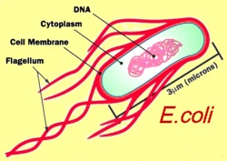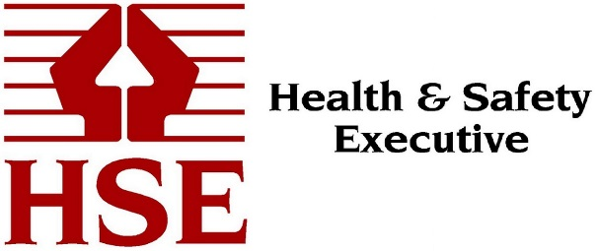

Accident Investigation

Accidents must be reported to the Health and Safety Executive via reporting system (RIDDOR).

* Deaths caused by workplace accidents
* Occupational diseases
* fractures, amputations, loss of sight etc
* Over 7 day incapacitation of a worker
* Dangerous occurrences
* Accidents to members of the public where they are taken to hospital.

The EHO receives ALL RIDDOR information in their area.

How can the EHO use the information to improve food premises?

ATP Swabs

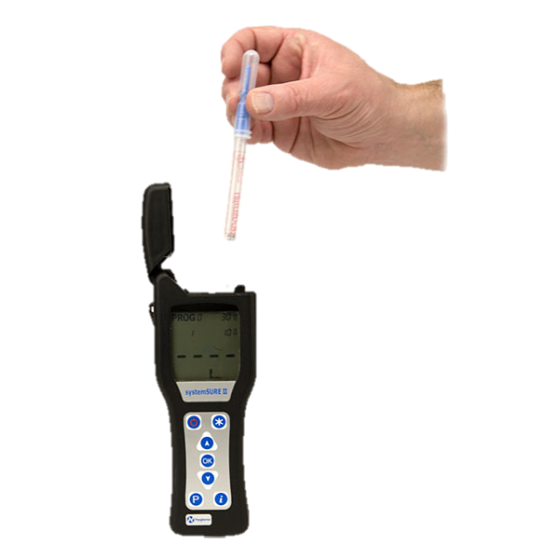

**What is ATP and how is it measured?**

All organic matter contains ATP including food, bacteria, mould and microorganisms. The detection of ATP indicates the presence of biological matter.

A sterile swab is used to take approximately a 10cm² sample. ATP uses bioluminescence to take a reflective light unit reading (RLU) from the swab.

. Measuring the amount of bioluminescence from an ATP reaction provides a good indication of surface cleanliness

Unclean surface → large amount ATP → more light produced → high reading

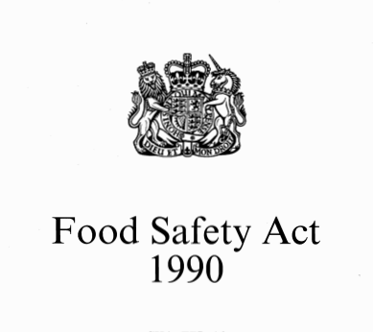

If a person renders (which means “makes”) a food injurious to health: by adding an article or substance to it; using an article or substance as an ingredient in its preparation; abstracting (which means “taking away”) any constituent from it; or subjecting it to any other process or treatment then they are guilty of an offence

1. It is an offence to supply food that fails to comply with food safety requirements
2. Strengthened powers of enforcement including detention and seizure of food
3. It requires training in basic food hygiene for all food handlers
4. All food premises must be registered
5. Authorises EHOs to issue improvement notices if there is a potential risk
6. EHOs can issue emergency prohibition notices to force caterers to stop their business immediately

Food businesses:

* Must ensure that the food served or sold is of the nature, substance or quality which consumers would expect, e.g. :
  + - Nature - pollock rather than cod;
    - Substance - contains foreign material including glass or packaging;
    - Quality – mouldy bread or stale cake.
* Ensure that the food is labelled, advertised and presented in a way that is not false or misleading, e.g. photos on menus that do not look like the dishes served to customers.
* Powers of entry at any reasonable time
* Inspect food and premises
* Power to seize and detain food
* Serve notices, power to close businesses
* Power to prosecute

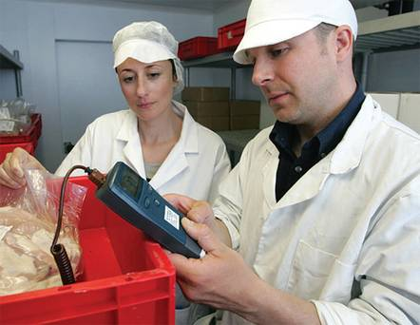

* Temperature control records delivery/storage/cooking
* Microbiological records
* Hygiene training for staff
* Use of HACCP system
* Pest control records
* Hygiene manuals, cleaning schedules
* Hygiene policy

|  |  |  |
| --- | --- | --- |
|  | Magistrates court | Crown court |
| Selling food that does not comply with the Food Safety Act | 6 months in prison or max £20,000 fine | 2 years in prison  Unlimited £ fine |
| Obstructing an Environmental health Officer | 3 months in prison or max £2,000 fine | 2 years in prison or £ unlimited fine |

* make sure food is supplied or sold in a hygienic way;
* identify food safety hazards;
* know which steps in your activities are critical for food safety;
* ensure safety controls are in place, maintained and reviewed.
* be clean and in good condition, made from easy to clean materials
* have potable (drinking) water;
* have pest control measures
* have adequate lighting and ventilation ;
* clean lavatories which do not lead directly into food rooms;
* have adequate hand washing facilities and drainage
* facilities for washing food and equipment;
* facilities for the storage and removal of food waste.

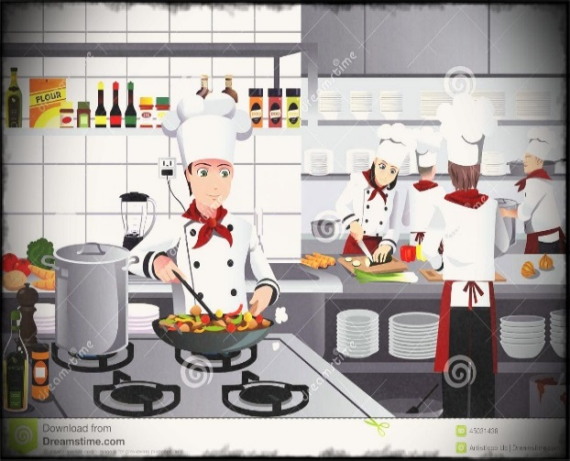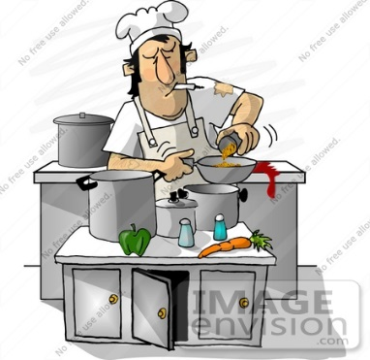

* Food handlers must receive adequate supervision, instruction and/or training in food hygiene. Each food business must decide what training is needed

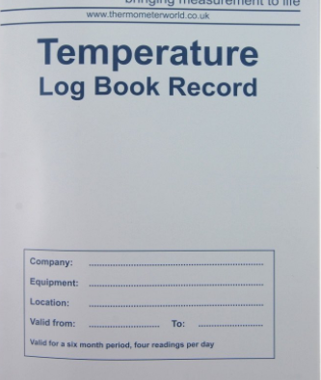

Fill in the chart, stating what the hazards/dangers might be at every stage and stating what action you would take

**Hazard** – anything that could cause harm to consumers

**HACCP** is designed to help food companies to minimise the risk from food hazards

|  |  |  |
| --- | --- | --- |
| **Stage** | **Hazard** | **Action** |
| Buying |  |  |
| Delivery |  |  |
| Storage |  |  |
| Preparation |  |  |
| Cooking |  |  |
| Chilling |  |  |



Penalties for Non-Compliance

* Prohibition from using part of business
* Fines and legal costs
* Prison sentence
* Closure of business
* Prohibition from running a food business
* Criminal record
* Defence of Due diligence also for this regulation

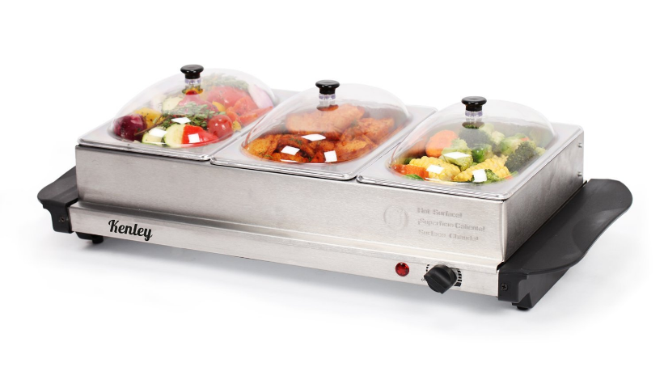

* Applies to high-risk foods
* Cold foods- store below 8oC
* Hot foods – store above 63oC

During service :-

* Cold food max 4hrs at room temperature then discard or refrigerate
* Hot food maximum 2 hrs
* Buffet food 90mins at room temperature

The Food Hygiene regulations 2006