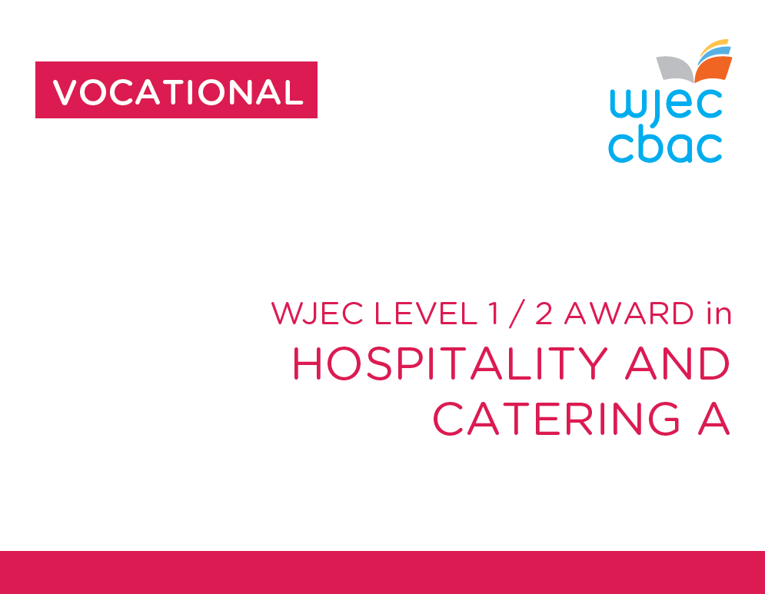

**Unit 1**

**The Hospitality and Catering industry**

Exam June

90 mins

40% overall grade



**LO3**

**Understand how hospitality and catering provision meets health and safety requirements**

|  |  |
| --- | --- |
|  |  |
|  |  |
|  |  |
|  |  |
|  |  |
|  |  |
|  |  |
|  |  |
|  |  |
|  |  |
|  |  |
|  |  |
|  |  |
|  |  |
|  |  |
|  |  |
|  |  |
|  |  |
|  |  |
|  |  |
|  |  |
|  |  |
|  |  |
|  |  |
|  |  |
|  |  |
|  |  |
|  |  |
|  |  |
|  |  |
|  |  |
|  |  |
|  |  |
|  |  |
|  |  |
|  |  |
|  |  |
|  |  |
|  |  |
|  |  |
|  |  |
|  |  |
|  |  |
|  |  |
|  |  |
|  |  |
|  |  |
|  |  |
|  |  |
|  |  |
|  |  |
|  |  |
|  |  |
|  |  |
|  |  |
|  |  |

