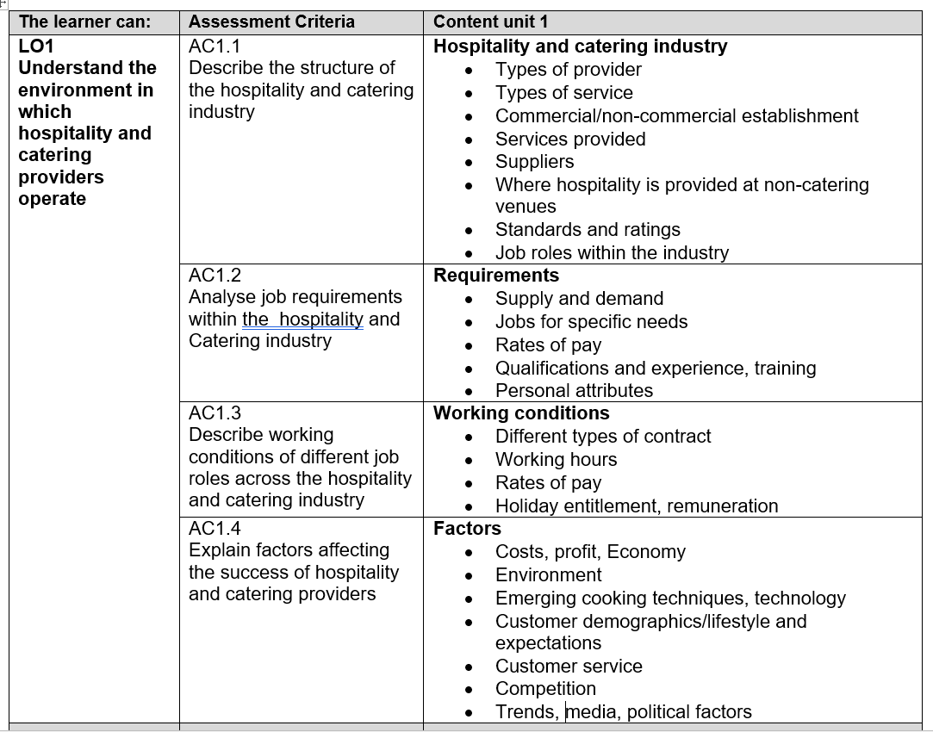
AO1
Understand the environment in which hospitality and catering providers operate
LEVEL 1 / 2 AWARD IN
HOSPITALITY AND CATERING unit 1
Name

Group

AC1.1 structure of the hospitality and catering industry

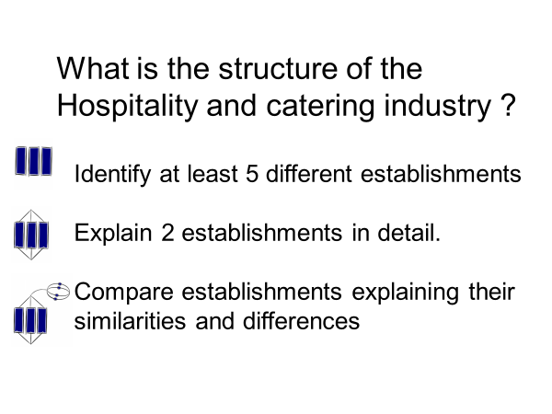
Residential
Hotels
Guest houses
Bed and breakfasts
Farmhouses
Motels
Holiday parks
Some public houses

Non profit
Hospitals
Prisons
Meals on wheels
Residential care homes
Armed services
.
Non Residential
Restaurants
Fast food outlets
Public houses
Bars
Delicatessens
Take away outlets
School meals
Burger vans

Key Word: | Meaning within the Catering Industry: look these up online
Establishment | A hospitality or catering outlet . May be a pub, restaurant, hotel, café etc
Hospitality | The service industry between hosts eg waiters, restaurant managers, hoteliers and their guests or customers.
Service | Industry where hospitality is provided or  Service of food ie how it is served and presented to the customer
Consortium | A group of cooperating companies, could be different brand names
Chain | A multi outlet company with several (sometimes hundreds) of establishments with the same brand name
Corporate | Refers to businesses and services provided to or by a company
In-house | Services or good provided by a company to its employees without using non company provision eg hygiene training could be provided in house by a company trainer or from an aoutside source such as a EHO
Residential | A type of establishment where there is overnight provision with a bed and bathroom . This may be on a paid basis such as a hotel or by an establishment such as a hospital or prison
Non-residential | An establishment that does not provide overnight accommodation of any type to its guests such as a restaurant or bar that provides food and drink only
Commercial | An establishment that is operated on a profit making basis, to pay its employees and cover its costs and give a profit to the company that owns it
Non-commercial | An establishment that operates without the goal of making a profit. This could be hospitals, prisons or company run canteens. Note that the establishment does need to make money to pay its employees, workers and the costs of food and overhead costs
Management | A level of employment where the employee is responsible for other employees and sometimes and area of the business, eg a Restaurant manager is responsible for the restaurant. Or a general manager responsible for the whole establishment
Outlets | Multi establishment organisations may refer to its individual establishments as outlets
Operatives | Operative level employees are responsible for their own jobs and their health and safety obligations without having responsibility for othger employeees

Types of establishment | 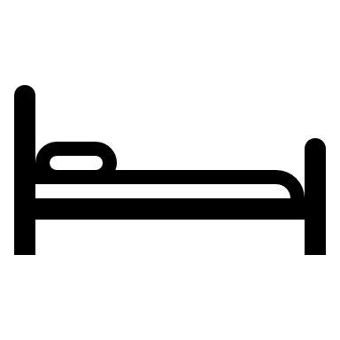 | Features
Hotels |  | The style of food provided will depend on the standard of the hotel  Hotel may provide  - No food provision  - Room service  - Hotel owned restaurants  - Franchise restaurants  - Breakfast provision only
Motels and holiday parks |  | Lower standard than hotels, food is usually buffet style breakfast. Corporate or independent
Bed & breakfasts, guesthouses |  | Often showcase local themes or produce.  May be breakfast, Half board or full board, family run
Restaurants |  | Variety of styles and food types, may be specialist eg italian, or gourmet or fine dining  Styles of service vary with types of food and cost  See styles of service section for more…
Cafes |  | Can vary from independent “greasy” spoon, Tea rooms or coffee shops.  Serve snacks and full meals
Fast Food |  | Chains eg KFC, Dominos or independent businesses  Limited menu, low cost, eat in or take away  Disposable packaging
Take aways |  | Dedicated take away or restaurant attached or may be just take away, most food is cooked to order.
Public Houses and Bars |  | Can serve “basket” meals sandwiches or full table service. Some chain pubs have a fixed menu eg Wetherspoons.  Bars more cosmopolitan menu than pubs , often themed to the type of establishment. Table service or eat at the bar
Hospitals |  | Patients may need reduced fat, sugar, protein diets depending on health  Soft meals, Vegetarian, vegan, religious, childrens meals  Budget for food controlled by NHS
Prisons |  | Food is prepared in by prison inmates to ensure that tight budgets for food are met
Millitary |  | Mass catering, Camps on active service, Canteens at bases.High energy, balanced nutritionally
Care home meals |  | food served may depend on the needs of the clients, some may have conditions which need special meals. Some residents may need help eating and drinking

Comparing different Catering establishments

Use the following words provided to complete a comparison between a 4* Hotel and a Guesthouse or B&B.
Put each statement into the correct column.

Holds more people. Usually family run. Only does a breakfast meal.
Small (just a few rooms). Has more facilities e.g. gym and pool.
Often part of a chain.
Lots of staff work there. Has a bar and restaurant. Has very few facilities.
Might do an evening meal. Meals can be taken in rooms.

Then use your own words to compare a 4* restaurant with McDonalds

4* Hotel | Guesthouse or B & B
Holds more people.  Has more facilities e.g. gym and pool.  Often part of a chain.  Lots of staff work there.  Has a bar and restaurant.  Meals can be taken in rooms | Usually family run.  Only does a breakfast meal.  Small (just a few rooms).  Has very few facilities.  Might do an evening meal. Meals can be taken in rooms.
4* Restaurant | McDonald’s
Wide menu of skilled dishes  High skilled kitchen and serving staff  Few customers a day  Open at set times  Closed one or more days – Monday is usual  Fine china and glassware | Limited menu of quick to prepare dishes  Lower skill of kitchen and service staff  Many customers a day 100s to 1000s  Open continuously  Open every day  Disposable packaging

Where are you now?

AC1.1.2 Styles of service
Personal service
Counter service
Table service

Travel service
Transported meal service
Tray service
Vending service
Meal delivery
Plate service
Family service
Silver service
Gueridon service
Cafeteria
Self service
Fast food
Take away
Buffet
Carvery

Style of service | Description
Cafeteria / self service | - A single long counter displaying the food available  - Could be multiple counters (like at a motorway service area)  - Queueing is often required  - It can be fast so produces a high turnover  - Simple, basic experience for customers  - Displays lead to impulse buying  - Low skilled serving staff
Fast food / take away | - Single or multiple counters where customer orders food from limited menu  - Food is collected from the counter  - A quick, simple type of service  - Can be a very high turnover of food  - Often a limited choice of menu  - Use disposable, cutlery, and packaging
Buffet / carvery | - Usually single counter  - Staff may serve some items eg meats from a joint  - Informal style of service  - Fast and simple service  - Reasonably low cost depending on the type of food served  - Poor portion control  - Needs efficient clearing away and arranging
Plate service | - Pre plated meals served from the kitchen  - Could be basic food or decorated cuisine  - From cafes to luxury restaurants  - Good portion control  - Consistent presentation  - Relys on skill of kitchen staff  - Time consuming for kitchen staff
Family service | - Dishes are put on the table where serving spoons are provided and customers serve themselves  - More sociable  - Less portion control  - Easy and quick to serve  - Suits groups of people  - Needs a large table because of all the dishes!
Silver service | - Food is served by staff using spoon and fork,  - Full silver service= all food served this way  - More personal customer experience  - Slower speed of service  - Variation in portion control  - Needs skilled staff
Gueridon service | - Food is served from a side table using a spoon and fork  - Dishes can be cooked, finished or assembled in front of the customer  - Eg crepe suzette  - Specialist, skilled service,  - Individual attention to customer  - High staff costs  - Time consuming service
Travel service and transported meal service | - An assembled meal provided or a choice from a menu  - Planes, trains
Tray service | - An assembled meal provided or a choice from a menu  - Tray service used in hospitals, room service
Vending service | - Food and drinks served from a machine  - 24hour food service  - Drinks, snacks and meals can be offered  - Can include hot meals
Meal delivery | Meals ordered by customer and then delivered within a short period of time. Customer does not have to visit the establishment. Needs staff to deliver and keep meal hot
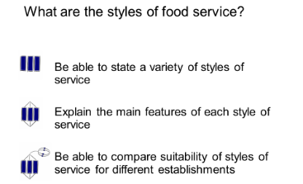

Where are you now?

AC1.1.3 Food at non catering venues

MENU
MENU

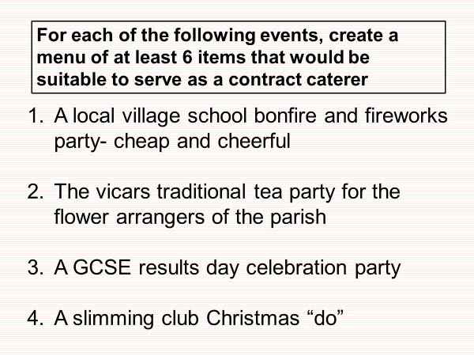

MENU
MENU

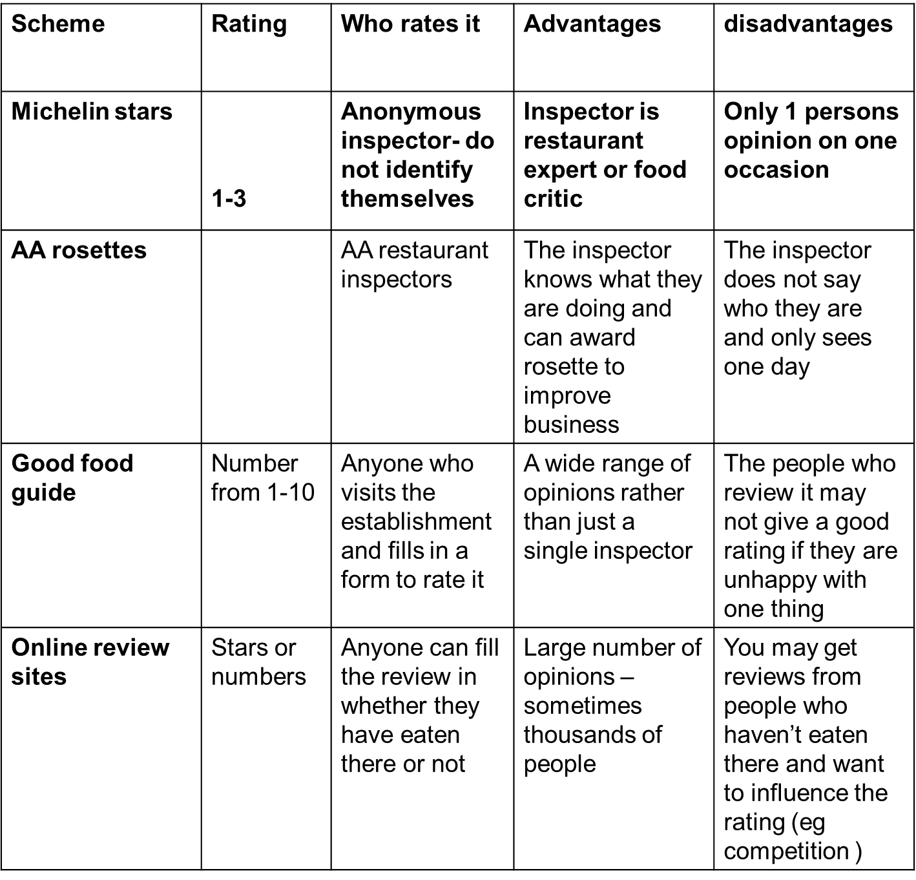
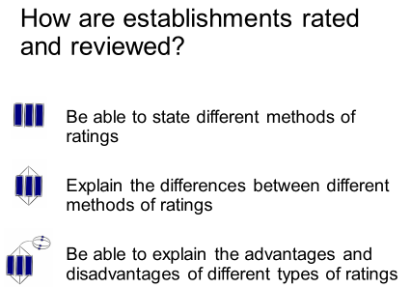

Suppliers to hospitality and catering

Type of supplier | Advantages | disadvantages
Specialist markets | Large choice of commodities  Several suppliers at the market means costs are kept down by competition  Supplies are always at their freshest  New supplies in every day | May not be easy to get to eg London  Work through the night and close early in the morning  Costs of transport back may be expensive  Purchaser has to judge quality for themselves before they buy
Local suppliers | Local deliveries, less environmental impact  May use local farms and companies for commodities  Smaller firms, personal business relationship  May be able to change order at short notice | - May not have a wide selection  - Smaller companies buy in smaller quantities so costs more  - May not be able to supply large orders
Large wholesalers | Very large range of commodities and sundries  Can have in house butchery department  Pre made and pre portioned food  Large bulk packaging of ingredients | - May be expensive for pre made foods  - Have to order well in advance  - Set delivery days  - Have to order large quantities to get a discount

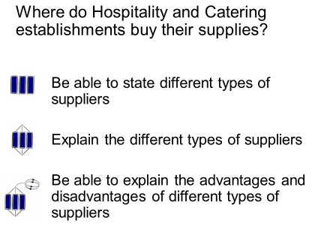

1. The Royal Hotel has decided to offer a buffet service for its New Years Eve Party.
(a) State two advantages of a buffet service to: [4]
the hotel:
(i)

(ii)

the customer:
(i)

(ii)

(b) Describe the role of the wait staff during a buffet service. [4]

Transported Meal Systems

The most well known type of transported meals is airline food – also known as ‘in-flight’ catering.

Research this type of catering and explain how the airline food system works.

Advantages of in-flight meals: | Disadvantages of in-flight meals:

AC1.2 Job roles in the Hospitality and Catering industry

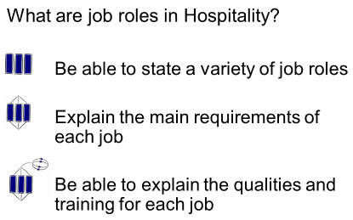
The kitchen brigade

Kitchen assistant
Commis chef
Kitchen porter

Profile – Head chef
Responsibilities

Skills

Qualifications
Salary
Career progression

Profile – Sous chef
Responsibilities

Skills

Qualifications
Salary
Career progression

Profile – Chef de partie
Responsibilities

Skills

Qualifications
Salary
Career progression

Profile – Commis chef
Responsibilities

Skills

Qualifications
Salary
Career progression

Profile – Kitchen Assistant
Responsibilities

Skills

Qualifications
Salary
Career progression

Front of house

Describe the job roles of the staff above
Restaurant manager is in overall charge of the restaurant,
Takes bookings, relays information to the head chef, completes staff rotas, ensures the smooth running of the restaurant

Head waiter/ess Second in charge of the restaurant,.
Greets and seats customers, relays information to the staff, Deals with complaints and issues referred by the waiting staff.
Wine waiter serve the wine to the customer and can advise customers on their choices as well to match with the food

Waiting staff Serve customers, clear and lay tables, check the customers are satisfied with the food and service.
May give advice on choices from the menu and special order foods
Station | Title (French) | Menu items prepared
Pastry chef | Le patissier | Baked goods, pastries, cakes, breads and desserts
Larder chef | Le garde manger | Cold foods, salads, cold starters, pates and buffet items
Vegetable chef | L’entremetier | Hot starters, soups, vegetables, pasta and starch based side dishes
Sauce chef | Le saucier | Sauces, stews, hot starters, sautes food to order
Fish chef | Le poisonnier | Fish and fish based dishes
Soup chef | Le potager | Soups, stews

AC 1.1 What are the working conditions in the Hospitality and Catering industry ?

When are the busy times for the Hospitality and catering industry?

Times of day Days of week Times of year

Lunchtime
Afternoon
Dinner time
(breakfast)

Friday
Saturday
Sunday
Pay day

Christmas
Tourist season
School holidays
Mothers day
valentines

Contracts of employment
Part-time

Full-time
Have permanent jobs and work all year. Over 36 hours a week
Contract explaining the terms of their employment.
They may work set shifts or have shifts that change daily/weekly/ monthly.
They will work a set amount of days over a 7 day week, including weekends.
Entitled to sick pay and holiday pay
Entitled to maternity pay

Have permanent jobs and work all year. 14-16 hours a week
Contract explaining the terms of their employment.
They may work set shifts or have shifts that change daily/weekly/ monthly.
They will work mostly at the busiest times of the day/week including weekends.
Entitled to sick pay and holiday pay (in proportion)
Entitled to maternity pay
…………………………….…………………………………………………………………………………

work for specific functions and can be employed through an agency.
They do not have a contract or set hours of work.
They are needed at busier times of the year e.g. At Christmas or for weddings, New years eve.

Casual
Temporary
Employed for a specific length of time such as the summer tourist season or the month of December.
Temporary staff have the same rights as permanent staff for the duration of their contract.
Temporary staff employed for longer than 2 years become permanent by law
……………………………………………………………………………………………………………………………………………………

Full-time and Part-time employees must have;

 | a written statement of employment or contract setting out their duties, rights and responsibilities
 | the statutory minimum level of paid holiday 28 days for full time workers
 | a pay slip showing all deductions, eg National insurance, tax . Earning above £155 a week
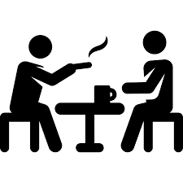 | the statutory minimum length of rest breaks- one 20 min break for 6 hrs worked
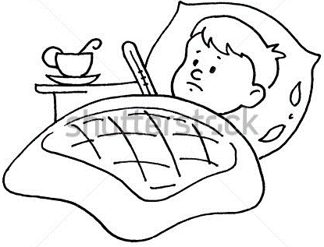 | Statutory Sick Pay (SSP) £88.45 pw for 26 weeks (some may get full wages for a limited amount of time)
 | Maternity, paternity and adoption pay and leave-90% of earnings for 6 weeks then £139.58 for next 33 weeks
Legislation protecting workers
- Disabled Discrimination Act 1995
- Equal Pay Regulations 1970
- Health and Safety At Work 1974
- National minimum wage
- Working Times Regulations 1998
- Part-time workers Regulations 2000

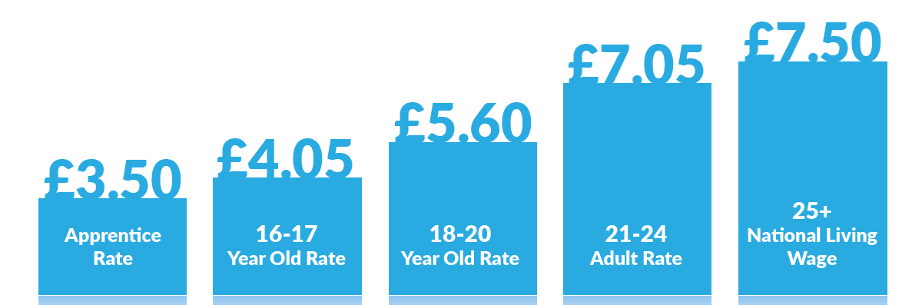

National minimum wage

3. The Royal Hotel needs to recruit staff for its busy holiday season, discuss the type of contract that would suit the following interviewees. What are the advantages to the Royal Hotel and the employees
(a) A College student who studies 5 days a week but gets weekends and holidays off college.

Suitable contract Part time or casual

Advantages for the student The student would be able to work shorter ours and still have time for their college studies . The student could work weekends when they are not at college. The student could work casual hours and fit it in round their studies

Advantages for the hotel
The hotel would be able to employ them part time so that they are not overstaffed the rest of the week
They would only be employing someone when they are busy ie in the evenings or at weekends. They could call the student in to work when they get especially busy and need someone extra

(b) A mother of a 12 year old who is at school nearby in term time.
Suitable contract part time contract working during the day

Advantages for the mother
She could work part time during the day when her child is at school . working part time she would have the same rights as a full time worker if she had a permanent contract

Advantages for the hotel
They could have someone working part time when the hotel has a lot of housekeeping work to be done during the day
There could be preparation work for a restaurant that needs someone to do it during the day

(c) where might an establishment find casual staff to work at short notice?
They could keep a list of people that are able to work on a casual basis or they could contact a specialist employment agency for catering staff

(d) How much would a 17 year old earn if they worked 8 hours over the weekend?
£4.05 X 8 hours = £32.40

(e) What other remuneration could they receive ?
They might get a share of the tips, or a meal at work before or after work
[10]

Sea View Guesthouse
Head Chef required
- You will be responsible for a busy kitchen and 4 kitchen staff.
- The Sea View Guesthouse Restaurant is open Tuesdays to Saturdays for both lunch and evening meals.
- We offer an à la carte menu that needs updating.
- Salary negotiable.

Explain 4 qualities that are essential for a head chef
What sort of salary could a head chef expect?

AC1.4 Factors affecting success of Hospitality and Catering providers.

What are the reasons that Hospitality businesses could fail?

- A saturated market – there is a fine line between competition & too many for the number of customers
- General business incompetence – 46% of business fail due to lack of business knowledge
- Lack of capital – not enough money to get through the first few months
- Location – either not enough people walk past (foot-fall) live & work nearby
- Quality of life - most restaurateurs work 60 hours a week – not the glamorous life they thought
- Lack of industry experience – most successful restaurateurs tend to have previous industry experience

- 7. Failure to create a good enough brand –
- They did not incorporate the 12 Ps of restaurant branding,( Place, Product, Price, People, Promotion, Promise, Principles, Props, Production, Performance, Positioning and Press)
- Name of the restaurant is too long.
- A restaurant with a name that is brief, descriptive and attractive is more likely to succeed.
- Lack of differentiation -
- the brand is not different enough
- 10. Poor financial controls –
- Main costs – labour and food exceeded 60% of sales

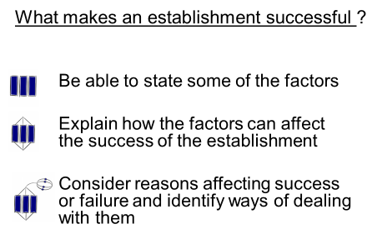
Where are you now?
 | Factors affecting success of Hospitality and Catering providers
Costs | need to make a profit. Consider cost of everything you buy and selling price.  Material - Anything involved in making product  Labour - Costs of staff  Overheads - Anything not connected with making products
Economy | - when the economy slows down, business have lower sales as consumers eat out less because they have less disposable income
Environment | 3 R’s, packaging, food waste, global warming, carbon footprint
Technology | Using technology to improve service, delivery and stock control – touch screen customer ordering, EPOS systems, stock management, apps for delivery services
Cooking techniques | - Emerging and innovative cooking techniques – sous vide, clean eating, steaming, new restaurants,
Competition | There could be a similar establishment near by or one appealing to a similar type of people (demographic)
Customer service | customer satisfaction – free WiFi, order online
Trends | healthy food options, pop-up bars, cafes and restaurants, cronut, clean eating, low carb, good fats,
Political factors | Increasing regulations – from government due to health issues, Brexit, use of migrant labour, migrants – ethnic foods
Media

SWOT analysis
Category | What type of business is it eg hotel or restaurant
Sector | Hospitality and catering sector
USP | Unique selling point
STP
Segment
Target Group
Positioning
SWOT Analysis
Strengths
Weaknesses
Opportunities
Threats
Competition

A hotel/restaurant did not make a profit last year and wants to work out what changes they need to make so that they can make a profit this year. Suggest different ways the hotel/restaurant can improve their profit. (6 marks)
Introduce and implement portion control
Review costs of ingredients for dishes and get cheaper suppliers
Reduce, reuse recycle
Make sure lighting heating etc is not on when not in use
Increase their prices
Use cheaper advertising eg web
Review staff to make sure they are not overstaffed, employ casual and part time staff

NB – you can choose the type of hotel or restaurant.

