Topic 3.8 – The nervous system

The nervous system

The nervous system allows us to respond to changes in our environment.
A stimulus is any detectable change in the internal or external environment of the organism. Specialised receptor cells act as transducers as they detect energy in one form and convert it to electrical energy. This electrical energy travels along neurones (nerve cells) as a nerve impulse. The coordinator (brain or spinal cord) processes the information received form the receptors and initiates the appropriate response by sending nerve impulses initiate a response in an effector, which is always a muscle or gland.

The central nervous system (CNS) is composed the brain and spinal cord. The CNS processes information provided by a stimulus and co-ordinates a response.

The peripheral nervous system (PNS) is made up of neurones (nerve cells). It has two parts:
  - The somatic nervous system is made up of pairs of nerves, branching from the brain and spinal cord. These neurones carry impulses from receptor cells to the CNS and then from the CNS to the effectors.
  - The autonomic nervous system provides unconscious control of the internal organs e.g. heartbeat and breathing.

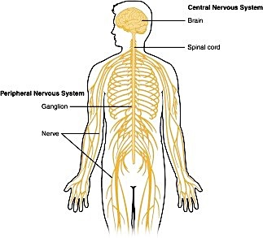

Neurones
Neurones are highly specialised cells which carry nerve impulses in one direction. There are three main types in a vertebrate:
  - Sensory neurone – Carries nerve impulses from the receptor cells in the sense organ to the CNS
  - Relay neurone – Found in the CNS and connects the sensory and motor neurones
  - Motor neurone – Transports the nerve impulse from the CNS to the effectors (muscles and glands)

The diagram below is a motor neurone:
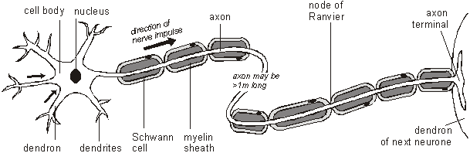

Structure | Function
Cell body | Contains a nucleus and granular cytoplasm
Cytoplasm | Granular; contains many clusters of ribosomes
Nucleus | Holds DNA
Nissl granules | Cytoplasmic granules comprising ribosomes grouped on RER
Dendrite | Thin fibre carrying impulses towards cell body. A cell body may have several dendrites.
Axon | A long fibre (formed from a membrane-covered cytoplasmic extension) that carries impulses away from cell body. At its end, the axon divides into branches, which form synapses with other neurones. A cell body has only one axon.
Schwann cells | Surround and support nerve fibres. In vertebrate embryos, they wrap around the developing axons many times and withdraw their cytoplasm, leaving a multi-layered phospholipid (fatty) myelin sheath.
Myelin sheath | A fatty material secreted by Schwann cells that surrounds some vertebrate neurones. The myelin sheath is an electrical insulator and speeds up the transmission of impulses. It insulates the neurone by preventing the movement of ions into and out of the axon.
Nodes of Ranvier | 1μm gaps in myelin sheath, where adjacent Schwann cells meet and where the axon membrane is exposed. They allow impulses to be transmitted rapidly by salutatory condiuction.
Synaptic end bulb | Swelling at the end of the axon, in which neurotransmitter is synthesised.
Axon ending / terminal | Secretes neurotransmitter, which transmits impulse to adjacent neurone.
* grey = found in grey matter; white = found in white matter of spinal cord.

The spinal cord
The spinal cord is a flattened cylinder of nervous tissue, running from the base of the brain to the lumbar region. The spinal cord is protected by vertebrae and tough outer membranes called the meninges. The diagram below shows a section through the spinal cord. The grey central region (Y) is the grey matter, which contains cell bodies and synapses. The outer, white region (X) is called white matter and contains axons coated in fatty myelin – it’s the myelin which gives this region its distinctive colour.

Pairs of roots allow neurones to enter and exit the spinal cord. The dorsal root allows the sensory neurone (A) to enter; it has a swelling called the dorsal root ganglion (L) which houses the cell bodies. The ventral root allows the motor neurone (B) to exit. Nerve cell C is the relay neurone within the grey matter.
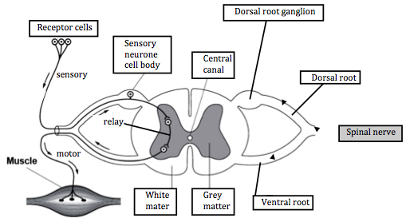

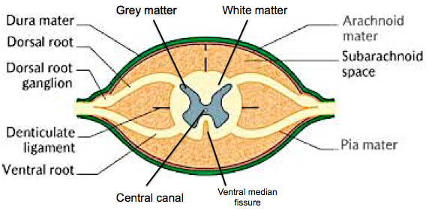

The reflex arc
A reflex is fast, automatic and beneficial.
Example: Stimulus - heat from a flame. Receptor cells in the skin convert heat energy into electrical energy. The nerve impulse travels along the sensory neurone to the spinal cord (via the dorsal root). The impulse passes to the relay neurone and then to the motor neurone. The nerve impulse exits the spinal cord along the motor neurone (via the ventral root) to the muscle (which is an effector). When the impulse reaches the muscle it contacts to pull the arm/hand away from the source of heat – this is a withdrawal reflex.

Examples of other reflexes include:
  - Blinking to protect the eye
  - Contraction of the iris to reduce the amount of light hitting the retina
Top Tip – You may be asked to draw the neurones onto an outline of the spinal cord, make sure you can draw the cell bodies and synapses in the correct positions. The elements of a reflex must include: STIMULUS → RECEPTOR → SENSORY NEURONE → RELAY NEURONE (CNS) → MOTOR NEURONE → EFFECTOR → RESPONSE
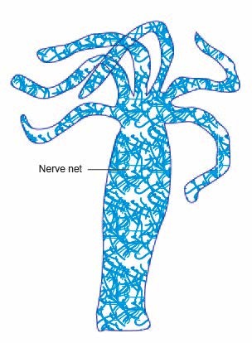

Nerve nets
Invertebrates such as jellyfish and hydra have simple nerve nets. You must be able to compare a nerve net with the mammalian neurone system. Hydra has no recognisable CNS and fewer types of receptor cells and therefore responds to a limited number of stimuli.
Hydra cannot detect the direction of a stimulus. The greater the intensity of the stimulus the more nerve cells are triggered initiating a greater response.

The nerve net has shorter neurones, which branch in all directions (vertebrates have longer neurones, which branch in one direction – the axon). Impulses travel slower and in all directions (in vertebrates impulses travel quicker and in one direction). Nerve nets have only one type of neurone, in mammals there are three.
Top Tip – You must compare like for like! Use terms such as slower instead of slow, shorter instead of short.

 | Hydra | Human
Nervous system type | Nerve net | CNS
Number of cell types in nervous system | 2 | Many
Regeneration | Rapid | Very slow if at all
Myelin sheath | Absent | Present
Conduction speed | Slow – approx. 5ms⁻¹ | Fast – up to 120 ms⁻¹
Ability to regenerate | Present | Absent
Neurone length and branching status | Shorter and branched | Longer and unbranched
Transmission direction | Neurone transmits in both directions | Neurone transmits in one direction only

Transmission of an impulse / propagation of an action potential
An action potential can be measured using a Cathode Ray Oscilloscope (look at the diagram below). You will need to be able to interpret an oscilloscope trace.
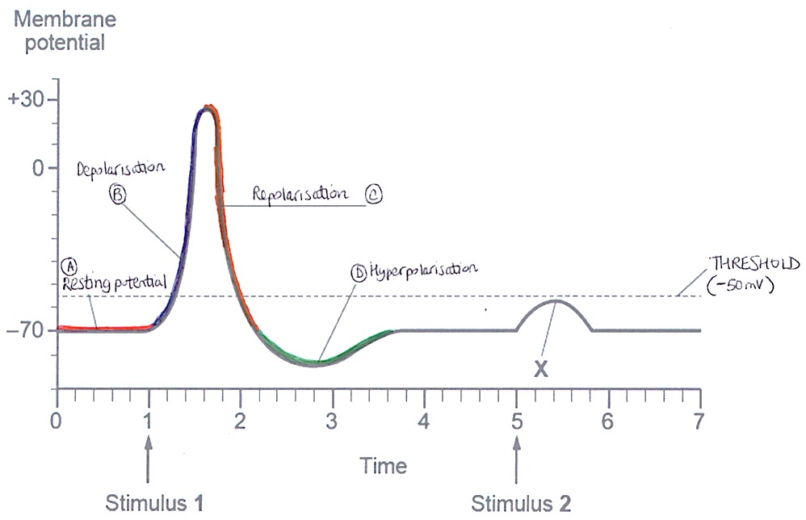
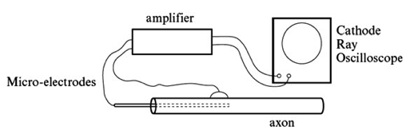

Point (A) shows a polarised cell membrane during the resting potential. After stimulus 1, voltage gated Na⁺ channels open and depolarisation begins (B) as Na⁺ ions flood into the axon. At the apex of the peak the membrane is depolarised and the voltage gated Na⁺ channels close and K⁺ channels open. K⁺ ions leave the axon, down their concentration gradient, causing repolarisation of the cell membrane (C). Hyper-repolarisation (D) occurs to -80mV due to the high permeability of the membrane to K⁺ (too many K⁺ ions leave the axoplasm). The sodium-potassium pump restores the resting potential and the membrane becomes polarised again.

Stimulus 2 is not strong enough to generate a full action potential. Too few voltage gated Na⁺ channels are opened and not enough sodium ions pass into the axon to cause full depolarisation – the action potential is not generated (look at the blip X on the graph above). To generate a full action potential depolarisation must cross the threshold value of -50mV (E).

As you can see from the oscilloscope traces there are four main parts to the trace. These will be explained over the next few pages:

A) Resting potential
When no nerve impulse is being transported along the axon a resting potential is maintained across the membrane. The potential difference, across the cell membrane, during a resting potential is -70mV.This is achieved by active transport; the sodium- potassium pump pumps 3 Na⁺ out of the axoplasm and only 2 K⁺ in (for reach ATP hydrolysed).
During resting potential the voltage-gated Na+ channels are closed but the membrane is highly permeable to K⁺ and they leak out by facilitated diffusion thorough open channels. This outward movement of positive ions means the outside of the cell membrane is positive relative to the inside. Furthermore large protein anions and organic phosphates (e.g.ATP⁴⁻) remain in the cytoplasm thus producing a negative potential difference across the membrane at around -70mV relative to the exterior of the axon. The membrane is polarised.
The ATP needed to maintain a resting potential is produced by the numerous mitochondria present in the axoplasm of the axon.
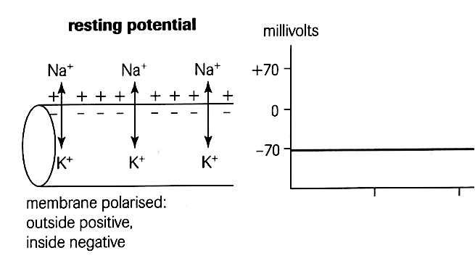

B) The action potential
ACTION POTENTIAL – DEPOLARISATION (about 3 milliseconds)
A stimulus (change in voltage across the axon membrane)) opens voltage gated Na+ channels. If the stimulus is of sufficient intensity (threshold -50mV), enough Na⁺ channels will open to cause depolarisation of the cell membrane at the apex of the peak. Na⁺ ions flood into the axon, down their concentration gradient, until the potential difference across the membrane becomes +40mV – this is an action potential. The voltage gated Na⁺ channels now close.
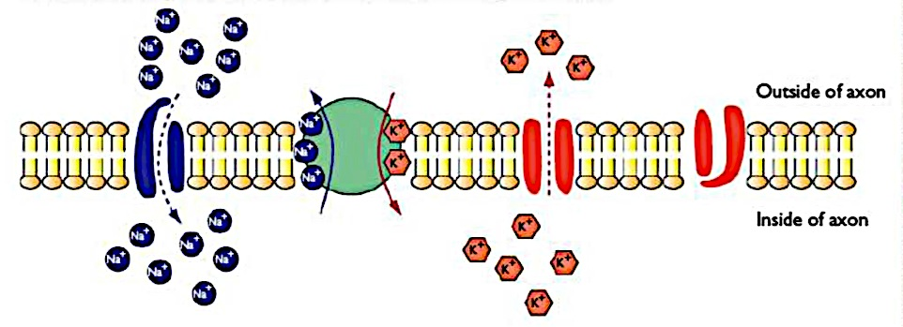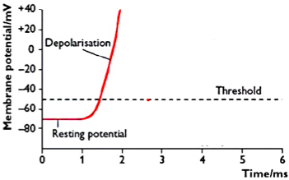

C) Repolarisation
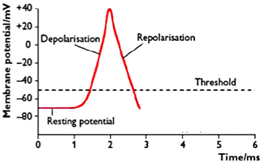
Repolarisation occurs when the resting potential is re-established. This occurs when the Na+ channels close and K+ channels open resulting in K+ ions flooding out of the axon and reducing the potential difference across the axon membrane (as more K⁺ are going OUT the inside becomes more negative and depolarises).

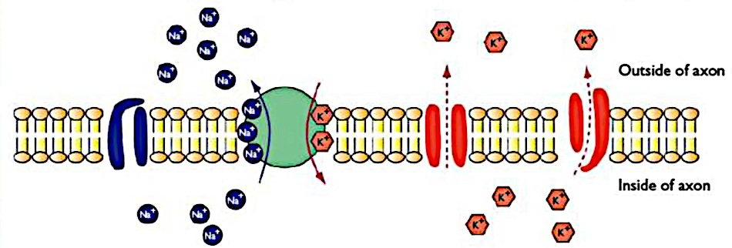
Refractory period
As the action potential is propagated along the axon by local currents, the sodium channels at the site of the initial action potential are inactivated and cannot open again until the resting potential has been re-established by the Na+/K+ pump, so a new action potential cannot be generated there. This is called the absolute refractory period, and lasts about 1ms. It ensures axon cannot transmit another action potential and that this ensures that transmission is in one direction only. For the next 5-10ms hyperpolarisation occurs.

D) Hyperpolarisation
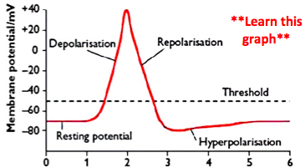

Too many K+ ions leave the axon out and an overshoot to -80mV occurs resulting in the membrane being hyperpolarised. The sodium-potassium pump restores the resting potential and the membrane becomes polarised again. During the hyperpolarisation phase an action potential can be generated providing the stimulus is stronger than usual. This is called the relative refractory period.

Propagation of the nerve impulse
Once a stimulus generates a full action potential the impulse is propagated along the axon due to the juxtaposition of positive and negative charges of the polarised and depolarised regions of the axon cell membrane. This generates localised electrical currents which open voltage gates Na+ channels, causing depolarisation of the axon section of the axon cell membrane.

Important points to note
- The depolarisation of the membrane coincides with the increase in permeability of the membrane to Na⁺ ions.
- The repolarisation coincides with an increased permeability to K⁺ ions.
A graph to show the change in potential difference during the passage of an action potential
A graph to show the conductance (permeability) of Na⁺ and K⁺ ions during the passage of an action potential
The All or Nothing response
If the intensity of the stimulus is below a certain threshold value, no action potential will be generated. But if the stimulus exceeds the threshold value (-50mV) a full action potential is generated and a nerve impulse will be propagated along the axon.
The action potential that is initiated is always the same size (+40mV) and it remains that same size as it is propagated along the axon. No energy is lost in transmission.
An increase in the intensity of the stimulus does not give a greater action potential. Instead, the frequency of action potentials increases.
So, the nervous impulse is either initiated or not and it is always the same size. This is the ‘all or nothing law’. It allows the action potential to act as a filter, preventing minor stimuli from setting up nervous impulses, so the brain is not overloaded with information.

Factors affecting the speed of transmission
The following factors affect the speed of transmission:
  - Temperature – Increases in temperature increase kinetic energy and therefore speeds up the transport of ions; this speeds up nerve transmission.
  - Diameter of the axon – The greater the diameter of the axon the lower the
resistance to the movement of ions. Giant squids have axons up to 1mm in diameter allowing them to react quickly in low temperatures.
  - Myelination – Schwann cells wrap around the axon (Y on the diagram below) and secrete a fatty myelin sheath (Z) which is an electrical insulator. Only the Nodes of Ranvier (X), which are gaps in the myelin sheath exposing the cell membrane, can become depolarised (only these regions have voltage gated Na⁺ channels). The action potential jumps from node to node and speeds up the rate of transmission; this is called saltatory transmission. The greater the distance between the nodes the greater the rate of transmission. Myelination is only found in vertebrates. Without myelin the impulse must be conducted over the entire length of the axon which takes a lot longer.
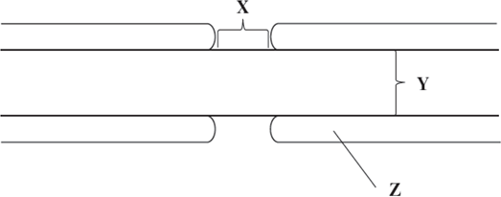
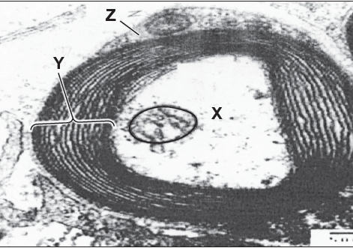

A section through an axon and fatty myelin sheath is shown to the left. X is the axon and axoplasm. Y is the fatty myelin sheath between layers of the coiled Schwann cell membrane. Z is the Schwann cell with a large nucleus.

Saltatory means ‘to leap’

Synapses
Synapses produce neurotransmitters and pass nerve impulses from neurone to neurone.
You need to be able to draw a synapse and label it fully!
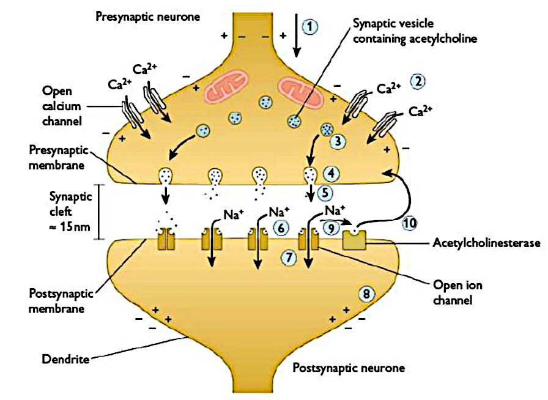
The diagram to the right shows some of the main features of a synapse.
The synaptic end bulb also has many mitochondria for ATP production. This is a cholinergic synapse with the neurotransmitter acetylcholine.

Synaptic transmission
When an action potential reaches the presynaptic membrane Ca²⁺ channel open allowing Ca²⁺ to enter the synaptic end bulb down their concentration gradient. Synaptic vessels, containing neurotransmitter, migrate towards the presynaptic membrane and fuse with it. The neurotransmitter is released by exocytosis. The neurotransmitter diffuses across the synaptic cleft and binds to receptor proteins on the post synaptic membrane. This opens Na⁺ channel allowing Na+ to flood into the post synaptic neurone. If sufficient Na⁺ enters the post synaptic neurone it will become depolarised (threshold value exceeded) and an action potential will be generated in that nerve cell.
Once an action potential has occurred the neurotransmitter is hydrolysed by the enzyme acetylcholinesterase in the synaptic cleft. This prevents successive impulses merging at the synapse and the synapse being constantly ‘on’ and intensifying/prolonging stimulation of the post synaptic neurone.
The resulting breakdown products -choline and ethanoic acid – are actively transported back into the synaptic end bulb and are regenerated into acetylcholine and repackaged into synaptic vesicles – this requires ATP, which is why the synaptic knob has many mitochondria.

Preventing the merging of synapses
- The effect of cholinesterase
- Active transport of Ca²⁺ out of the synaptic end bulb
- Reabsorption of neurotransmitter molecules.

Properties of synapses
The synapse has the following functions:
  - Transmit information from neurone to neurone
  - Pass impulses in one direction only
  - Act as junctions
  - Prevents overstimulation
  - Filter out low level stimuli

The effect of chemicals on the synapse
Many drugs act at the synapse and can either amplify or inhibit synaptic transmission. Psychoactive drugs act on the CNS by affecting neurotransmitters or their receptors. The following table summarises how the synapse could be affected by different drugs.

Amplification | Inhibition
Pre-synaptic:  Accelerating neurotransmitter production in the synaptic end bulb (cocaine).  Opening calcium channels in the pre-synaptic membrane.  Accelerating the release of neurotransmitter from the synaptic end bulb by exocytosis.  Blocking the removal or recycling of neurotransmitter substance from the synaptic cleft back into the synaptic end bulb (cocaine). | Pre-synaptic:  Inhibiting neurotransmitter production in the synaptic end bulb.  Closing calcium channels in the pre- synaptic membrane.  Inhibiting the release of neurotransmitter from the synaptic end bulb by exocytosis.
Post-synaptic:  Making the post-synaptic receptors more sensitive to the neurotransmitter.  Opening the sodium channels on the post synaptic membrane.  Inhibiting cholinesterase activity in the synaptic cleft (organophosphorus insecticides – an agonist)  Mimicking the neurotransmitter substance (cannabis). | Post-synaptic:  Making the post-synaptic receptors less sensitive to the neurotransmitter.  Closing sodium channels on the post- synaptic membrane.  Increasing cholinesterase activity in the synaptic cleft.  Masking the effect of the neurotransmitter substance.  Blocking receptors on the post-synaptic membrane.

Top Tip – Always look at diagrams carefully. Start by describing what you see then apply your knowledge and understanding.

