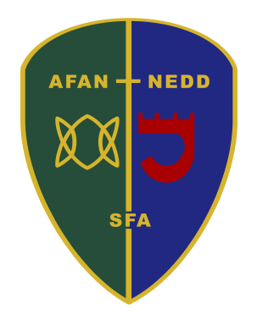

Afan Nedd Under 12’s Football Trials (season 2021/22)

Venue – Ysgol Bae Baglan, Seaway Parade, Port Talbot, SA12 7BL

First Trial - Monday 24th May 5-7pm
Second Trial (invite only) - Monday 31st May 5-7pm
Third Trial (invite only) - Monday 7Th June 5-7pm

£3 per player to cover cost of venue Hire

Trials will be open to all Neath Port Talbot Schools for footballers who will be playing Under 12’s football for the 2021/22 season (this year’s current schools year 6). All previous Afan Nedd players are required to trial alongside new trialist.

All players wanting to attend the trial are to register
by texting 07984583025
by Sunday 23rd May 2021 Please give:

Full name of player
Date of Birth
Comprehensive school attending
Player’s preferred trial position (not guaranteed on the day)
Emergency contact number & name
Any health conditions
Please note that players not registered before the trial will not be able to take part.

All players are to be:

Suitably dressed for weather conditions
Shin pads (no shin pads No trail)
Drink (Labelled with name)
Suitable footwear
Players to have their own hand sanitiser

Please note due to COVID-19 all players are to be dropped off to the venue and parents/guardians will not be able to stay at the venue to watch the trials due to the health and safety protocols set out by Welsh Government and the FAW.

Year 7 pupils for the 2021/22 academic year who are attending the below schools are eligible:

Ysgol Bro Dur, Ystalyfera, Ysgol Bae Baglan, Cefn Saeson, Dwr y Felin, Ysgol Cwm Brombil, Llangatwg,
St Josephs, Cwmtawe

