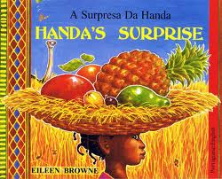
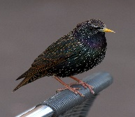
Little Starlings
Week Beginning 18th January – 21st January 2022
Home learning
Handa’s Surprise – Story of the week HANDA'S SURPRISE Picture Book Animation - Bing video
Monday 17th January | Tuesday 18th January | Wednesday 19th January | Thursday 20th January | Friday 21st January
 | Read Handa’s Surprise – link above. | Read Handa’s Surprise – link above. | Read Handa’s Surprise – link above. | Read Handa’s Surprise – link above.
See home learning suggested activity sheet | Language, Literacy and Communication  Friendship – what makes a good friend?  Handa is going to surprise her friend Akeyo  Talk to Mum and Dad about what you think a good friend is.  Draw a picture of you, on the same piece of paper draw a picture of your friend. This could be someone from the Little Starlings or someone you know.  How do they make you feel?  Can you copy the word underneath, maybe it is Happy, may be it is that they make you Smile.  Practise writing your name then copy your friends name.  Do you know any of the letter sounds in your name?  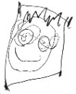 | Language, Literacy and Communication  Can you make a cave?  In your house talk to Mum and Dad about where you could build a cave.  With a focus on vocabulary  Use words such as under, over, inside, behind when talking whilst making the cave.  Think about things that you can use to make a cave, maybe some blankets or the duvet from the bed.  Can you create a cave by putting the blanket over the top?  What will you take in your cave?  Discuss and ask the question why?  Once inside the cave you could share a storybook together. Talk about the book, the characters and what happened in the story.  Share your cave adventure pictures with Mrs Arnold. | Language, Literacy and Communication  Can you create a picture of a farm?  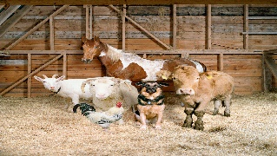  Think about the animals we have talked about that the Farmer looks after. Sign into Hwb and go onto J2E.  Can you draw Mrs Arnold a picture of a farm? What animals will you choose?  If you cannot sign into hwb, draw your farm on a piece of paper.  You can send this to Mrs Arnold on class dojo | Welly Walk  When you are out for your exercise walk take a piece of paper and pencil with you.  Can you draw a picture of the things that you see on your walk?  What is the weather like today?  Can you sing our song?  Sut mae twydd heddiw?  Can you draw Mrs Arnold a picture of what it looks like outside?  Is the sun shining, or is it raining? Is it cold and frosty? What is the ground like, is it hard and icy or is it soft and muddy?  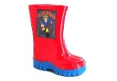
 | Maths and Numeracy  How many animals does Handa meet in the story?  Can you count them all?  How many animals are there?  Can you write each number, think about what each number looks like.  Ask an adult to help you to write each number  1,2,3,4,5  Can you use shaving foam or flour? Ask an adult to help, spread the shaving foam or flour on a table. Use your finger to write each number in the shaving foam or flour. Remember to use your magic finger to write each number in the air before you start.  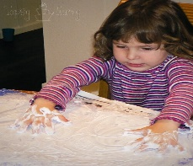 | Maths and Numeracy  Number songs and rhymes  What is your favourite number rhyme?  My favourite is four little fingers, four little fingers, four little fingers, tap tap tap. Do you remember that song? Can you sing it to Mum, Dad or a brother or sister?  What is your favourite song?  Do you like…..  If you’re happy and you know it?  The wheels on the bus?  Incy Wincy Spider?  Baa baa black sheep?  0ur new topic is Fair Aware linked to Fair Trade. We have been singing Old Macdonald.  Share your songs with Mum and Dad – what other songs can you think of?  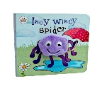  You could record yourself singing them and send it to Mrs Arnold.  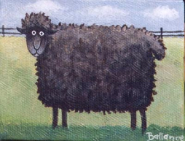  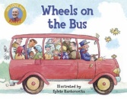 | Maths and Numeracy  Can you create a repeating pattern?  You could use your toys to create a simple pattern.  Either use toys that you have at home or can you draw pictures of shapes.  If you draw a circle and a square, can you create a simple pattern so you could have circle, square, circle, square, circle  Extension - what else can you use to make a pattern – can you create a pattern using claps and stamps.  Stamp your foot, clap your hands once, stamp your foot.  Parents you will need to explain what a repeating pattern is, so doing something the same, repeating what you do. Model it for them so that they can see it first then encourage them to create their own, support where needed. | Maths and Numeracy  Can you make a chart of all the things that you saw on your welly walk?  You could even collect the things that you saw and stick them on to your chart, such as a leaf, a stick, some mud.  Natural objects chart  I found 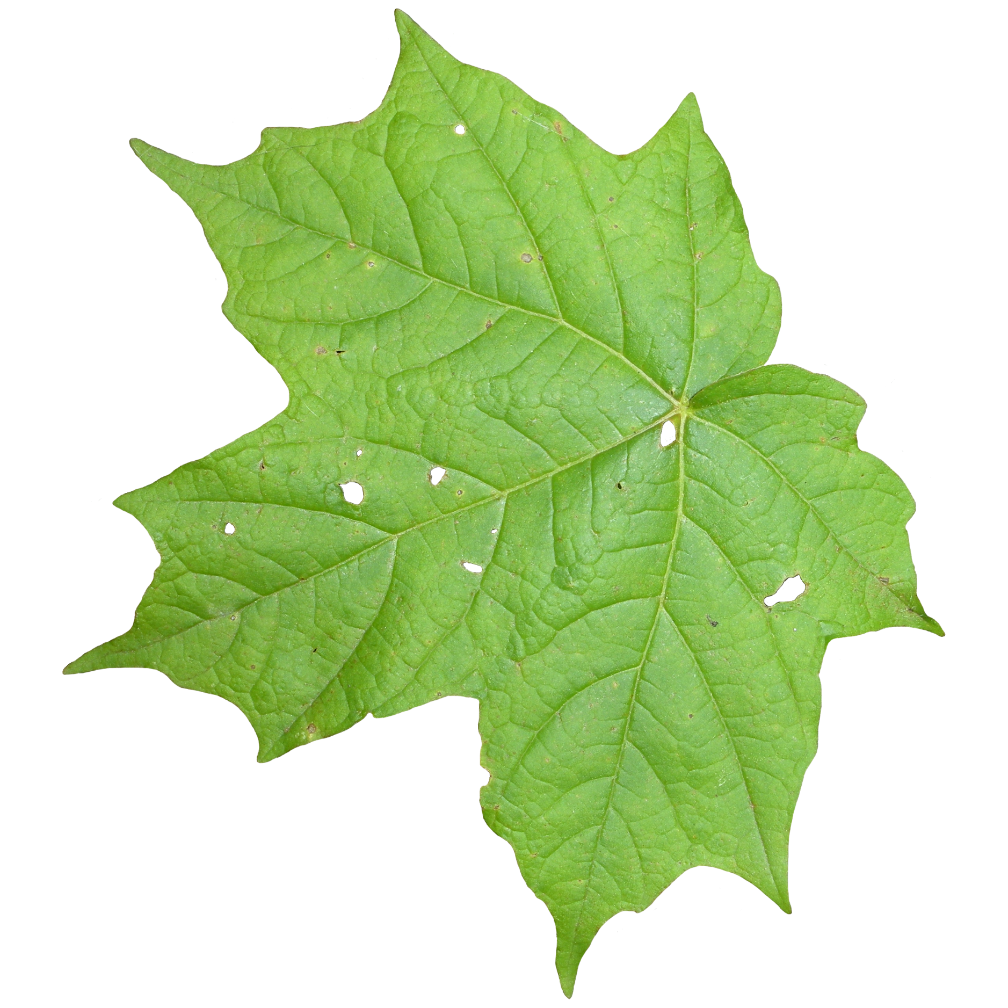
 | ICT  Can you go onto your hwb account, go to J2E have a look for paint. On there you can choose a background to draw a picture.  Can you create a picture on there for Mrs Arnold?  See what animals you could add to your picture on J2E paint. | Expressive Art  Choose your favourite character from the story. Can you draw Mrs Arnold a picture of them. You could choose Handa, Akeyo,monkey, or any of the animals that Handa meets on her way or maybe there is someone/ something else that you would like to draw.  Choose your medium – ie will you draw your picture, paint your picture or use sticky bits to glue and stick pieces to your favourite character from the story.  Send a picture of your picture to Mrs Arnold.  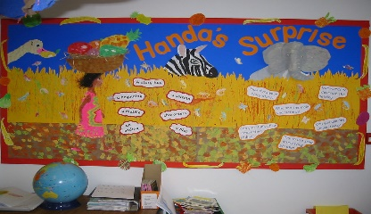 | Health and Wellbeing  Can you do some mindfulness?  Ask a grown up to put some relaxing music on  Below is an example  https://www.youtube.com/watch?v=WUXEeAXywCY  Whilst the music is on, sit on your bottom, cross your legs and fold your arms, then close your eyes.  Listen to the music and breathe in and out and relax. Do this for a few minutes.  Then visit cosmic kids yoga.  Here is an example  Frank the Frog  https://www.youtube.com/watch?v=TY8xx7c6_z0 | Health and Wellbeing  Can you do 5 star jumps?  Can you count each star jump?  Can you touch your toes five times?  Can you count each time you touch your toes?  Can you hop on one foot?  Now hop on the other foot.  How many jumps can you do? Try jumping on two feet, can you count your jumps?  What else can you do?  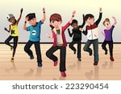  Send a picture to Mrs Arnold.  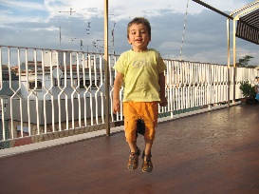
 | Book of the day:  The Three Little Pigs  https://www.youtube.com/watch?v=2s7cz6p7jew&list=PLA0KytfKDJiisleteghd3UYV1Q1iPIKDP | Book of the day: ‘  Owl Babies  https://www.youtube.com/watch?v=TPQRiSTYFHo | Book of the day:  Have a look on Reading Buddies.  Choose a book to share.  Share with Mrs Arnold what book you chose. | Book of the day:  You choose your favourite storybook and share it with someone in your family.  Share with Mrs Arnold which book you chose and why it is your favourite book.

