Emerald Class – Spelling Test words
26th April for test on 30th April

Remember, spend a little time every day to learn your group words and test yourself on Friday before the next words are given.
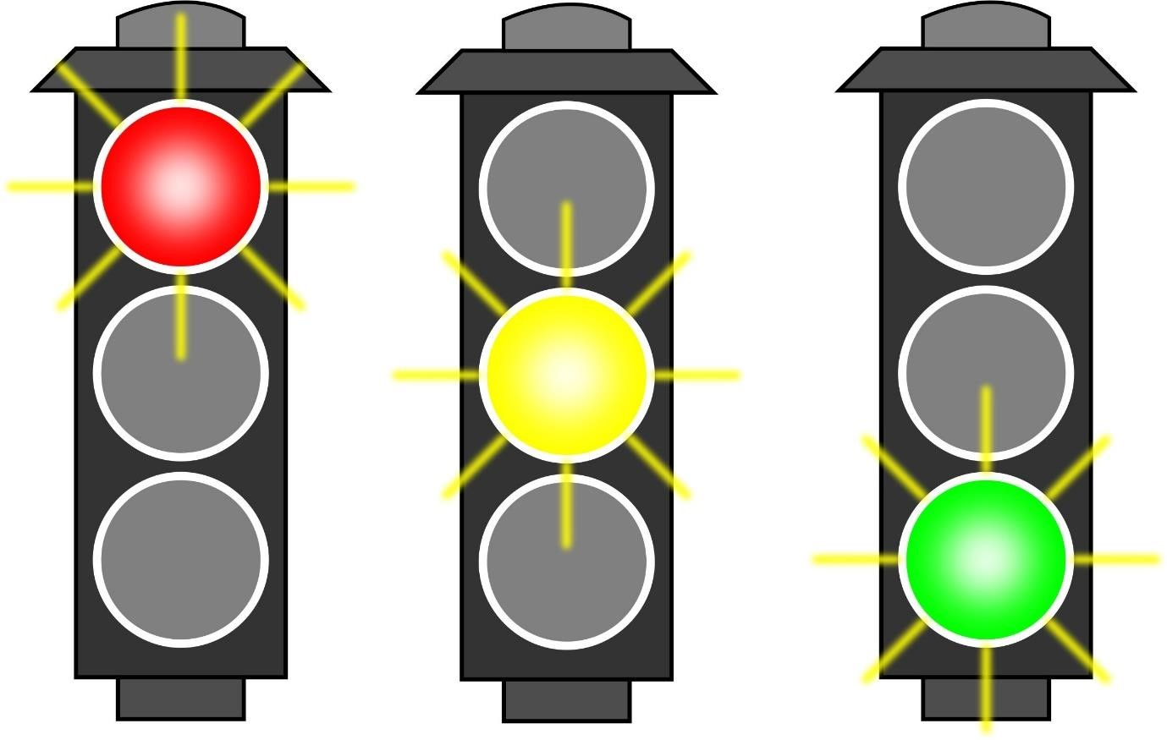

stand  stick  stiff  still  sting  stink  step  stop |  | back  crack  lack  rack  stack  track  flick  kick  lick  pick |  | angrily  clumsily  easily  happily  heavily  hungrily  lazily  luckily  merrily  noisily  prettily  readily

