Emerald Class – Spelling Test words
19th April for test on 23rd April

Remember, spend a little time every day to learn your group words and test yourself on Friday before the next words are given.
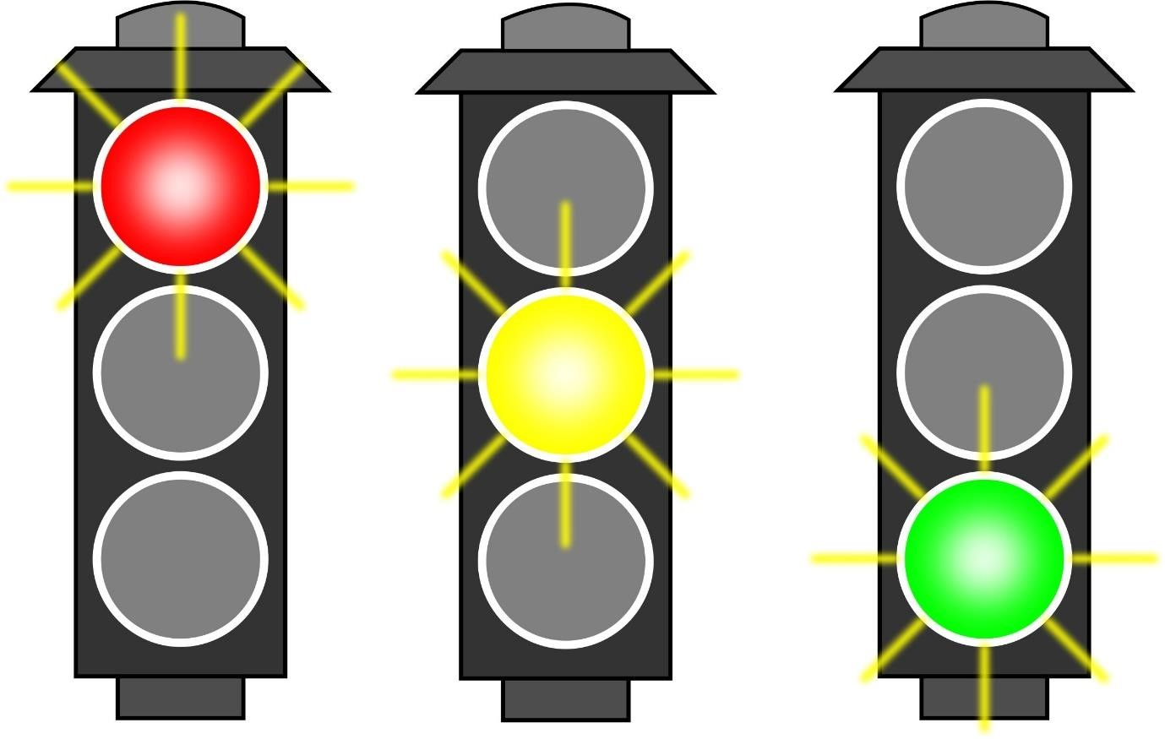

track  trap  trick  trip  trot  truck  twig  twin |  | high  sigh  might  night  right  sight  slight  tight  bright  flight |  | cuddly  gently  grumbly  horribly  miserably  possibly  probably  simply  sparkly  suitably  terribly  visibly

