Emerald Class – Spelling Test words
1st February for test on 5th February

Remember, spend a little time every day to learn your group words and test yourself on Friday before the next words are given.
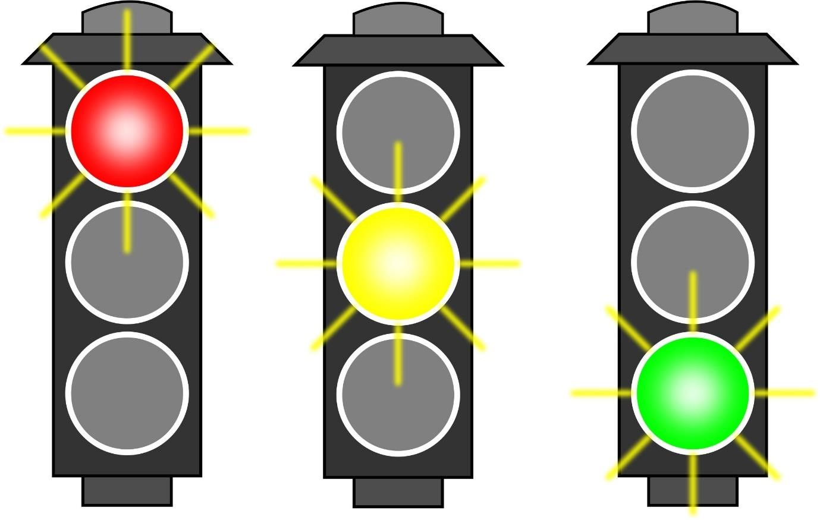

bill  fill  hill  kill  mill  pill  sill  till |  | made  cage  page  cake  lake  make  take  care  came  game |  | choice  voice  rejoice  avoid  spoil  spoilt  toilet  ointment  joint  point  appointment  disappoint

