Weekly Champion Challenges
Choose one challenge from the list below to do each afternoon this week!
Send me a photo when you have completed your work and you can achieve Dojo points. Have fun!
Challenges for week beginning Monday 1st February
Monday  Our Blood  Can you watch the BBC Bitesize clip all about blood?  Copy and paste this  link or type BBC  Bitesize - What is in your blood?  Match the blood cells with their jobs and complete the quiz at the end.  https://www.bbc.co.uk/bitesize/topics/zwdr6yc/articles/zqv4cwx  Think of and write five questions you could ask a member of your family to test their knowledge of blood. | Tuesday  Our Senses  Can you watch the BBC Bitesize clip all about senses?  Copy and paste this link or type BBC Bitesize - What are our senses?  See what you know by completing the activity that follows the video and then complete the quiz.  https://www.bbc.co.uk/bitesize/topics/z9yycdm/articles/zxy987h  Draw a picture of your body and label it with to show the 5 senses. | Wednesday  Our Skin  Using one of our senses: touch!  Can you find things that are soft, warm, smooth or cold? Explore things inside and outside then use JIT5 in Hwb to record what you found. Go to ‘write’, use a blank background and write a list of what your skin felt today!  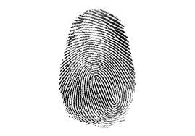  Have a go at making fingerprints to show how your skin is unique to you and different to everyone else’s. Follow the instructions.  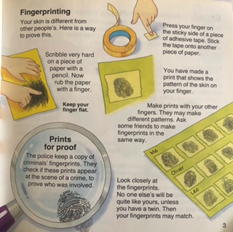 | Thursday  Sound  Using one of our senses: hearing!  Copy and past this link to listen to a song I have created in ‘Song Maker’. Go to Chrome Music Lab yourself and have a go to see what sounds you can create in ‘Song Maker’. Try clicking onto ‘Rhythm’ to make some more great sounds!  https://musiclab.chromeexperiments.com/Song-Maker/song/6234019998466048 | Friday  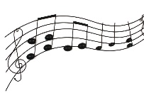  Welsh Music  Day  An important day for the people of Wales. See if you can find 5 names of famous Welsh singers and listen to a song for each singer. Which one is your favourite?  Beth ydy dy hoff gan di?  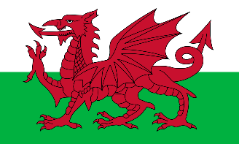  Try to do a physical activity too as it is our PE day!

