Onyx Home learning – Theme: ‘The Christmasaurus’ by Tom Fletcher
Week Beginning 6th December 2020
 | Monday | Tuesday | Wednesday | Thursday | Friday
am Literacy | Spellings – practice for 10 minutes  What do you think Santa said when he found out the Christmasaurus stayed at William’s house? You can print the sheet or just draw Santa with a speech bubble and write. | Spellings – practice for 10 minutes  Instructions- Write instructions for how Santa gets the toys on the children’s lists. | Spellings – practice for 10 minutes  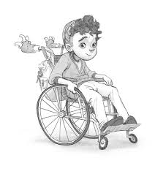  Thinking – Here is William Trundle. Write about the difficulties he would have if he was in our class. | Spellings – practice for 10 minutes  Thinking – Some people, like William, can’t run or jump like others.  Design some exercises for people who are in a wheelchair. You can draw pictures and/or write instructions. | Spellings – ask an adult to give you a test  Oracy –  Fun Friday  Live Chat  On J2Messenger (HWB)  10.30 – 11am
am Numeracy | Times Tables – practice 3x or 4x (6x if you’re ready) 10 mins  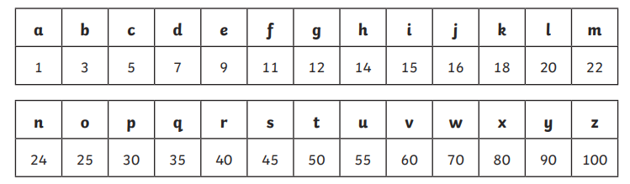  Look at this number code (larger version below)  Which character has the biggest value name? You can do this with all the names of the people in your family if you prefer. Add up the letters in each name. | Times Tables – practice 3x or 4x (6x if you’re ready) 10 mins  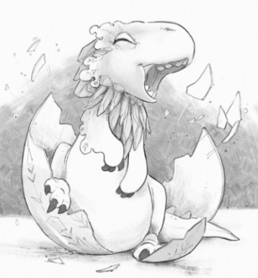  Data – Make up some Maths facts about the Christmasaurus. Copy the table and complete it. | Times Tables – practice 3x or 4x (6x if you’re ready) 10 mins  Mapping – Draw your own map of the North Pole. Include street names (made-up) and a Key for any symbols.  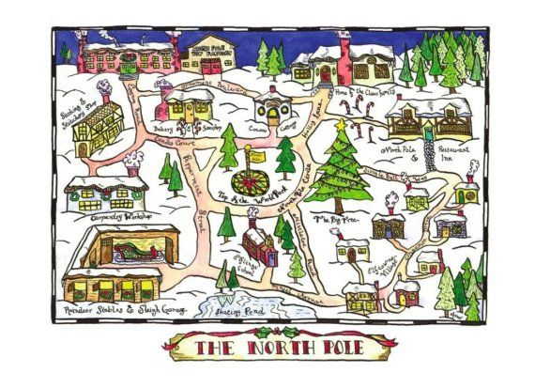 | Times Tables – practice 3x or 4x (6x if you’re ready) 10 mins  Measure - Go on to J2measure on HWB. Copy and paste some images of elves from the internet. Measure each elf with the ruler and label their heights. | Times Tables – practice 3x or 4x (6x if you’re ready) 10 mins  Investigate - The elves in the Elf Village live in houses. Every house has three storeys (floors) so that the elves can use some of the space as a workshop and to store all the toys that they make. Each different storey of the house must be painted a colour - that’s the rule in Elf Village. How many ways could the houses be painted if you have two colours? Draw pictures to help you.
  Name
  Age
  Birth Place
  Height
  Weight
  Eye colour
  Body colour
  Number of teeth
  Length of tail
pm | Champion Challenges  Choose from the cross-curricular Challenges | PE / Health and Wellbeing  PE with Joe Wicks  Planning from Mr Jones to follow | Champion Challenges  Choose from the cross-curricular Challenges | Champion Challenges  Choose from the cross-curricular Challenges | Finish off anything you need to first, then…..  Golden  Time

