WALT: Make armpit fudge. Date:

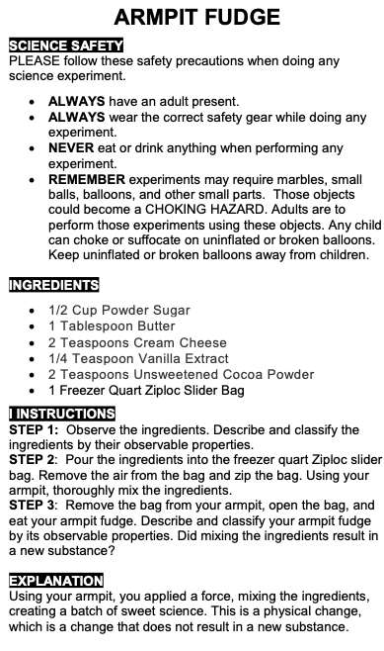
Make ‘armpit fudge’ following the girl scouts guide. Place all the ingredients in a zip-lock bag, squeeze the air out and make sure it sealed up tightly! Place the bag under the armpit and start jiggli

